Overview for real time monitoring devices: measurements of bubble and drop size distributions and phase inversion
Sebastian Maaß¹, Jörn Emmerich^{1,2} and Matthias Kraume³
1 SOPAT GmbH, Berlin, Germany; 2 Technische Universität Berlin, bioprocess engineering; 3 Technische Universität Berlin, chemical engineering
*Corresponding author: Sebastian.maass@sopat.de
Highlights
- Introduction of new automation technique for multiphase applications
- General overview of inline techniques for the particle characterization given
- ISO standards are applied to the evaluation and show the advantages of image analysis

1. Introduction
The exact knowledge of drop size distributions (DSD) plays a major role in liquid-liquid extraction, for controlling and optimizing processes and separation efficiency as well as reducing residence times. Many efforts have been made to measure the size of liquid dispersed droplets. The techniques can be divided into those that require a sample to be withdrawn from the vessel, column or pipe and those that take the measurement in situ. The next step forwardc is the control of the fluid particle size in such systems. Therefore, fast information acquisition is needed but difficult to obtain. While many users are confronted with these requirements an adequate measurement technique for all applications is needed but has not yet been developed. A further difficulty handling such dispersed systems is the possible danger of a phase inversion (PI). Does this phenomenon occur spontaneously during a process, it can have fatal consequences for the process and/or equipment.
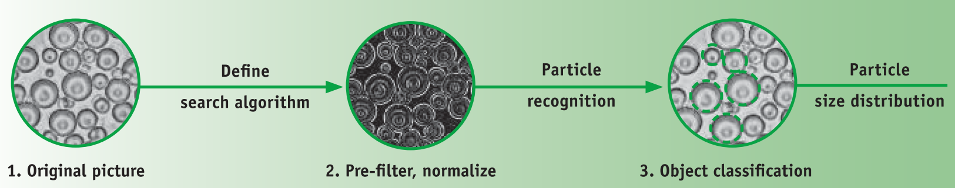
Fig. 1: Photo-optical Measuring Method for Particle Size Distributions

2. Methods
An overview is given for already existing measurement techniques. They are divided into three main groups: sound, laser and photo based techniques. The FBRM® [1], the 2-D ORM® [2] and the PARSUM IPP 30 [3] which all give online and in-situ information together with an in house developed photo optical technique SOPAT-VR® [4, 5] will be discussed in detail. They have been tested for different applications in various multiphase system (liquid-liquid, gas-liquid-liquid, gas-liquid-liquid-solid). The results achieved by the different measurement techniques are compared with each other. As proposed in literature, image analysis is used as the standard method that all other techniques are compared with. The photo-optical SOPAT measuring technique for particle sizing is capable of acquiring raw data (two-dimensional images) of the dispersed phase (here: droplets) during the process and measure the sizes by means of automated image analysis, see Fig. 1. This study demonstrates the capability of a photo-optical measurement method by taking the example of a separation apparatuses after a mixer.
3. Results and discussion
Fig. 2 exemplarily shows the measured DSDs for the separation process. The experiments showed clearly that the initial droplet size is of major importance for the separation efficiency. The studies, varying volume flow, dispersed phase concentration as well as dispersed phase are shown and its influence determined. Additionally it could not only detect the required DSD, but also was able to distinguish between different dispersed phases, for example disturbing bubbles and furthermore the beginning of PI have been detected and therefore the measurement system could be used as a warning for PI. As the results are available inline and in real time, a closed control loop can be established.
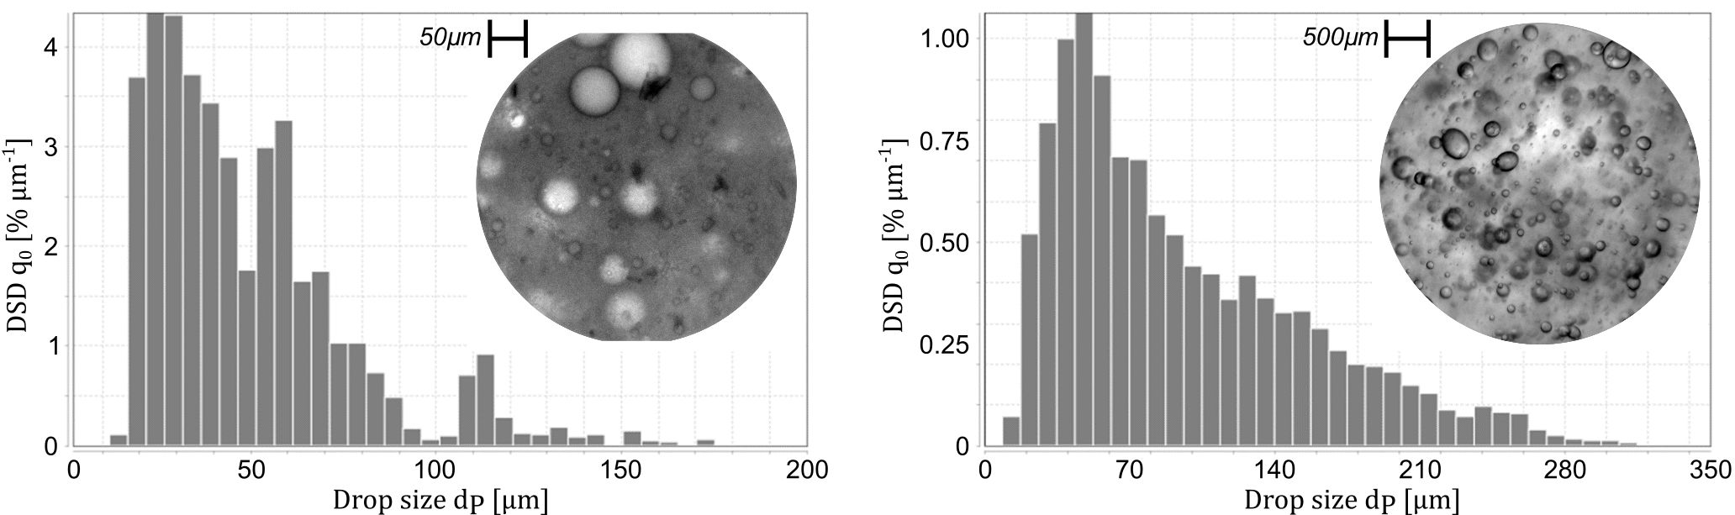
Fig. 1: Measured DSD for w/o (left) and o/w separation process (right) with exemplary photo-optical image data
References
[1] Ruf et al., Modeling and experimental analysis of PSD measurements through FBRM. Part. Part. Sys. Char., 17 (2000) 167-179.
[2] Lovick, J., Mouza, A.A., Paras, S.V., Lye, G.J. and Angeli, P., 2005. Drop size distribution in highly concentrated liquid-liquid dispersions using a light back scattering method. J. Chem. Technol. Biotechnol., 80(5): 545-552.
[3] Petrak, Simultaneous measurement of particle size and particle velocity by the spatial filtering technique. Part. Part. Sys. Char., 19 (2002) 391-400.
[4] Maaß, S., Rojahn, J., Hänsch, R. and Kraume, M., (2012); Automated drop detection using image analysis for online particle size monitoring in multiphase systems. Comp. Chem. Eng., 45: 27-37
[5] Panckow, R. P., Comandè, G., Maaß, S. and M. Kraume (2015). Determination of Particle Size Distributions in Multiphase Systems Containing Nonspherical Fluid Particles. Chem. Eng. & Technol. 38 (11), 2011-2016.

