From Conceptual Design to Process Design Optimization: Future research challenges
Ludovic Montastruc¹, Ségolène Belletante², Alexandre Pagot², Stéphane Negny¹, Ludovic Raynal²
1Université de Toulouse, Laboratoire de Génie Chimique UMR CNRS/INPT/UPS France, 2IFP Energies nouvelles, Rond-point de l'échangeur de Solaize - BP 3,69360 Solaize,France
*Corresponding author: ludovic.montastruc@ensiacet.fr
Highlights
- The new role of Process Systems Engineering (PSE) focusing on process synthesis.
- Future research challenges that process synthesis will have to face.

1. Introduction
Process synthesis is a dynamic research domain widely explored by the process systems engineering (PSE) community. This topic was first put forth 60 years ago. Westerberg in his retrospective on design and process synthesis, has defined process synthesis as the part of engineering “where one invents the structure and operating levels for a new chemical manufacturing process”[1]. Process synthesis applies to both the design of a completely new process flowsheet and the retrofit and optimization of an existing process. Furthermore, process synthesis is the assembly and interconnection of unit operations into a process network involving different physical and chemical phenomena to transform a material into desired products for given energy inputs with the goal of optimizing either economic, environmental, and/or social objectives [2]. This dynamics of this research will be further increased due to the future research challenges that process synthesis will face, e.g., biomass transformation, shale production, embedded process, modular plant design, and intermittent production of energy.
2. Methods
A systematic literature review method composed of a search strategy and an analysis of the collected documents are performed. The purpose is to identify the main methods and approaches developed in the literature and to examine them thoroughly. The PSE research groups several topics or subjects: continue or batch, simulation or optimization, Linear Programming or No Linear Programming with or without integer variables, mono or multi- objective….. We identify the most influential research teams and papers that played major roles. In the considered period2011-2016, 1288 articles were published, and 16 research teams wrote 95% of them only. While these teams are all working on process and conceptual design, from figure 1, one can identify a first category of authors who are more focused on optimization methods, i.e., Barton, Biegler, Floudas, and Grossmann. For these groups, process synthesis is one application of the optimization methods that they develop in their research teams because the conversion of process alternatives into mathematical models often results in MINLPs that are difficult to solve. For other authors, mono- or multiobjective optimization is often a tool that is included in their methodology. One major observation from this figure is that the authors study the process synthesis under the domain of their scientific backgrounds. Indeed, You, Puigjaner, and Srinivasan are more focused on supply chain; Klemes, Kravanja, El Hawagi, and Marechal on heat integration aspects, whereas Maravelias tackles the problem with his vision as a scheduling specialist. A majority of authors are more on the process design area except for two of them who are more focused on conceptual design, i.e., Gani and Engell. Finally, another category of researchers, composed of Marquardt and Ng, try to have a more comprehensive approach that seeks to integrate all previous elements.
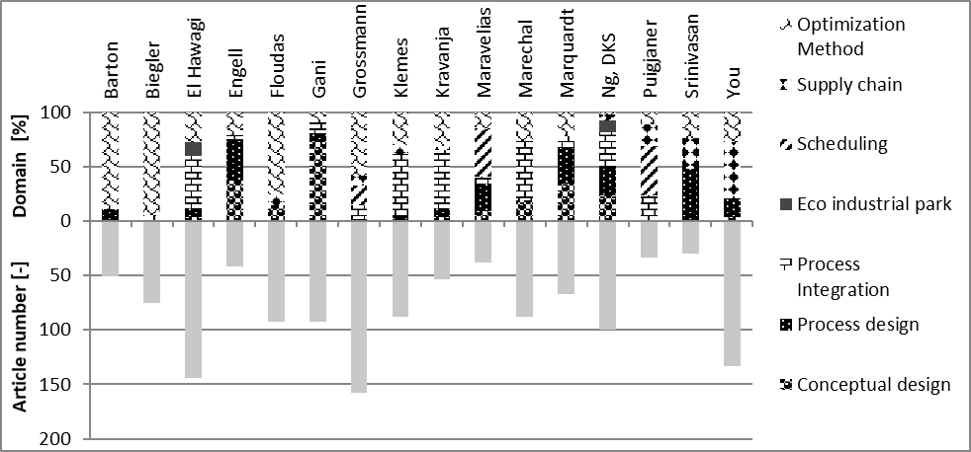
Figure 1. Relationship between domain clusters and research teams
3. Conclusions
In addition to these future challenges, theoretical advances are also required. Obviously, the development of optimization methods and algorithms must continue to provide solutions to the global optimization problem. Either conventional or intensified unit operations require more detailed models to introduce small-scale phenomena, which influence the performance of unit operations. Such an approach leads to the introduction of multiscale information in the design process. The development of methods to handle uncertainties is also a crucial challenge. During the process design stages via optimization approaches, hybrid approaches, or through metamodeling (multiparametric approach, “surrogate model,” etc.), the introduction of inaccuracies and/or uncertainties on data is performed by local sensitivity studies or calculation of flexibility indices. In recent years, new methods of global sensitivity (e.g., Sobol method and chaos polynomials) have emerged, allowing the effective modeling and propagation of uncertainties in numerical simulation. Similarly, machine-learning methods have expanded considerably, for example, in the treatment of partitioning or discrimination problems. Furthermore, the modeling of poorly known data remains a major asset of the fuzzy logic. A possible strategy of renewing the methods for design processes could be the use of these three techniques, separated or combined, in order to reach more robust solutions that can allow inaccuracies/uncertainties inherent to the design stage, but at the same time, deal with hazards during process operation.
References
- Westerberg, A. W. (2004). A retrospective on design and process synthesis. Computers & Chemical Engineering, 28(4), 447–458.
- Chen, Q., & Grossmann, I. E. (2017). Recent Developments and Challenges in Optimization-Based Process Synthesis. Annual review of chemical and biomolecular engineering, 8, 249–283.

