“Egg-Yolk” Catalyst Particle Design for Improved Flexibility of Industrial Scale Fixed-Bed Reactor used for CO₂ Methanation
Ronny Tobias Zimmermann¹, Jens Bremer², Kai Sundmacher^{1,2}
1 Otto-von-Guericke Universität, Universitätsplatz 2, 39106 Magdeburg, Germany;
2 Max-Planck-Institut für Dynamik komplexer technischer Systeme, Sandtorstraße 1, 39106 Magdeburg, Germany
*Corresponding author: ronny.zimmermann@mpi-magdeburg.mpg.de
Highlights
- Combined catalyst particle and reactor optimization.
- Dynamic and flexible fixed-bed reactor operation.
- Reduced parametric sensitivity of reactors filled with “egg-yolk” particles.

1. Introduction
Surplus electrical energy harvested from renewable energy sources can be efficiently stored by generation of hydrogen via electrolysis of water. Due to the missing hydrogen infrastructure, it is favorable to convert hydrogen together with carbon dioxide into synthetic methane. Methane can be readily distributed in existing pipeline networks and is a key substance of the chemical industry.
However, the high exothermicity of the methanation reaction imposes a challenge for the operation of the typically employed fixed-bed reactors. Due to catalyst deactivation, safety constraints and the thermodynamic equilibrium of the reaction, the temperature of the fixed-bed has to be limited [1]. For dynamic operation of these reactors, according to the availability of surplus energy, high parametric sensitivity and wrong-way behavior further amplify this aspect [2]. Much research has been done to keep the fixed-bed temperature in defined bounds, mostly focusing on the manipulation of variables on the reactor scale [3]. However, the knowledge about the influence of the catalyst particle design on the reactor behavior is rather limited. Therefore, in this contribution, the influence of the catalyst particle design on the reactor behavior has been investigated.

2. Methods
The influences of the catalyst particle activity, permeability and heat conductivity on the performance of the reactor have been examined by employing a dynamic heterogeneous reactor model. Homogeneously active particles and particles with multiple zones, focusing on particles with an “egg-yolk” configuration, were compared. Subsequently, the carbon dioxide conversion of the reactor was optimized subject to these degrees of freedom for the different particle concepts without surpassing the catalyst particle deactivation temperature. The optimized concepts were further compared by sensitivity analyzes regarding coolant temperature, reactor inlet flow rate and reactor pressure as well as by dynamic simulation studies.

3. Results and discussion
The sensitivity analysis regarding the coolant temperature reveals a reduced temperature increase on the ignition curve of the reactor filled with optimized “egg-yolk” catalyst particles in comparison to the reactor filled with optimized homogeneously active catalyst particles as shown in Figure 1. This allows for the operation of the fixed-bed reactor at high carbon dioxide conversions without surpassing the critical catalyst particle deactivation temperature in a broad range of coolant temperatures. The same is not possible with homogeneously active particles.
Similar results were obtained from the sensitivity analyzes of the inlet flow rate and the reactor pressure. The carbon dioxide conversion and the maximum particle temperature of reactor filled with homogeneously active particles show a large sensitivity with regard to these parameters. In contrast, the carbon dioxide conversion and the maximum particle temperature are almost constant in the reactor filled with “egg-yolk” particles in the investigated parameter range.
Furthermore, the dynamic simulation studies show a fast transition between the operation points of the reactor filled with “egg-yolk” particles. The transition of the operation points of the reactor filled with homogeneously active particles takes much longer and can exhibit significant wrong-way behavior.

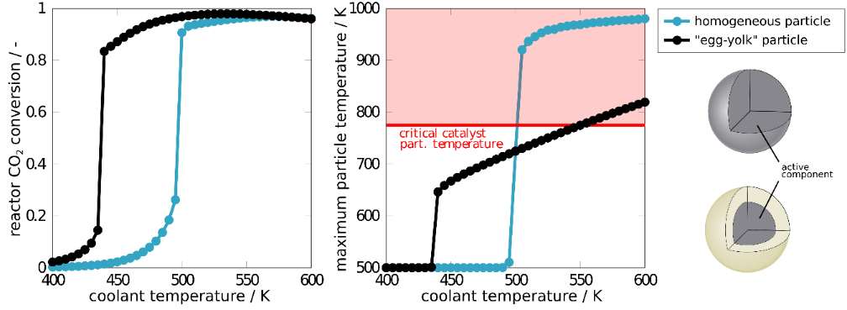
Figure 1. Comparison of the ignition curves of a catalytic fixed-bed tubular reactor filled with optimized homogeneously active particles and optimized “egg-yolk” particles fed by a stoichiometric and undiluted mixture of CO₂ and H₂.
4. Conclusions
The high exothermicity of the methanation reaction imposes a challenge for fixed-bed methanation reactors during steady state and dynamic operation, as the fixed-bed temperature has to be limited, mainly due to catalyst deactivation. Therefore, the carbon dioxide conversion of an industrial scale fixed-bed methanation reactor has been optimized by variation of degrees of freedom on the particle scale without surpassing the critical catalyst deactivation temperature for different particle concepts. Subsequent sensitivity analyzes and dynamic simulation studies revealed beneficial behavior of reactors with “egg-yolk” particles in comparison to the typically used homogenously active catalyst particles. Reactors filled with “egg-yolk” particles show a much broader range of operation points with high carbon dioxide conversion without surpassing the critical catalyst deactivation temperature and faster transition between operation points.

Acknowledgement
This research work was conducted within the Priority Program SPP 2080 “Catalysts and reactors under dynamic operating conditions for the storage and conversion of renewable energy”. The financial support from the German Research Foundation (DFG) is gratefully acknowledged.
References
- S. Rönsch, J. Schneider, S. Matthischke, M. Schlüter, M. Götz, J. Lefebvre, P. Prabhakaran, S. Bajohr, Fuel 166 (2016) 276-296.
- D. Schlereth, O. Hinrichsen, Chem. Eng. Res. & Des. 92 (2014) 702-712.
- J. Bremer, K. H. G. Rätze, K. Sundmacher, AIChE J. 63 (2017) 23-31.

