Modelling of reverse water-gas shift on copper-based catalysts using a convection-diffusion packed bed microkinetic model
Damjan Lašič Jurković¹, Anže Prašnikar¹, Andrej Pohar¹, Blaž Likozar¹
1 Department of Catalysis and Chemical Reaction Engineering National Institute of Chemistry, Hajdrihova 19, 1000 Ljubljana, Slovenia
*Corresponding author: damjan.lasic@ki.si
Highlights
- RWGS was performed with 4 different catalysts (10% Cu / Al₂O₃, TiO₂, SiO₂, ZrO₂)
- Data was compared with modelling results for different reactor types – CSTR, PFR and PB
- Bulk-gas diffusion plays an important mass-transfer role at our operating conditions
- DFT-derived RWGS kinetic model from literature was improved for higher predictive power

1. Introduction
Over the last decades, there is an increasing need to capture and convert CO₂ to help reduce the effect of global warming. One of such routes is to convert CO₂ to syngas via reverse water-gas shift reaction (RWGS), and then further synthesize useful products such as liquid fuels and chemicals.^{[1]} In order to produce efficient catalysts for this process, a thorough understanding of the surface reaction mechanisms is needed. Microkinetic modelling, with the help of experimental data and reaction parameters obtained by ab-initio methods such as DFT,^{[2]} is a useful tool that can be used both for understanding the process and process optimization. In this work, different reactor models are developed and used with experimental data from activity^{[3]} and analytics to fine-tune the reaction parameters and obtain good model predictive power.
2. Methods
For the experimental part, four different copper-based catalysts (10 wt. % Cu on Al₂O₃, TiO₂, SiO₂ and ZrO₂) were synthesized using the deposition-precipitation method. The synthesized catalysts were analyzed with different experimental techniques, such as XRD, BET, SEM, EDX and various chemisorption techniques such as H₂ TPR, H₂ and CO TPD and pulsed N₂O oxidation. The latter was used to determine the concentration of surface active sites that was later used as an input to the model and varied with the supporting material used.
A one-dimensional packed bed reactor model was developed for system simulation. The model accounted for both convective and diffusive mass transport, as well as the full microkinetic chemistry consisting of surface reactions, and adsorption/desorption processes obtained from ^{[2]}. The model was solved using the CVODE solver written in C,^{[4]} and the numerical regression with the experimental data using the model was performed using the COBYLA method from the SciPy library written in Python.^{[5]}
3. Results and discussion
The microkinetic model from the literature was used to calculate the conversions and product selectivity at the experimental conditions used, and compared to experimental data. The type of the reactor used in the model (CSTR, PFR or PB) was given additional attention.

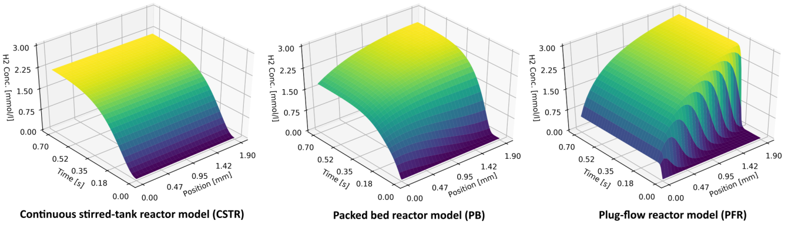
Figure 1. Comparison of different reactor models for the microkinetic RWGS reaction system. Depicted is the dependence of hydrogen concentration on the position of the reactor and the time in the simulation.

As seen in Figure 1, significant differences can be obtained when different models are used at the conditions in this study. This is due to the diffusion playing and important role at the gas flows and packed bed heights used. It can be seen that the packed bed reactor falls between the CSTR and PFR approaches with the degree of the reaction.
All of the models were used in numerical regression and the PB model gave the best fit to the experimental data. It was shown that with the improved model, it is possible to correctly predict the activity of copper based supported catalysts only from N₂O oxidation data, regardless of the supporting material used.
4. Conclusions
In this work, we show that for most experimental setups, gas diffusion plays an important role in mass transfer and has to be taken into account when modelling such systems. In addition, using the data obtained by experiments performed on different copper based catalysts, we explored various DFT-derived RWGS models from the literature and adjusted the best-fitting one to further improve its predictive power. It was shown that using N₂O oxidation data and our updated model, it’s possible to correctly predict RWGS experimental activity of copper catalysts using different supporting materials.
References
- E. Schwab, A. Milanov, S. A. Schunk, A. Behrens, N. Schödel, Chemie Ing. Tech. 87 (2015) 347–353
- I. Fishtik, R. Datta, Surface Science 512 (2002) 229–254
- D. L. Jurković, A. Pohar, V. D. B. C. Dasireddy, B. Likozar, Chem. Eng. Technol. 40 (2017) 973–980
- Cohen S. D., Hindmarsh A. C.: Computers in Physics, 1996, 10(2), 138-143
- Powell M J D.: Acta Numerica, 1998, 7, 287-336

