Towards the quantitative prediction of precipitation of nanoparticulate pharmaceutical compounds
Tobias Schikarski¹& Holger Trzenschiok¹, Andreas Güldenpfennig¹, Lukas Pflug², Marc Avila³, Wolfgang Peukert^{1*}
1 Institute of Particle Technology, Friedrich-Alexander Universität Erlangen-Nürnberg; 2 Chair of Applied Mathematics, Friedrich-Alexander Universität Erlangen-Nürnberg; 3 Center of Applied Space Technology and Microgravity, Universität Bremen
*Corresponding author: wolfgang.peukert@fau.de
Highlights
- Precipitated nanoparticles of Ibuprofen down to 25nm
- Precise simulations of precipitation of Ibuprofen in a T-mixer
- Trend of particle size and shape of PSD are well captured for all Re in simulations

1. Introduction
It is estimated that more than 40% of new drug candidates fall into the Biopharmaceutic Class II and IV characterized by the low solubility of the active pharmaceutical ingredient (API), which results in low bioavailability [1]. Manufacturing drug particles in the nanometer range have been found to be a promising method to enhance the dissolution rate and, thus, the bioavailability. In particular, below 50nm the dissolution rate begins to drastically increase compared to the coarse-grained powder in the micrometer range. In doing so, precipitation of API nanoparticles attracted the attention in recent years due to the simple process condition, the easy scale-up as well as the low energy costs involved [1,2]. Still, the most challenging task remains on gaining suspensions stable with respect to the particle size distribution and crystallinity at defined process condition [1,2]. Numerical modeling of precipitation has been proven to be a useful tool to understand the interaction of the underlying processes for inorganic compounds. However, the transfer to organic compounds, e.g. API’s, haven’t led to great success so far, primarily due to the influence of the organic stabilizers usually applied. A recently in our group developed stabilization method closes this gap, provides insights into the underlying processes during precipitation of organic nanoparticles and allows to predict the resulting particle size distribution for well-stabilized nanoparticles.
2. Methods
A simple T-mixer is used to mix an alkaline aqueous ibuprofen solution with an acidic aqueous Zirconium chloride solution and to trigger the precipitation of Ibuprofen while Zr-ions stabilize the formed particles. The Villermaux-Dushmann reaction is conducted to quantify the mixing efficiency experimentally. The numerical approach consists of direct numerical flow simulations of the mixing process solving the Navier-Stokes and the convection-diffusion equation. A parameter-free approach is here applied which does not require any turbulence modeling. To describe particle formation, the nucleation and diffusion-limited growth is described by the population balance equation along Lagrangian trajectories. Details on the mixing and precipitation experiments as well as on the flow simulations can be found in [3,4].
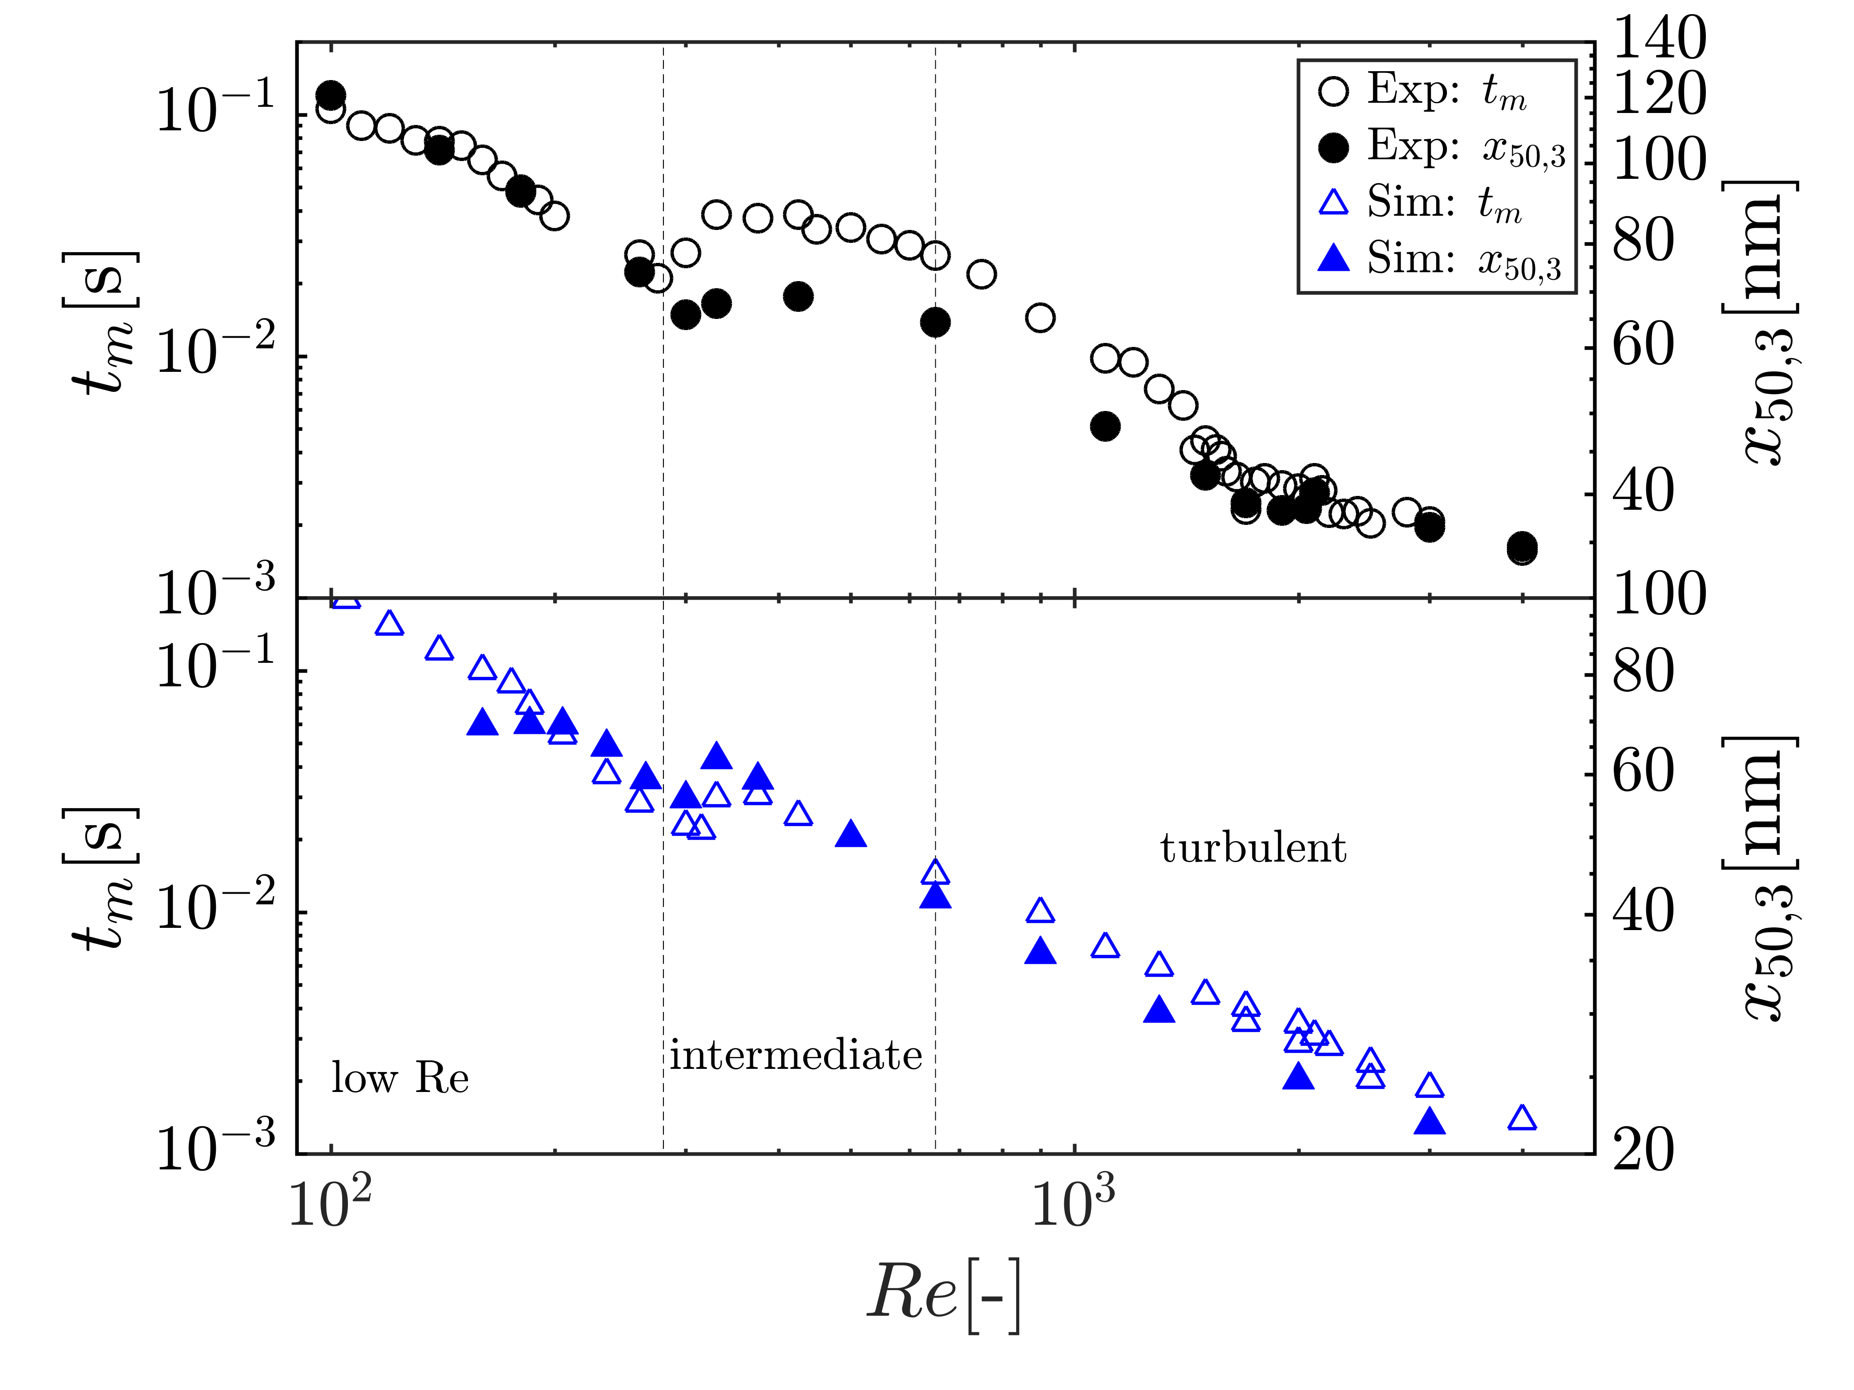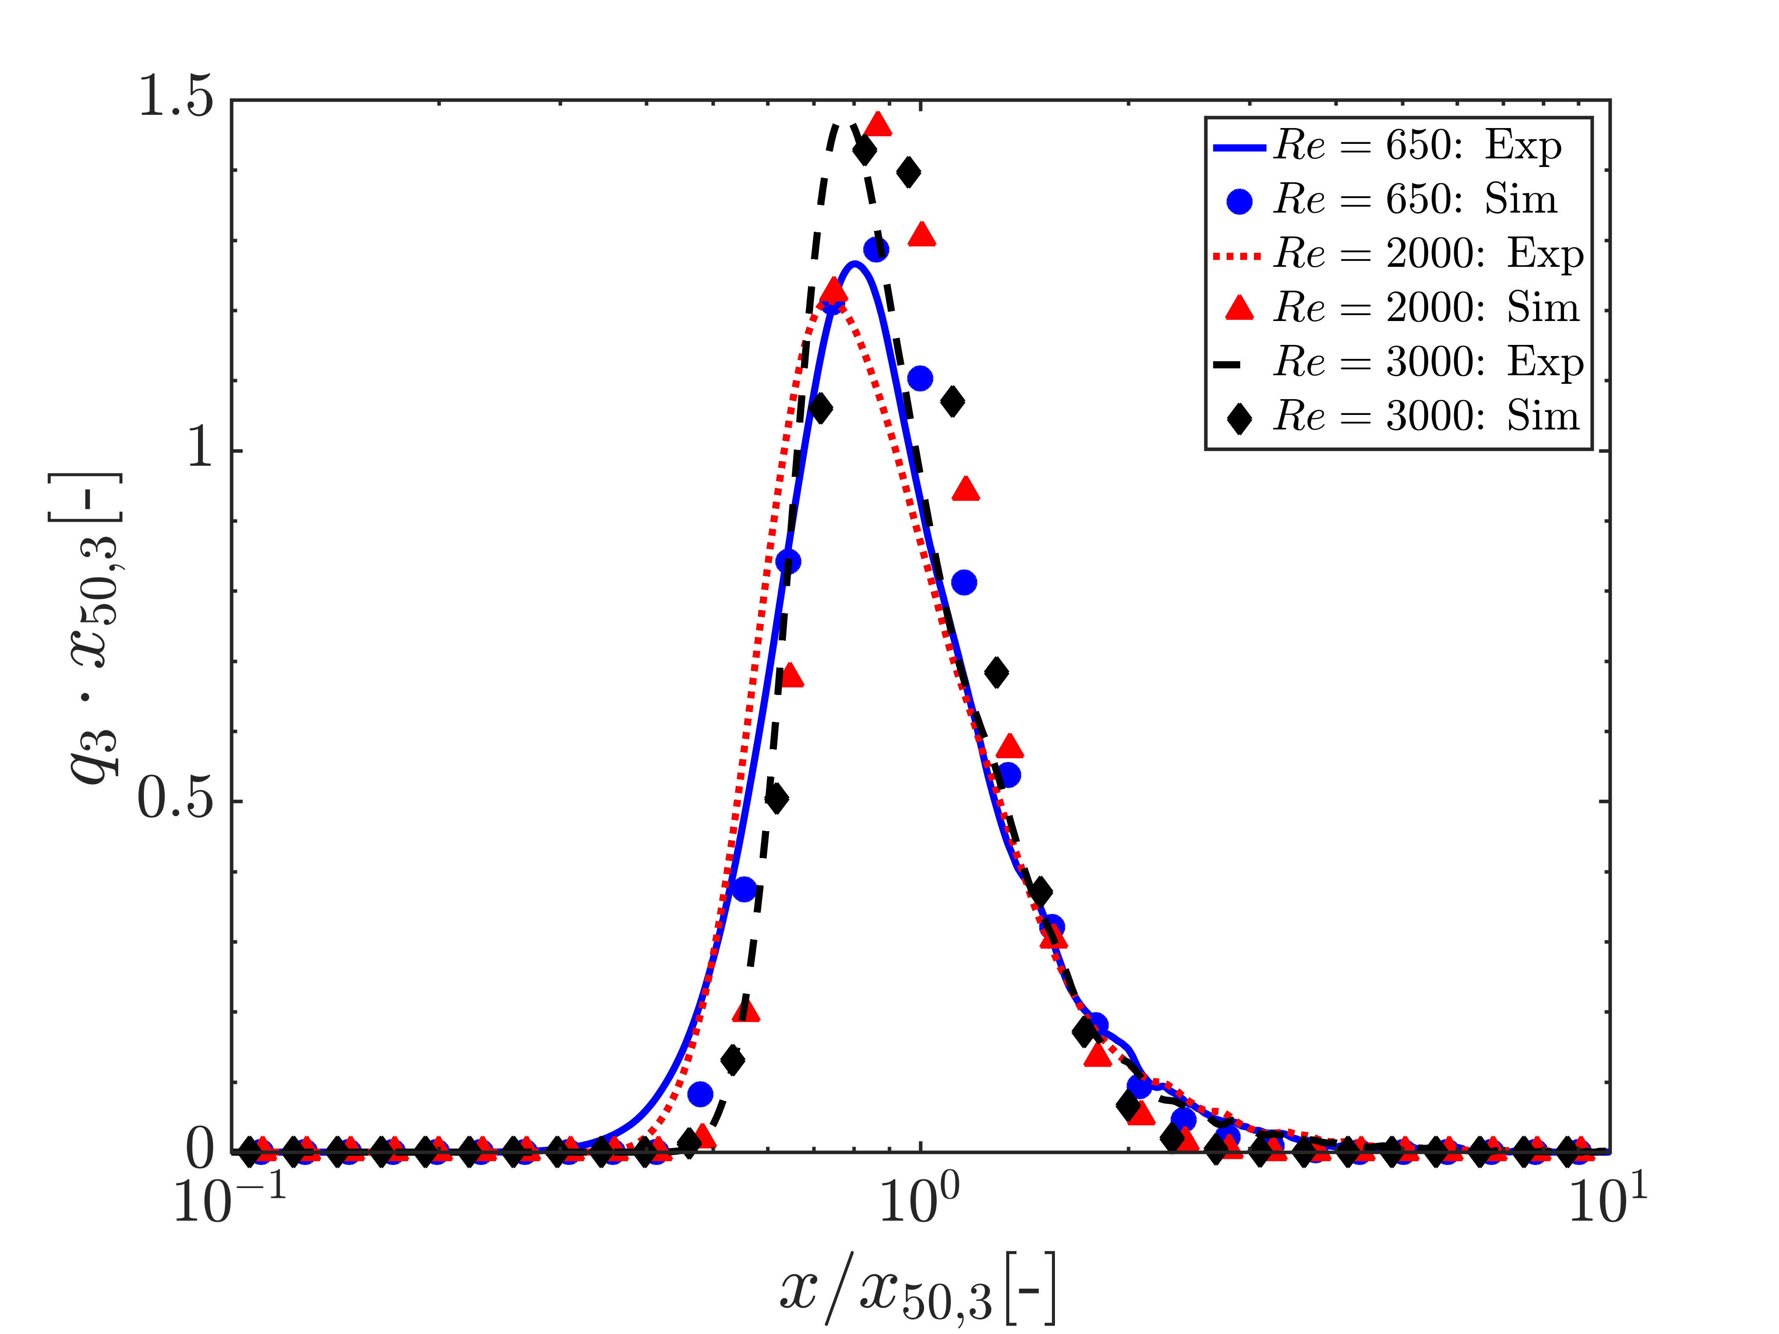
a)
b)
Figure 1. (a) Experimentally measured and computationally estimated mixing time t_{m} (left y-axis) and median particle size x_{50,3} (right y-axis) as a function of Reynolds number Re. (b) Comparison of normalized particle size distributions at particular Re.
3. Results and discussion
The supersaturation is the thermodynamic driving force of the precipitation, which is here determined by the rate the two fluids are brought in contact with each other. Thus, the primary particle formation steps nucleation and growth are mixing controlled under the assumption of fast chemical reactions. This prevailing view is substantiated in Fig. 1a), which depicts a nearly perfect alignment of the experimentally determined mixing efficiency with the median particle size x_{50,3} as Re increases. To properly simulate the precipitation, the mixing needs to be accurately captured at first, which was achieved in excellent qualitative agreement to experiments in our recent study [4]. Subsequently, the particle formation induced by the inherent mixing history along each Lagrangian trajectory is simulated resulting in a finally accumulated PSD. With this approach, we are able to predict qualitatively the median particle size over the entire Re-regime considered without any modeling, see Fig. 1a). Note that only known physicochemical constants of Ibuprofen have been incorporated (particle density, molecular weight, diffusion coefficient). The only unknown parameter is the experimentally hardly accessible interfacial energy, which is determined by a model-based approach. The thus determined fixed, single value for all calculated PSD’s is in the typical order of known organic substances. Remarkably, the shape of the particle size distributions is very well captured by the simulations in particular at high Re, see Fig 1b).
4. Conclusions
Modeling of precipitation, in particular, of organic nanoparticles is challenging. Our results demonstrate considerable progress and provide the potential for broader applications in future. In the talk, we will outline in detail the applied approach. In particular, we will focus on the interaction of mixing and supersaturation build-up, the prediction of PSDs and scale-up to very high Reynolds numbers and explain the role of the interfacial energy for predictive numerical modeling and simulation.
References
- A. A. Thorat, S.V. Dalvi, Chem. Eng. J. 181 (2012) 1-34.
- S. M. D’Addio, R.K. Prud’homme, Adv. Drug. Deliv. Rev. 63 (2011) 417-426.
- H. Trzenschiok, M. Distaso, W. Peukert. Chem. Eng. J. 361 (2019) 429-438.
- T. Schikarski, H. Trzenschiok, W. Peukert, M. Avila, Reac. Chem. Eng. (2019)

