Fouling monitoring in food and bioprocess with MEMS sensor: comparison of local steady and periodic thermal excitation
Yassim Boukazia^{1,*}, Guillaume Delaplace², Mathilde Cadé³, Frédéric Bellouard⁴, Marc Bégué⁵, Luc Fillaudeau¹
1 LISBP (CNRS 5504 - INRA 792 – INSA), Toulouse, FRANCE; 2 PIHM-UMET (INRA 638), Lille, France, 3 IRH Ingénieur Conseil, Ludres, France; 4 Aqualabo, Caudan, France, 5 LMDC, Toulouse, France
*Corresponding author: boukazia@insa-toulouse.fr
Highlights
- In-situ fouling sensor based on MEMS technology and thermal excitation.
- Steady Permanent and Periodic Thermal Regimes are compared.
- Responses are scrutinized versus fouling magnitude and thermal properties.

1. Introduction
In industrial (bio)process, undesirable components impact efficiency [1; 2]. Monitoring and quantification of (bio)fouling through in-situ and local sensors constitute scientific and technological challenges. In present work, a prototype fouling sensor based on MicroElectroMechanical System (MEMS) technology and thermal pulse analysis method (INRA patent FR2885694) has been developed and produced by Aqualabo Company (France). Steady permanent Thermal Regime (STR) and Periodic Thermal Regime (PTR) were investigated and compared to theory to extract fouling properties (thickness, thermal conductivity and diffusivity)
2. Methods
Studied sensor is based on hotwire method with powered and regulated Joule effect [1]. Hot wire and fluid temperatures are continuously recorded. According to heat conduction’s law, temperature difference ($∆θ$) evolves as linear function with heat flux ($φ$) and thermal resistance ($R_{th}$) in STR mode (Eq.1). In PTR mode (Eq.2), sinusoidal excitation is imposed and $∆θ$ evolves as a function of $φ$ and fouling nature [3]. Mean temperature difference, $\overline{{∆θ}_{PTR}}$, amplitude, A and phase lag, ΔΦ enable to determine thermal resistance and diffusivity of deposit. Considering both excitation modes, deposit thermal properties can be extracted and compared with theory.
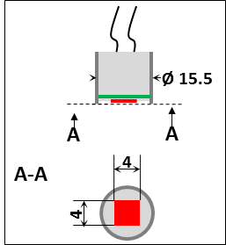 | ${∆θ}_{STR}=φ.\left(\frac{1}{h}+\frac{{th}_{d}}{λ_{d}}\right)=φ.Rth$ Eq.1
${∆θ}_{PTR}\left(x,t\right)={∆θ}_{P}\left(x,t\right)+{∆θ}_{C}\left(x\right)=A.\cos\left(ωt+Δϕ\right)+Rth.\overline{φ}$ Eq.2
where$A=Rth.A_{φ}.exp\left(-\sqrt{\frac{ω}{2a}}x\right)$ Eq.3, and $Δϕ=-\sqrt{\frac{ω}{2a}}x$ Eq.4
 | With ${Rth}_{d}=\frac{{th}_{d}}{λ_{d}}$ Eq.5
Sensor structure includes a plan square MEMS (red line) stuck on a printed circuit board (PCB, th=800µm, green wire) and encapsulated in a stainless steel cylinder (grey wires) filled with an electrical insulation resin. MEMS surface is in direct contact with fluid (bulk). Sensor was tested in a 5L mixing reactor (fluid: water, Re=2.2E06 and 20±1°C). Multiple PVC scotch layers (TESA® 53948, th=130µm, ρ_{d}=1300 kg.m⁻³ [4]) were used to generate fouling. Thermal conductivity and heat capacity were measured at λ=0.115 W.m⁻¹.K⁻¹ and Cp=1025 J.K⁻¹.kg⁻¹ (NEOTIM FP2C), thus thermal diffusivity, a=λ/(ρ.Cp)=8.63E-08 m².s⁻¹. Experiments were performed in clean (reference) and fouled (up to 5 layers) conditions. In STR, five successive heat flux steps were applied (0.2 to 7.5 kW.m⁻², 30min/step). In PTR, a mean heat flux, $\overline{φ}$=4700W/m² with an amplitude A_{ϕ}=4100W/m² was applied. Spectral response was investigated for 8 frequencies (0.001 to 0.2Hz).
3. Results and discussion
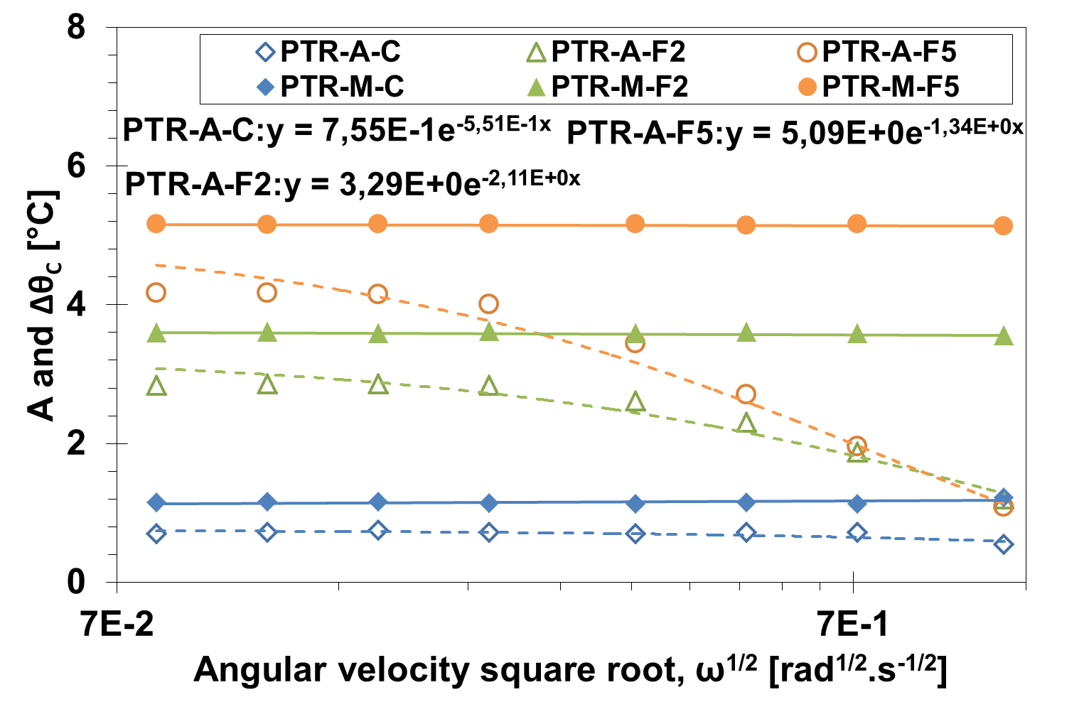  Figure 1 A and${ ∆θ}_{C}$ spectrum in clean (C) and fouled conditions (F2: 2 layers,F5: 5 layers) | 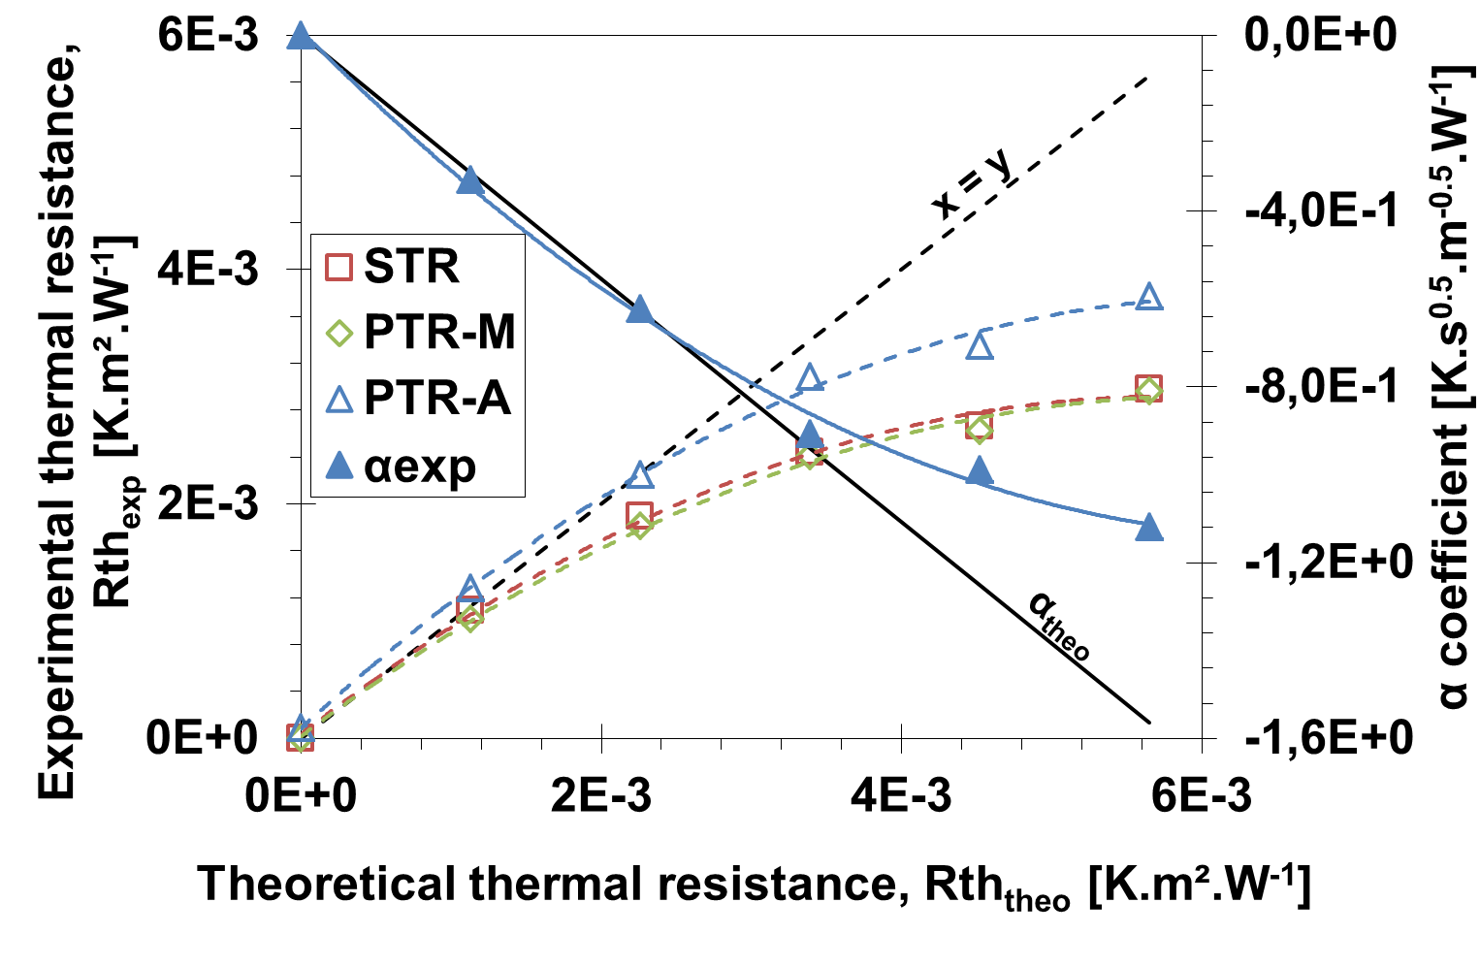Figure 2 Rth_{exp} (dotted lines) and α coefficient (-th_{d}/2.a^{0.5}) (solids lines) versus Rth_{theo}.
In STR, heat resistances were determined by linearization of thermal responses, Δθ_{STR}. In PTR (Figure 1), mean temperature difference (PTR-M) and thermal amplitude (PTR-A) were used to extract heat resistance depending of fouling conditions. Thermal properties were calculated with efficient heat flux identified in STR. Deviation between nominal and efficient flux can be attributed to edge effects due to packaging. Figure 2 compares the evolution of calculated heat resistances (Eq. 1, 2, 3) with theoretical fouling heat resistance (Eq.5). For low thermal resistance, experimental and theoretical values are close. Non-linear evolution of thermal resistances (beyond 3.4 K.m².W⁻¹) indicates the upper sensor limit of detection (LOD). PTR-A response shows better fair values than STR and PTR-M responses. Later inflexion is also noted with α coefficient evolution and confirms the upper LOD observed in STR, PTR-M and PTR-A thermal resistance study. Considering linearity area, thermal diffusivity measured is equal to 9.30E-08 m².s⁻¹.
4. Conclusions
In STR and PTR modes, thermal resistance responses are similar and match with theoretical values. The thermal diffusivity according to literature can be extracted through spectral analysis. Both methods give different upper LOD, at Rth=3.6E-03 and 5.5E-03K.m².W⁻¹ for STR and PTR respectively. In PTR, LOD is equivalent to a dense biofouling (λ_{d}=0.6 W.m⁻¹.K⁻¹) of 3.4mm.
References
- J. Crattelet, Journal of Food Engineering 119 (2013) 72 – 83.
- K. A. Hamilton, Water Research 134 (2018) 261 – 279.
- F. Strub, International Journal of Thermal Sciences 44 (2005) 1154 – 1160.
- Titow, PVC Technology (1984), p. 857

