**Preparation of water-soluble mercaptocarboxylated silver nanoparticle   
and its antibacterial properties and Pickering emulsion formation**

Yusuke Horiki1, Momoka Hamano1, Jun Sawai2, Kazumitsu Naoe1*, and Masanao Imai3

*1 Dept. of Materials Sci. & Chem. Eng.,Faculty of Advanced Eng., National Institute of Technology, Nara College, Yamato-Koriyama, Nara 639-1080, Japan; 2 Dept. of Nutrition & Life Sci., Kanagawa Institute of Technology, Atsugi,　Kanagawa, 243-0292, Japan; 3 Graduate School of Bioresource Sci., Nihon University, Fujisawa, Kanagawa 252-0880, Japan*

*\*Corresponding author: naoe@chem.nara-k.ac.jp*

**Highlights**

* Water-soluble mercaptocarboxylated silver nanoparticles were prepared.
* The silver nanoparticles have antibacterial activity.
* O/W Pickering emulsions using the silver nanoparticles were successfully　prepared.

**1. Introduction**

In recent years, nanomaterials such as metal and semiconductor nanoparticles have been one of the most studied topics in chemistry and physics. Water-soluble nanoparticles have received considerable interest due to the potential environmental and economic benefits of functional "nano" inks and of carrying out catalysis in aqueous systems. Silver is known as an excellent antimicrobial agent and has been well used as disinfectant and microbiocide from old times. Antibacterial activity of silver is enhanced in nano scale and is dependent upon the size of silver particles [1]. Pickering emulsions are emulsions stabilized by solid particles adsorbed at liquid-liquid interface. They are expected as food, pharmaceutical, and cosmetic media because this emulsion system can reduce the use of artificial surfactant. Pickering emulsions stabilized by nanoparticles have been also reported [2]. In this study, preparation of water-soluble silver nanoparticles and their antibacterial properties are investigated. Preparation of Pickering emulsions using the silver nanoparticles is also investigated.

**2. Methods**

Silver nanoparticles (AgNPs) were prepared by phase transfer method [3]. Using silver nitrate as a model silver salt silver ions were transferred to the organic phase by tetrakis(decyl) ammonium bromide (TDAB) as a phase transfer agent and reduced by sodium borohydride in the presence of 11-mercaptoundecanoic acid (MUA) as a stabilizing agent. The UV-vis spectrum of the prepared AgNPs aqueous solution was measured and the nano-geometry of the AgNPs was characterized by Field Emission (FE)-SEM. Antibacterial activity against *Escherichia coli* (NBRC3301) and *Bacillus subtilis* (NBRC3134) was evaluated. Emulsions were prepared by adding toluene to the AgNPs aqueous phase containing NaCl and stirring them for 2 minutes with a homogenizer.

**3. Results and discussion**

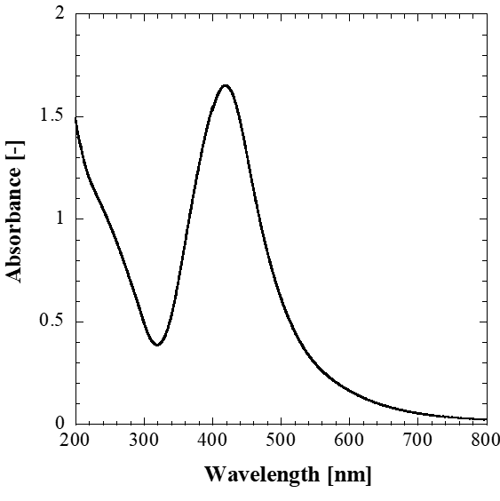The prepared AgNPs were well dispersed in aqueous solutions due to the carboxylic group of the stabilizing agent MUA. From UV-vis spectrum measurement the maximum absorption wavelength of the prepared AgNPs was 419 nm (Figure 1). It is known that the maximum absorption　wavelength of the UV-vis spectrum of AgNPs exists near 420 nm due to the localized surface plasmon resonance (SPR) of the nanoparticles [4]. FE-SEM measurement showed the diameter of ca. 10 nm of the prepared AgNPs. The AgNPs exhibited excellent antimicrobial activity toward gram-negative *Escherichia coli* and gram-positive *Bacillus subtilis* (Figure 2).

**Figure 1.** UV spectrum of the mercaptocarboxylated silver nanoparticle aqueous solution.





**Figure 2.** Effect of silver nanoparticle concentration on the growth of target bacteria (a) *E. coli* and (b) *B. subtilis .*

Toluene solution was added to the AgNPs aqueous solution containing NaCl, and mixed by using a homogenizer for 2 min. After mixing the emulsion phase was formed. Emulsions with a diameter of ca. 2 mm were successfully prepared. Fluorescence microscopy of the emulsions with hydrophobic fluorescence dye Nile Red revealed the formation of oil-in-water (O/W) emulsions.

**4.Conclusions**Water-soluble AgNPs were prepared by the phase transfer method, and their properties were characterized. The silver nanoparticles have antibacterial activity toward *Escherichia coli* and *Bacillus subtilis.* O/W Pickering emlusions were prepared using the silver nanoparticles.

**References**[1]Pancak, A. et al., J. Phys. Chem. B, 110, 16248-16253 (2006)

[2] Yamanaka, K. et al., Colloids Surf. A: Physicochem. Eng. Aspects, 436, 18-25 (2013)

[3] Brust, M. et al., Chem. Commum., 801-802 (1994)  
[4] Cliffel, D. E. et al., Langmuir, 16, 9699-9702 (2000)