Environmental benefits of SGE-RED energy recovery using LCA
Carolina Tristán, Marta Rumayor, Marcos Fallanza, Antonio Dominguez, Raquel Ibañez, Inmaculada Ortiz
Chemical and Biomolecular Engineering Department, Universidad de Cantabria, Av. Los Castros s/n 39005 Santander, Spain
*Corresponding author: inmaculada.ortiz@unican.es
Highlights
- The SGE-RED process environmental benefits are proved by a cradle-to-gate LCA method.
- The best RO desalination plant-RED scenario, regarding environmental issues, is found.
- LCA results will enable to identify the SGE-RED process bottlenecks and challenges.

1. Introduction
Salinity gradient energy (SGE) is a promising alternative source of energy, currently attaining growing attention among the scientific community. Reverse Electrodialysis (RED) is arising as one of the most advantageous membrane-based technologies for recovering energy from the controlled mixing of two solutions of different salinities. At present, research efforts are mainly focused on RED technical development as well as modelling and optimisation [1, 2]. Nonetheless, the environmental sustainability of an SGE-RED system must be compared against other energy renewable sources to verify the potential environmental benefits.
In this regard, the Life Cycle Assessment (LCA) is an effective tool used to evaluate the environmental sustainability of products, processes or services against a well-known benchmark [3]. Our research group is currently addressing the evaluation of the potential environmental benefits of SGE-RED units for the recovery of energy from desalination discharge effluents. The study comprises the evaluation of the use of natural resources and the carbon footprint associated with an SGE-RED energy recovery process to partially substitute fossil-fuelled based supply to a reverse osmosis (RO) desalination plant, which features an intensive energy use
2. Methods
A “cradle-to-gate” LCA methodology has been applied in this study. First, a simple system (System-1) comprised by an SGE-RED is analysed (Figure 1(a)). The impacts related to the generation of a 1 kWh from the SGE-RED unit —defined as the functional unit in the LCA methodology— have been assessed and compared with other renewable power resources. The second system (System-2) integrates the SGE-RED unit in a RO desalination plant (Figure 1(b)). The energy supply required to treat 1 m³ of seawater (SW) or brine water (BW) in the RO plant is partially delivered by the SGE-RED unit and the RO untreated brine by RED is directly released to the marine environment.
A mathematical model has been built for each system. The EGS-RED model consists of a set of mass and energy balances and experimental parameters obtained in previous activities [2]. The inputs and outputs obtained from the model are collected in the LCI. The infrastructure influence is evaluated by modelling the construction of an SGE-RED unit considering the lifetime of the membrane as the main variable.. A sensitivity analysis is performed including the following variables: flow water streams; streams concentrations; temperature; and membrane lifetime to evaluate different operation scenarios.
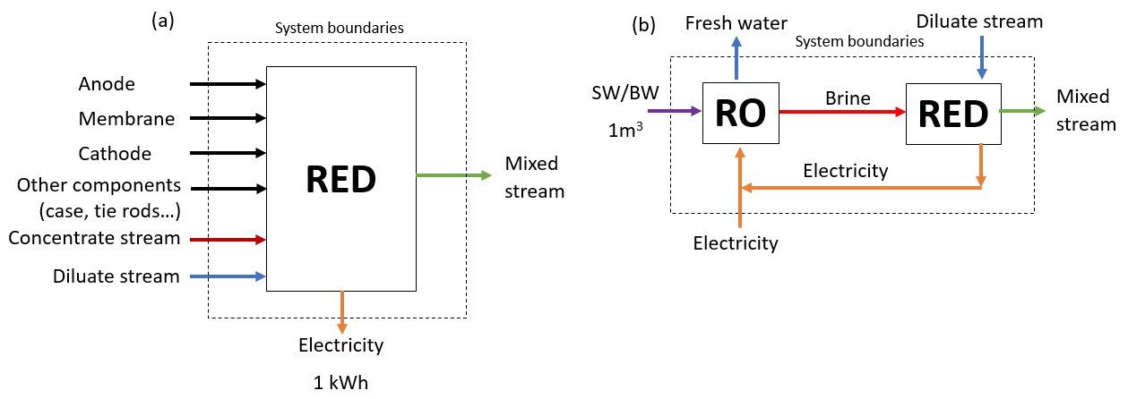

Figure 1. Boundaries of (a) System-1 (RED design) and (b) System-2 (RED integrated in a reverse osmosis (RO) plant)

LCA is completed using the GaBi Professional software applying the mid-point method CML 2001. In this project, global warming and brine discharge impacts are considered. Global warming potential (GWP) is assigned as the main impact indicator to assess the carbon footprint of the analysed alternatives. The potential damage caused by concentrated brine effluents is evaluated by a new impact category developed within the study.
3. Results and discussion
LCA results enable to identify the bottlenecks and challenges of SGE-RED process and its implementation in a RO desalination plant. The System-1 results shows the environmental effects of a 1,0 kWh SGE-RED system and allow their comparison with other renewable power sources. The System-2 results demonstrate the potential environmental benefits of the RO-RED hybrid system in the different proposed scenarios. The sensitivity analysis indicates the combination of the tested variables that ensures that the process is beneficial from an environmental perspective when compared with similar process options.
4. Conclusions
The LCA tool enables the quantitative assessment of the environmental benefits of the SGE-RED technology in a systematic way, and helps in finding the optimum environmental related RO-RED scenario.
5. Acknowledgements
Financial support from project: Gradisal “RM16-XX-046-SODERCAN/FEDER” and the projects CTQ2015-66078-R and CTM2017-87850-R is acknowledged.
References
[1] R.A. Tufa, S. Pawlowski, J. Veerman, K. Bouzek, E. Fontananova, G. di Profio, S. Velizarov, J. Goulão Crespo, K. Nijmeijer, E. Curcio, App Energy. 225 (2018) 290–331.
[2] R. Ortiz-Imedio, L. Gomez-Coma, M. Fallanza, A. Ortiz, R. Ibañez, I. Ortiz, Desalination (accepted; 2019; DOI: 10.1016/j.desal.2019.01.005).
[3] M. Rumayor, A. Dominguez-Ramos, A. Irabien, Sustainable Production and Consumption. 18 (2019) 72–82.

