How hurricane Harvey affected the Chemical and Process Industry.
Valeria Casson Moreno¹, Noor Quddus², Alessio Misuri¹, Valerio Cozzani^{1*}
1 University of Bologna, Department of Civil, Chemical, Environmental and Materials Engineering, Italy;
2 Texas A&M University, Mary Kay O’Connor Process Safety Center, College Station, United States
*Corresponding author: valerio.cozzani@unibo.it
Highlights
- The effect of hurricane Harvey on Chemical and Process Industry was investigated
- The focus was on the release of chemicals from industrial installations
- Vulnerable equipment were identified
- A lack of effectiveness of physical safety barriers was revealed

1. Introduction
The number of climate related natural catastrophes is growing in last years (Hopper, 2016), arising the concern of stakeholders such as civil society, industry and insurance companies. Indeed, in the recent past, the impact of natural phenomena on industrial facilities has proved to be able of severe consequences and escalating scenarios (Krausmann and Cruz, 2016). For this reason, understanding NAtural events triggering a TECHnological scenario​ (NaTech) is becoming a crucial topic.
In this study, the effects of hurricane Harvey on Chemical and Process Industry were analyzed. Harvey was one of the most severe and costliest hurricane hitting the United States ever. It heavily affected the economy of the region: during Harvey, the estimated loss on U.S. refining capacity was of approximately 20 %.
The analysis is focused on the releases of hazardous substances during the hurricane. The aim was to identify the equipment and conditions involved. The key issues highlighted in the present research provide a valuable insight for better informed decision making during risk assessment and management of NaTech events.
2. Methods
The analysis of the events is based on the data available from the United States Coast Guard National Response Center (NRC) Database (http://nrc.uscg.mil/). The Database is aimed at the collection of information on oil spills and chemical releases. Among all the dataset available, the records included in the present analysis were those related to industrial facilities only and explicitly ascribable to hurricane Harvey.
3. Results and discussion
The total number of record selected from the NRC Database was 80. The majority of the records (91 %) are related to on-shore facilities and, in particular, the claimed loss of containment was from: (i) equipment (85 %) and (ii) pipelines (4%). In 2 cases, the release of chemicals took place from mobile trailers: one of the cases is the well-known Arkema incident (Chemical Safety Board, 2018). The remaining 9% of the cases described are related to off-shore facilities.
The analysis of the equipment involved in the loss of containment revealed that tanks are the most vulnerable equipment (see Figure 1). Nevertheless, it has to be noted that a similar share of events involved emergency gas flares: the release of chemical was not “accidental” but took place because of emergency shut-down (and following start-up) procedures as a consequence of the hurricane.
The majority of the releases recorded was to air (41 %, see Figure 2), followed by water (35 %) and soil (5 %). Unfortunately, in 6 cases only (8 %), the release was contained (e.g. in dikes or containment ponds), revealing a lack of effectiveness of physical safety barriers.

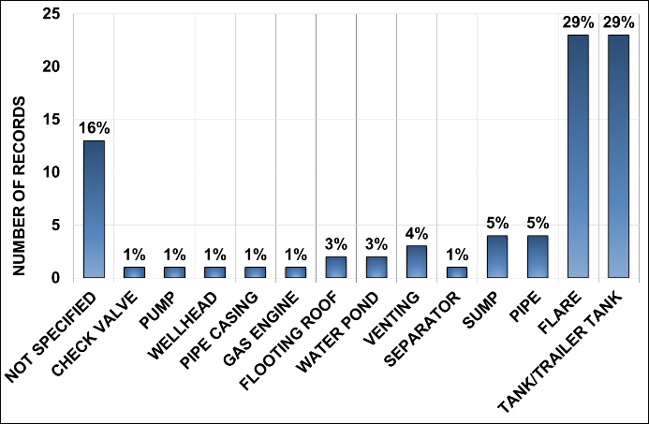
Figure 1. Analysis of the equipment involved in the release of chemicals during hurricane Harvey based on NRC data.
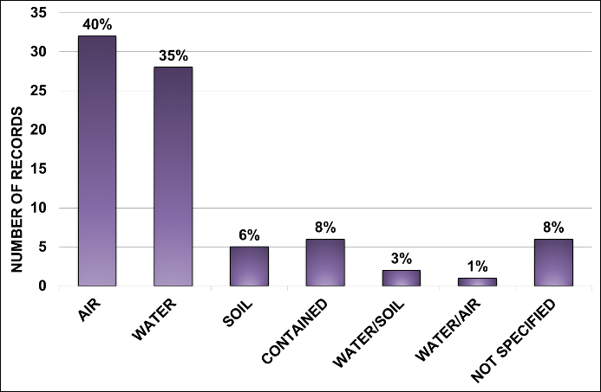
Figure 2. Analysis of the release to air, soil, and water environments during hurricane Harvey based on NRC data.
4. Conclusions
The analysis of data on the releases of chemicals during Harvey highlighted that tanks were the most vulnerable equipment during the hurricane. Of particular note was the role of flares during emergency shut-down and start-up operations. In general, a lack of effectiveness of physical safety barriers was observed.
References
- P. Hopper, Weather and Climate Extremes 11 (2016) 70-79.
- Krausmann, E., Cruz, A. M., Past Natech Events, Natech Risk Assessment and Management: Reducing the Risk of Natural-Hazard Impact on Hazardous Installations, 2016, 3-31.
- United States Coast Guard National Response Center: http://nrc.uscg.mil/ (accessed 10.1.18).
- Chemical Safety Board, Arkema Final Report, 2018. https://www.csb.gov/csb-releases-arkema-final-report/

