Oxidative coupling of methane: performance comparison of powdered, pelletized and 3D printed catalysts at miniplant scale
Tim Karsten¹, Vesna Middelkoop², Hamid Reza Godini³, Jens Uwe Repke¹
¹Process Dynamics and Operation Group, Sekr, KWT-9, Technische Universität Berlin, Germany.
²Flemish Institute for Technological Research, VITO NV, Boeretang 200, Mol, Belgium.
³ Dept. Chemical Engineering and Chemistry, Eindhoven University of Technology, Eindhoven, The Netherlands.

*Corresponding author: tim.karsten@tu-berlin.de
Highlights
- 3D structured catalysts show promising performance and low pressure drop
- Examined correlation between pressure profile and reactor performance
- Performance of a scaled up reactor for OCM demonstrated

1. Introduction
Powdered catalysts in most cases offer high reactivity and specific surface area, both for oxidative coupling of methane (OCM) and other gas phase reactions. However, powdered catalysts have significant drawbacks too. Their use often results in high specific pressure drops and they are difficult to handle and maintain. This is the reason that powdered catalysts are rarely used in large-scale applications. On the other hand, pelletized catalysts are conventionally used, as they are easier to work with and show a decent compromise between reactivity and pressure drop. The use of modern 3D printers opens up the possibility to print catalyst material directly. 3D printed catalysts represent a real alternative to pellets with tuneable porosity, high surface area, low pressure drop and improved heat and mass transfer.
The aim of this work is a comparative investigation into powdered, pelletized and 3D structured catalysts on a miniplant scale using the example of the oxidative coupling of methane.
The OCM reaction is a promising way to produce ethylene directly from natural gas or biogas. It presents an attractive alternative to naphtha cracking as it can utilizes different and more widely available feedstock.
2. Methods
For all the experiments that were carried out, MnNa2WO4/SiO2, provided by Johnson Matthey, was used as catalyst for the OCM reaction testing. The powder was first pressed and subsequently ground to obtain a particle size range of dp=400-600µm. The pellets, provided by Johnson Matthey too, were produced through extrusion with a particle size of 2.7mm. The catalyst powder was printed by VITO into catalyst structures with periodic lattices, using a direct write technique that offers a high degree of control over the composition, surface area and geometry.
The structures, pellets and source powder (Figure 1) were tested in a miniplant scale reactor at TU Berlin with a total reactor volume of 1.8l. The performance in terms of C2 yield was assessed under different temperatures and feed rates. Other parameters, such as the CH₄ to O₂ ratio, pressure and dilution were kept constant.
In order to examine the possible loss of reactivity due to the fabrication process, a second set of experiments was performed. The pellets and structures were ground back to a powder with the same particle size as the source material. Subsequently, the three powder samples were tested in a smaller size fixed bed reactor under the same operating conditions.
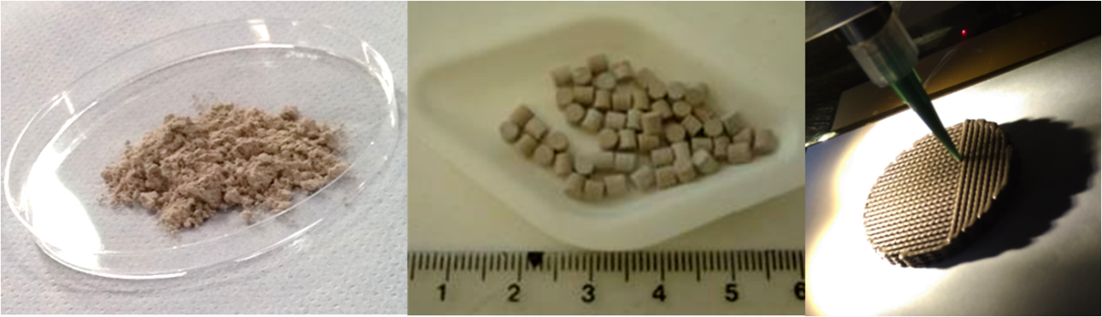
Figure 1. MnNa2WO4/SiO2 catalysts for OCM reaction tests; powdered (left), pelletized (middle), 3D printed structures (right)

3. Results and discussion
The main design considerations in the scaled-up reactor were (1.) facilitating the stacking of the 3D printed structures and (2.) ensuring a robust seal between the perimeter of the structures and the inner wall of the reactor tube in order to prevent gas from bypassing along the length of the reactor. The resulting scaled-up reactor demonstrates the design modularity and ability to perform OCM reactions in applications that are larger than lab scale.
The preliminary results of testing the structured catalysts are promising when compared to the conventional packed bed configurations. The influence of the different catalyst shapes on the pressure drop along the reactor was examined and quantified showing a correlation between the specific surface area and the reactivity, or C2 yield. Furthermore, it can be seen to what extent the production process of the pellets and 3D printed structures influence the reactivity of the catalyst.
4. Conclusions
In this work, the different shapes of OCM catalysts and their influence on C2 yield have been quantified and compared. It has been shown that 3D printed structures have the potential to provide tailor-made catalysts for large-scale applications, offering increased accessibility of the active sites within their engineered porosity.

Acknowledgments
This project has received funding from the European Union’s Horizon 2020 research and innovation programme under grant agreement No 679933

