Development of capillary suspension by green tea powder and coconut oil to produce novel sol-gel characteristic functional food.
Hiroki Sato† and Masanao Imai*
Course of Bioresource Utilization Sciences, Graduate School of Bioresource Sciences, Nihon University, 1866 Kameino, Fujisawa, Kanagawa-pref. 252-0880, Japan
† present address: Iwai Pharma Tech Co.Ltd., 3-17-10 Higashi-Kojiya, Ota-ku,Tokyo 144-0033, Japan
*corresponding author: XLT05104@nifty.com
Highlights
- Capillary suspension by green tea powder and coconut oil appears novel rheological food.
- When the volumetric fraction of additive water was 0.032, the fluid dynamics was changed.
- Apparent viscosity and shear stress were increased by small amount of additive fluid.

1. Introduction
Solid-liquid suspension was commonly appeared in foods, cosmetics and pharmaceutical supplements. Fluid dynamic character of conventional solid-liquid suspension was drastically changed by small amount of additive fluid^{1]}. That has been called as a capillary suspension illustrated by Fig.1. Networks of liquid bridges of additive fluid were looks like as a “capillary mesh”^{2]}. Some additive small amount of fluid was introduced into a conventional solid particles in oil suspension, fluid dynamics was drastically changed at the desired amount of additive fluid. It showed typical rheological character not Newtonian fluid. The aim of this study was to investigate change of fluid dynamic character of food based solid in oil suspension and capillary suspension^{3]}. It was promise for forthcoming novel rheological characteristic fluid applied for tubular packaged foods, cosmetics and pharmaceutical supplements^{4]}.
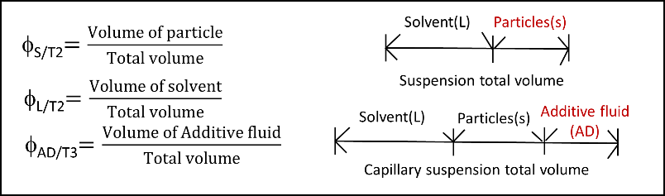
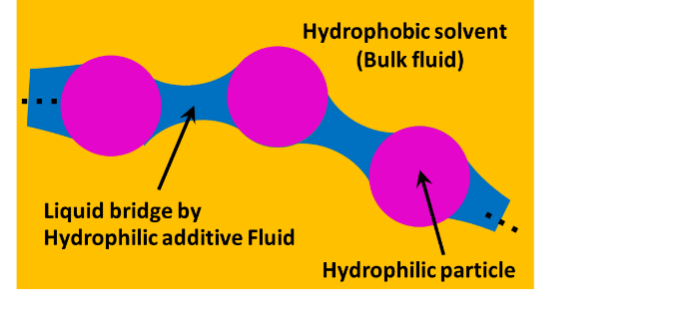
Table 1. Definition of volume fractions.

Figure 1. Network structure of capillary suspension.
2. Methods
In this study, green tea powder and coconut oil was employed to make a conventional solid in oil suspension. Water was used as an additive fluid to make a capillary suspension. Green tea powder was purchased from Tsujiri Ltd. (Kyoto, Japan). Spherical assumed mean diameter was measured as 4.07 μm. Density of green tea powder in dried state was measured 1.12 [g・cm⁻³]. Coconut oil was purchased from Nissin Oillio Co. Ltd. (Tokyo, Japan). Density of coconut oil was measured 0.926 [g・cm⁻³]. Coconut oil appeared liquid state at room temperature. Rheological character of suspension and capillary suspension was measured by ARES Rheometer, TA Instruments. Disc diameter was 8 mm. Gap was set at 0.5 mm, and the shear rate in measuring was ranged within 0.1 s⁻¹ – 100 s⁻¹. Temperature was conveniently set at room temperature 298±1 K.
3. Results and discussion
Definition of volumetric fraction of green tea powder particle in coconut oil shows as Φ_{Ｓ／Ｔ２} , where S indicates “solid” , L indicates liquid, and T2 means “2 components system”. Volumetric fraction of additive water shows as Φ_{ＡＤ／Ｔ３} ,where AD indicates “additive water”, and T3 means “3 components system”. Table 1 summarized these definitions.
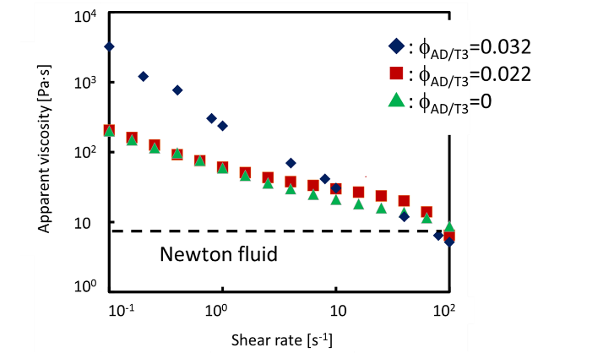
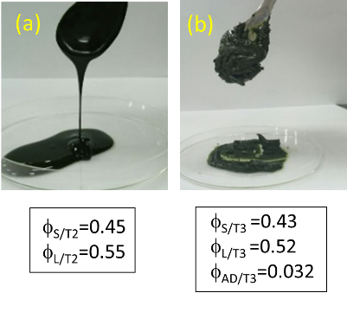

Figure 2. Preparation of capillary suspension
(a)Normal suspension (b) Capillary suspension.
Figure 3. Apparent viscosity vs. Shear rate

When the volumetric fraction of additive pure water more than 0.032, the fluid dynamics of suspension was drastically changed to gel-like capillary suspension (Fig.2).
The rheological properties of the capillary suspension were measured by a strain-controlled rheometer. Apparent viscosity and shear stress were increased by adding a small amount of additive fluid (Fig.3). This indicated that capillary suspension has characteristic to keep the form.
4. Conclusions
Capillary suspension composed by green tea powder and coconut oil was successfully prepared. Apparent viscosity and shear stress were increased by small amount of additive fluid. When the volumetric fraction of additive water Φ_{ＡＤ／Ｔ３} was 0.032, the fluid dynamics was changed to gel like character. Novel rheological characteristic fluid was applied for tubular packaged foods, cosmetics and pharmaceutical supplements. They were promised as easy handling for chidden, older people and handicapped persons.
References
- Erin Koos, Norbert Willenbacher, Science. 331, 897, (2011)
- Erin Koos, Norbert Willenbacher, Soft Matter. 8, 3398, (2012)
- Susanne Wollgarten, Ceren Yuce, Erin Koos, Norbert Willenbacher,
Food Hydrocolloids. 52, 167-174, (2016)
- Susanne Hoffmann, Erin Koos, Norbert Willenbacher, Food Hydrocolloids. 40, 44-52, (2014)

