Control of Shell and Particle Porosity in Fluidized Bed Layering Granulation

Andreas Bück¹, Christoph Neugebauer², Carsten Seidel², Robert Dürr³, Achim Kienle^{2,3}
1 Institute of Particle Technology, Friedrich-Alexander University, 91058 Erlangen, Germany
2 Automation and Modeling, Otto von Guericke University, 39106 Magdeburg, Germany
3 Max Planck Institute for Dynamics of Complex Technical Systems, 39106 Magdeburg, Germany
*Corresponding author: andreas.bueck@fau.de
Highlights
- steady-state operation of continues Fluidzed Bed Layering Granulation
- robust formation of tailor-made particle properties
- model-based process control with multiple input multiple output controller

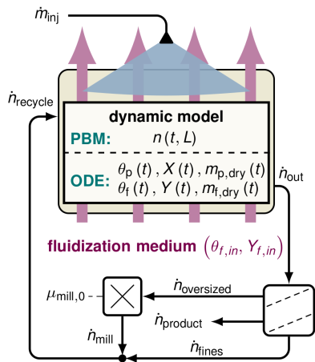
1. Introduction
Figure 1. Structure of the dynamic model as presented in [4].
An important class of particle formulation processes is the fluidized bed layering granulation (FBLG). It is widely applied in processing industries to gain high-quality granules. In brief, a solid containing liquid is sprayed onto a bed of fluidized particles. Since the fluidization medium is a heated gas, the liquid phase of the injection evaporates while the solid remains on the particles surface inducing a layer-wise particle growth. On the large scale FBLGs are operated continuously. This allows the formulation of particles with uniform characteristics under steady state conditions.
It is well known from previous studies that particle properties depend on the process conditions. For instance, Rieck et al. [1] showed by means of experiments that the thermal conditions of the FBLG process determine the porosity of the particle shell and, in consequence, the apparent particle porosity and density. As Litster and Ennis [2] pointed out, most of the other particle properties, e.g. particle strength, flowability, and dissolution behavior depend on the shell or apparent particle porosity and particle size. Therefore, constant thermal conditions are essential for the production of tailor-made particles. As was shown by Neugebauer et al. [3], the application of feedback controllers is promising to improve the performance of particulate processes. Scope of the present contribution is the development and validation of a multiple input multiple output MIMO control strategy which is capable to control both, particle size and porosity.
2. Methods
The present contribution is based on the dynamic model of FBLG presented in Neugebauer et al. [4]. The model consists, as depicted in Figure 1, of two bi-directional coupled sub-models: The first, a population balance model, represents the growth of the particles; the second considers the thermal conditions within the granulation process. In the present contribution, the dynamic model is extended to account for (a) the dynamics of the temperature θ_{f,in} due to the heating and (b) the influence of particle porosity ε_{p} on the breakage behavior during milling. Afterwards, the resulting model is linearized in the vicinity of a given reference point. By means of the root-locus method two decentralized PI controllers are designed. The first controls ε_{p} by adjusting θ_{f,in}, the second stabilizes the particle size distribution – here the Sauter diameter d₃₂ is used as a representative - by actuating the mill μ_{mill,0} .
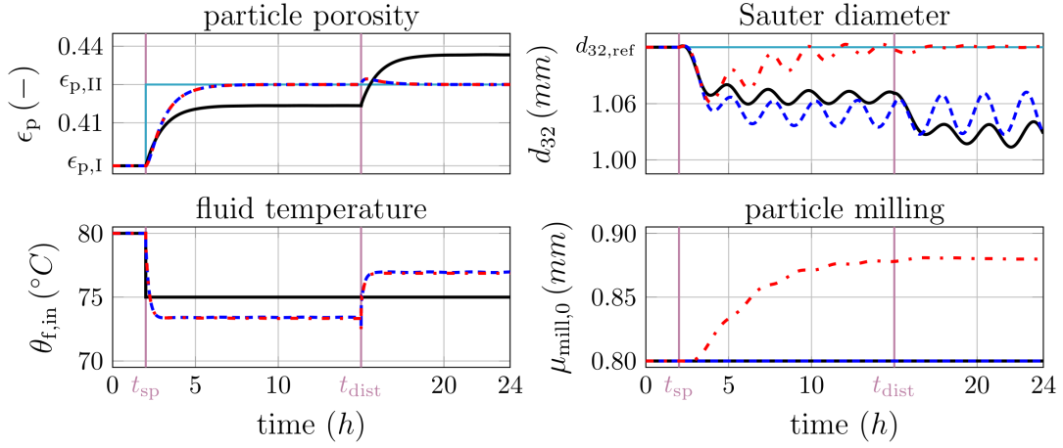
3. Results and discussion
Figure 2. Simulation results according to different configurations: open-loop (black solid line), SISO (blue dashed), and MIMO control strategy (red dash-dotted).
To study the influence of different operating parameters on the process dynamics and product properties the following scenario is defined: at t_{sp} = 2 h the set-point of ε_{p} is increased, whereas a process disturbance, in specific an increase of Y_{f,in}, appears at t_{dist} = 15 h. The corresponding simulation results are presented in Figure 2. As indicted by the open-loop results, the manipulation of θ_{f,in} and Y_{f,in} induce variations of ε_{p}. However, a proper adjustment of ε_{p} is challenging as it depends significantly on both parameters. This issue can be overcome, as illustrated by the simulation results, by the application of the first controller: By actuating θ_{f,in} the particle porosity ε_{p} can be driven to its new reference value. In addition, the process disturbance at t_{dist} = 15 h can be rejected. On the contrary, a change of ε_{p} results in variations of the breakage behavior of particles. In consequence, as monitored by d₃₂, self-sustained oscillations of the particles size distribution can occur. As those highly undesired oscillations provoke variations of bed mass and mass flows they might result in a process break-down. To stabilize the particle size distribution, the control strategy is extended by the second controller. Referring to the simulation results presented in Figure 2, the application of the overall control strategy guarantees both, a stable process regime as well as constant product properties.

Acknowledgments The financial support of DFG (Deutsche Forschungsgemeinschaft) within the priority program SPP 1679 is gratefully acknowledged.
References
- C. Rieck et al., Powder Technology, 272 (2015), 120 – 131.
- J. Litster, B. Ennis, The Science and Engineering of Granulation Processes, 2004.
- C. Neugebauer et al., Powder Technology, in press, DOI: 10.1016/j.powtec.2019.05.030
- C. Neugebauer et al., Processes, 6 (2018), 235.

