Development of a Hybrid Ozone-Biological Process for the Treatment of Drill Cuttings: Microbial Consortium Characterization and Dynamics.
Argyro Tsipa¹, Ioannis Vyrides¹, Kostas Andreou¹, Giorgos Kazamias², Michalis Chatzicharalampous², Costas Varavvas², Michalis Koutinas¹
1 Department of Environmental Science & Technology, Cyprus University of Technology, 30 Archbishop Kyprianou Str., 3036, Limassol, Cyprus; 2 Innovating Environmental Solutions Center, 33 Spyrou Kyprianou str, 3rd Industrial Area of Ypsonas, Ypsonas 4193, Limassol, Cyprus
*Corresponding author: michail.koutinas@cut.ac.cy
Highlights
- Isolation of microorganisms adapted to drilling fluids.
- Microbial consortium characterization using next-generation sequencing.
- Monitoring of microbial consortium dynamics using quantitative polymerase chain reaction.

1. Introduction
The entire eastern Mediterranean is swimming in huge untapped oil and gas (O&G) reserves. Thus, drilling operations have recently increased considerably in Cyprus necessitating the safe disposal of drill cuttings (DC) currently posing important waste management and environmental problems mainly due to the vast quantities generated and the high content in contaminants. IESC Ltd and Cyprus University of Technology currently aim to develop an enhanced hybrid ozone oxidation-bioremediation system at pilot-scale for DC treatment producing added-value compost as well as a consortium of microorganisms with applicability in bioremediation of similar waste.
The study of population dynamics through qPCR may quantify the expression of specific metabolic routes involved in the biodegradation of different pollutants [1]. Furthermore, metagenomic methods, such as Next Generation Sequencing (NGS), employed for assessing the composition of entire environmental communities in a variety of microbial habitats have resulted in discovering new genes and gene products from uncultivated microorganisms, assembling whole genomes [2]. Recent NGS studies applied in hydrocarbon bioremediation processes have shown the crucial effect of these techniques in identifying, monitoring and estimating the proportions of degrading populations during soil bioremediation providing information for novel biocatalysts and enzymes involved [3].
The proposed waste management technology is expected to significantly reduce current thermal processing costs, while the company aims in eventually moving the novel technology for DC management to full scale and to increase its competitiveness through production of added-value commodities. The work is part of the OzoneBioPro project, which is funded from the Research Promotion foundation of Cyprus.
2. Methods
Operation of the pilot system: DC treatment involved ozonation in a 0.3 m³ reactor followed by bioremediation (1 m³ each installation) through composting with the addition of green waste and activated sludge. Various process parameters in ozonation and bioremediation were evaluated.
Molecular biology techniques: Total RNA isolation, cDNA synthesis and Quantitative Real-Time Polymerase Chain Reaction (Q-RT-PCR) was conducted as previously described [4].
Isolation of microbial degraders: Samples of untreated DC including oil contaminated soil and activated sludge, respectively, were used. The isolation procedure was conducted using minimal medium (M9) supplemented with drill cutting fluid following the procedure applied in [1]. The microbial isolates were identified through DNA extraction followed by PCR amplification, while the PCR products were sequenced using Next-Generation sequencing (Macrogen, the Netherlands). Analysis of obtained sequences was performed using the BLAST NCBI database.

3. Results and discussion
The objectives of the development of the hybrid ozone oxidation-bioremediation technology are explained in Fig. 1. Currently, the isolation of microbial degraders adapted to DC is finalized and the hybrid pilot unit has been designed and constructed at the premises of IESC Ltd in Limassol (Cyprus). The presentation will include evaluation of the performance of the ozonation-bioremediation system for DC treatment, evaluation of the microbial dynamics in the bioprocess using NGS and qPCR as well as characterization of the microbial consortium constructed for enhancement of DC bioremediation.
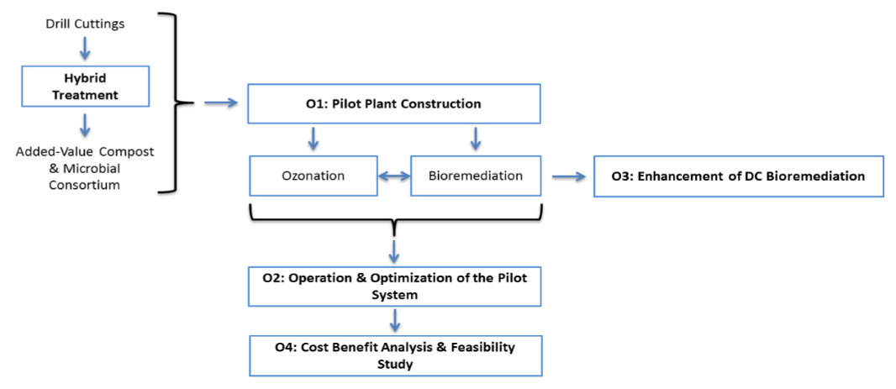
Figure 1. Outline of project objectives.
4. Conclusions
Application of NGS and qPCR for monitoring the microbial diversity, the genomes of all microorganisms incorporated and expression from specific metabolic routes in DC bioremediation will progress research beyond the current state-of-the-art through correlation of microbial diversity with the efficiency of bioremediation under different process conditions.
References
- E.M. Drakou, M. Koutinas, I. Pantelides, M. Tsolakidou, I. Vyrides, Int. Biodeterior. Biodegrad. 99 (2015) 85-94.
- J. Frias-Lopez, Y. Shi, G. W. Tyson, M. L. Coleman, S. C. Schuster, S. W. Chisholm, E. F. DeLong, Proc. Natl. Acad. Sci. U.S.A. 105 (2008), 3805-3810.
- G. Ζafra, T. Taylor, A. E. Absalón, D. V.C ortés-Espinosa, J. Hazard. Mater. 318 (2016) 702-710.
- M. Koutinas, M. Lam, A. Kiparissides, R. Silva‐Rocha, M. Godinho, A.G. Livingston, E.N. Pistikopoulos, V. De Lorenzo, V.A.P. Martins Dos Santos, A. Mantalaris, Environ. Microb. 12 (2010) 1705-1718.

