M³C and scale up&down of lactic acid bacteria fermentations based on pH-gradients and population heterogeneity
Klaus Pellicer Alborch¹, Robert Spann², Gürkan Sin³, Krist V. Gernaey³, Peter Neubauer⁴, Stefan Junne⁴
1 BASF SE, Ludwigshafen am Rhein, Germany; 2 Chr. Hansen A/S, Hørsholm, Denmark; 3 Process and Systems Engineering Center (PROSYS), DTU Chemical Engineering, Department of Chemical and Biochemical Engineering, Technical University of Denmark, Søltofts Plads, Building 227, DK-2800 Kongens Lyngby, Denmark; 4 Chair of Bioprocess Engineering, Institute of Biotechnology, Technical University of Berlin, Ackerstraße 76, ACK24, 13355 Berlin, Germany
*Corresponding author: k.pellicer@pellicerconsultants.com
Highlights
- Scale up&down of production of lactic acid bacteria starter cultures for dairy industry
- Model-based process monitoring&control with the pH-value as only input variable
- PAT for determination of population heterogeneity under different pH-gradients
- Growth prediction based on single-cell size distribution measurements

1. Introduction
Oscillatory conditions, which usually appear in large scale bioreactors due to limitations in the power input and extended mixing times, can lead to cell stress and increased occurrence of population heterogeneity. Such heterogeneities are regularly observed in industrial production; however, the underlying mechanisms are seldom perceived or considered in bioprocess development. Since the occurrence of subpopulations may have a significant impact on the productivity of industrial cultures, cellular heterogeneity requires quantification with appropriate monitoring tools [1].
In case of lactic acid bacteria production, pH-gradients are the main concern when facing scale-up, since they lead to growth retardation, a loss of productivity and an altered population heterogeneity.
2. Methods
In order to study the impact of these gradients on the population heterogeneity of Streptococcus thermophilus cultures, various scale-down approaches were applied. Firstly, compartmentation of different zones was achieved through two- and three-compartment scale-down reactors (Two-CR and Three-CR, respectively), both consisted of a 10 L nitrogen aerated stirred tank reactor (STR) connected to one or two non-aerated plug flow reactors (PFR), respectively [2]. Base addition was performed from the bottom of one PFR, whilst acid was introduced from the bottom of the second PFR in the Three-CR system. Thus, (i) a zone of high pH-value (i.e. the base addition zone in the industrial reactor, simulated in one PFR), (ii) a compartment with low pH environment (i.e. the zone far away from the base addition, mimicked in the other PFR) and (iii) a homogeneous bulk zone (simulated in the STR) were achieved in lab scale. Secondly, pulse feeding experiments were performed in a one compartment reactor, so that the whole population was subjected to the same pH shifts.
The physiologic heterogeneity of the population was assessed by means of the morphological heterogeneity in cocci chain length formation under optimal and pH-oscillating environments with at-line light microscopy analysis and automated cell image recognition. Furthermore, the consequences for cell growth, substrate conversion and product formation were studied in detail.
3. Results and discussion
The authors observed that the chain length of S. thermophilus varies as a response to environmental stress. A narrow distribution of short chain lengths during the exponential phase under optimum conditions was revealed, whilst the cell size distribution was broad and shifted to longer chain lengths under pH-gradients, as induced in scale-down fermentations. It could be shown that the appearance of certain cocci chain lengths is directly correlated to a reduced growth activity. Moreover, the different scale-down approaches were compared to the population heterogeneity detected in the production scale to identify the most suitable design.
By coupling of a mechanistic model [3, 4] to predict macroscopic state variables (such as substrate consumption, biomass growth and by-product formation, among others), a population balance model (PBM) was developed. This needs only the actual pH-value in the bioreactor to predict the cocci chain length distribution on-line, which gives information about the current biomass quantity as well as quality in the broth (Figure 1). In this manner, a change in the running process (e.g. increase stirring speed to decrease pH-gradients) is still possible in order to ensure the product characteristics at the harvesting point, with the highest yield.

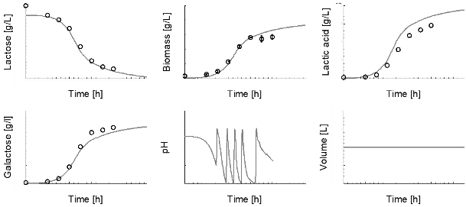
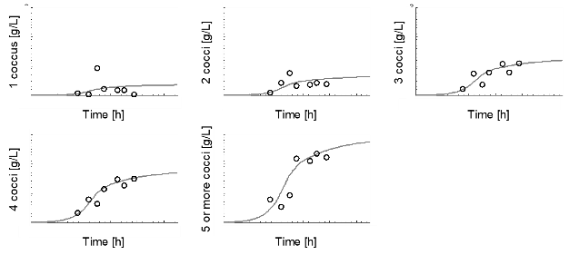

Figure 1. Development of macroscopic variables (left) and of variable chain lengths (right) over fermentation time of a S. thermophilus culture under certain pH-gradients. Experimental data (dots) and population balance model (line).
4. Conclusions
The M³C methodology presented here is able to predict biomass quality (i.e. acidification activity, as a function of the chain length) based solely on the pH-value in the culture broth. Using CFD studies in the industrial scale, pH-gradients and compartmentalization could be easily incorporated into the PBM. This approach, coupled to in-situ quantification of the cell size distribution with advanced on-line microscopic techniques and image analysis using neural networks (NNs), would enable growth performance prediction in real-time. This would allow for (i) the rapid evaluation of media, (ii) the adjustment of the power input during base addition to keep pH-gradient formation as non-sensitive for process performance, (iii) the determination of a suitable point for harvest under consideration of cell vitality, and (iv) in general the improvement of quality control.
References
- K. Pellicer-Alborch, A. Angersbach, P. Neubauer, S. Junne, Front. Bioeng. Biotech. 6, 188 (2018) 1–10.
- A. Lemoine, N. M. Martínez-Iturralde, R. Spann, P. Neubauer, S. Junne, Biotech. Bioeng. 112, 6 (2015) 1220-1231.
- R. Spann, J. Glibstrup, K. Pellicer-Alborch, S. Junne, P. Neubauer, C. Roca, D. Kold, A. E. Lantz, G. Sin, K. V. Gernaey, U. Krühne, Biotech. Bioeng. (2018) 1-38.
- R. Spann, C. Roca, D. Kold, A. E. Lantz, K. V. Gernaey, G. Sin, Biochem. Eng. J. 135 (2018) 49-60.

