A computational workflow to study particle transport in porous media: coupling CFD and deep learning

Gianluca Boccardo¹, Agnese Marcato¹, Daniele Marchisio¹
¹Department of Applied Science and Technology, Politecnico di Torino, Torino, Italy;
*Corresponding author: gianluca.boccardo@polito.it
Highlights
- CFD simulations of fine filtration in packed beds are performed
- Deep-learning methods are used for feature extraction and parameter identification
- Effectiveness of different machine-learning setups are presented
1. Introduction
The study of particle transport in porous media is of the utmost importance as it touches a wide variety of different fields: from the study of contaminant transport in aquifers to the design of effective packed bed reactors in chemical engineering. One of the difficulties lies in the many parameters characterizing the porous media (which are generally geometric), and whose impact and synergy of action can be impossible to analytically predict. These particularities, which render the problem of particle transport in random media difficult to treat, at the same time make it a prime candidate for machine learning (ML) and specifically deep-learning (DL) approaches. These techniques are particularly suited to extract essential features hidden in data, and are making their way from computer science to “hard sciences”, e.g. in chemical engineering [1]. In this work we couple our recent CFD work exploring fluid flow and particle transport and deposition [2] with a variety of different classes of classical and deep neural networks (NNs and DNNs).
2. Methods
The first step was the creation of the geometry: first, randomly arranged distributions of non-overlapping circular elements are generated, then, CFD simulations of fluid flow and particle transport and deposition were performed, using the open-source CFD code OpenFOAM: a snapshot of a simulation can be seen in Fig. 1. One thousand of these fully solved CFD realizations are used for generating the datasets, each differing in a random variation of the defining spatial features: porosity, grain diameter, channel width. Reynolds and Peclet numbers (respectively via the imposed pressure drop and the mass diffusion coefficient) were also randomly varied.
3. Results and discussion
Using the obtained “fully-solved” CFD dataset described earlier, a parameter identification analysis was performed by employing differently built NNs and DNNs (using Matlab Machine Learning Toolbox). First, a single layer NN was used for prediction of permeability and particle deposition efficiency. When a new, random set of parameters (inside the training range) was given to the NN, the result prediction was almost perfect (error <0.5%) as the parity diagrams in Fig. 3 show. Different number of neurons were used, from 10 to 100, with 20 neurons giving the best results: this fits with the expected trade-off between a too coarse prediction with fewer neurons and overfitting with too many. Then, deep-neural networks with different arrangements of 20 neurons in 1-, 2-, and 3-layered fully-connected networks were tested, without appreciable differences in prediction accuracy, showing that for these number of features a simple 1-layer network suffices. Then, we tested the obtained neural network to make predictions using input data from outside the range where the network was trained: as it is to be expected, the predictions degrade in quality the further the input data is from the training range. Nonetheless, as it can be seen in Fig. 2, reasonable accuracy (<10% error) can still be obtained even when all input parameters are well below (or above) the limits of the data range: this shows the wide range of applicability of this approach.
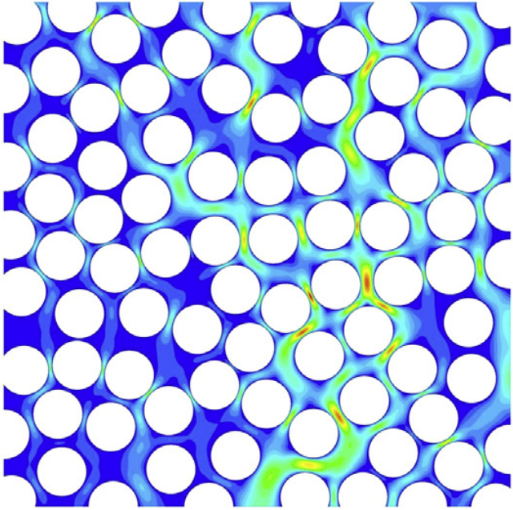  Figure 1. CFD contour plots of velocity magnitude for the 2D random arrangement of circles | 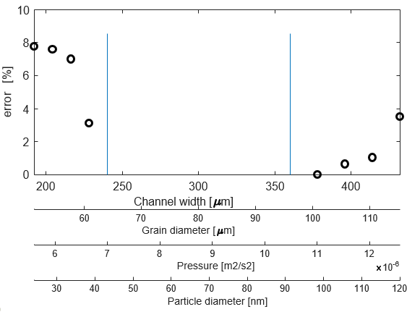  Figure 2. Prediction errors when input data (quantitities on the different scales) is outside the training range of the neural network, indicated by the vertical lines (inside of which error is circa 0%, as seen in Fig. 2).
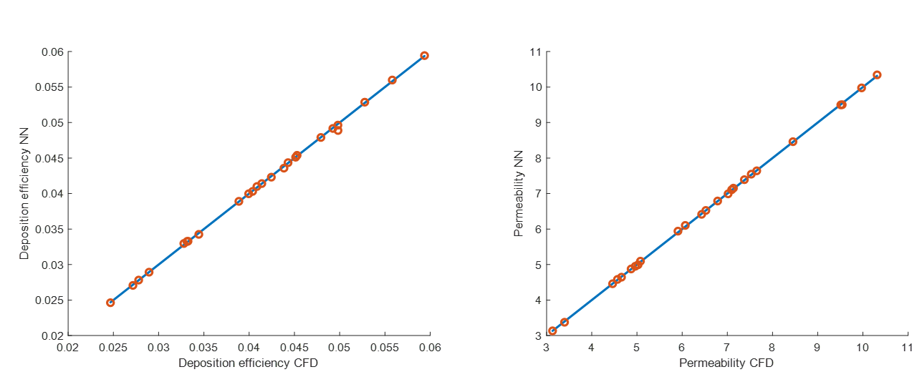
Figure 3. Parity diagrams comparing actual CFD simulations with NN-predicted results.
4. Conclusions
Different types of neural networks are used to predict both fluid dynamic and mass transfer properties in porous media: the results show that this approach is very successful, reducing the cost of property prediction by orders of magnitude (CFD: around 10 minutes, NN: around a second). This allows for fast reactor/filter prototyping, on-line process control (analyzing process response in real time) and makes tightly-coupled multi-scale modelling possible by means of efficient, machine-learning powered, surrogate models for pore-scale transport.
References
- Chu, X.,et al., 2018. A computationally light data-driven approach for heat transfer and hydraulic characteristics modeling of supercritical fluids: From DNS to DNN. International Journal of Heat and Mass Transfer, 123, pp.629-636.
- Boccardo G., Marchisio D.L., Sethi R., 2014, Microscale simulation of particle deposition in porous media, Journal of Colloid and Interface Science, 417, pp. 227-237.

