On the potential of adsorption processes for low-carbon hydrogen production with carbon capture
Anne Streb¹, Mijndert van der Spek¹, Matteo Gazzani², Marco Mazzotti^{1*}
1 ETH Zurich, Zurich/Switzerland; 2 Utrecht University, Utrecht/the Netherlands
*Corresponding author: marco.mazzotti@ipe.mavt.ethz.ch
Highlights
- Adsorption processes developed for the simultaneous production of H₂ and CO₂
- Process intensification achieved: single stage for two separation tasks
- Competitive energy consumption
- Suitable for a variety of multicomponent feedstreams
1. Introduction
Carbon neutral hydrogen is expected to play an important role in future energy systems, especially in industry, transportation and heating applications. Today, hydrogen is used at large scale in many industrial processes, e.g. ammonia and methanol production and oil refining. However, it is mainly produced through conversion of fossil fuels, e.g. via steam methane reforming (SMR) followed by water gas shift (WGS) and pressure swing adsorption purification (PSA), resulting in high CO₂ emission intensity. Adding carbon capture and storage (CCS) to fossil fuel based H₂ production is a means to produce large amounts of low-carbon H₂ in a timely manner thereby paving the way towards an energy system where H₂ plays a pivotal role as low carbon energy carrier. We have developed a promising process integrating both H₂ purification and CO₂ separation within a single adsorption cycle. This option does not require an additional separation stage potentially reducing capital cost and energy requirement compared to the alternative of a separate downstream CO₂ separation process.
2. Methods
We have developed various cycles for integrating the production of high purity H₂ and CO₂ based on heuristics and on the use of a non-isothermal one-dimensional model for an adsorber column. The model was validated for a variety of conditions and cycles [1,2]. The feedstream composition, pressure and temperature are representative for the outlet of a WGS reactor consisting of mainly H₂ and CO₂ with CH₄, CO and N₂ as relevant impurities. The most promising cycles in terms of the key performance indicators, namely the purity and recovery of hydrogen and CO₂, the productivity and the energy consumption, are optimized by combining the use of the simulation tool with that of a multi-objective optimization routine [3].
3. Results and discussion
For all cycles, there exists a tradeoff between H₂ purity and recovery at a given CO₂ purity and recovery (and vice versa). Notably, three of the developed cycles can purify hydrogen to greater than 99.97 %, as required for fuel cells for transportation, with a recovery of > 90 % while coproducing CO₂ at > 90 % recovery and > 96 % purity, as required for CO₂ transportation and storage. The cycles are flexible regarding the feedstream composition: the specifications given above can be reached for a feedstream with a high CO content (~5 %) representative of the outlet of a high temperature WGS reactor as well as for a feedstream with a lower CO content (< 0.5 %) representative for the outlet of a low temperature WGS reactor.
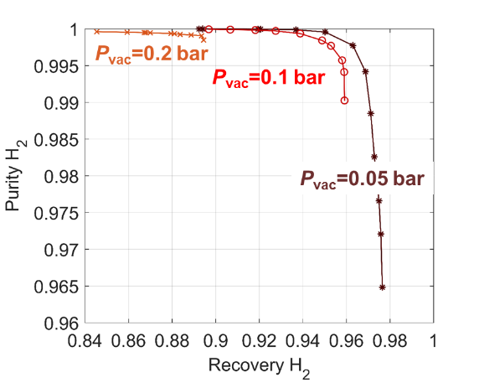
Figure 1. Optimized separation performance for a vacuum pressure swing adsorption cycle at different evacuation pressures, inlet: SMR + HT-WGS, coproduction of CO₂ at > 90 % recovery and > 95 % purity
To achieve the separation requirements, a subatmospheric pressure is required to withdraw CO₂. Lowering this pressure enhances the separation performance and increases the productivity at the expense of a higher energy consumption. The required hydrogen purity is another important factor: the minimum energy consumption increases with higher required hydrogen purities while the productivity decreases. For a hydrogen purity of 99.97 % with a recovery > 90 % (coproduction of CO₂ at > 90 % recovery and > 96 % purity), a minimum energy consumption for the separation of below 0.4 MJ/kg CO₂ separated (below 2.3 MJ/kg H₂ separated) can be obtained. This energy requirement is significantly lower than the energy required for pre-combustion capture using absorption, e.g. with MDEA, which is in the range of 2 MJ/kg CO₂ [4]. The energy required in the latter, however, is mainly steam whereas the former requires electricity for vacuum pumps. The equivalent electricity consumption for both processes assuming a conservative conversion efficiency of 20 % from steam to electricity is similar, but the adsorption process only requires a single process instead of two.
4. Conclusions and outlook
Advanced adsorption processes show promise for process intensification in the context of hydrogen production with CCS. Several cycles have been developed for the coproduction of high purity CO₂ and hydrogen. The equivalent electricity consumption is similar to commercial processes but an entire separation stage is now avoided. Moreover, the cycles are particularly promising due to a high flexibility towards different feedstream compositions. Layering of different adsorbents or the use of advanced adsorbent materials like MOFs leaves room for further process improvement.
References
- Schell J., Casas N. and Mazzotti M. (2012), Ind. Eng. Chem. Res., 52 (2013) 8311-8322
- Marx, D. et al., Ind. Eng. Chem. Res., 55 (2016) 1401-1412.
- F. Capra, M. Gazzani, L. Joss, M. Mazzotti, and E. Martelli, Ind. Eng. Chem. Res., 57 (2018) 9977–9993
- Meerman et al., IJGGC, 9(2012)

