Fine and ultrafine particle deposition in packed-bed catalytic reactors

Gianluca Boccardo¹, Rajandrea Sethi², Daniele Marchisio¹
1 Department of Applied Science and Technology, Politecnico di Torino, Torino, Italy;
2 Department of Environment, Land and Infrastructure Engineering, Politecnico di Torino, Torino, Italy
*Corresponding author: gianluca.boccardo@polito.it
Highlights
- CFD simulations of fine filtration in packed beds are performed
- In-silico generated random packings are used to successfully represent packed beds.
- Polydisperse particles are considered: results very different from theoretical predictions.

1. Introduction
In this work (whose main results were recently accepted for publication [1]) we have performed an extensive CFD simulation campaign studying particle transport and deposition in different catalytic systems and under different conditions. Two types of geometric models representing different porous media were created. The first is a number of random packings of spheres created via rigid body simulations: this approach was tested and validated in previous studies [3]. The second is a regular arrangement of spheres, which was also successfully employed in previous works to study fine particles dispersion. Using these random packings, simulations of particle deposition have been performed at different operating conditions. In the first part we calculated values of particle deposition efficiency and compared our results with the classical filtration theory, highlighting the issues in the use of the simplified models upon which the theory is based. In the second part we have studied the effect of polydisperse particle populations: this is also missing in the classical filtration theory, which always considers the transport of particles with uniform diameter. Thus, we have performed population balance modelling simulations for particle deposition, employing the quadrature method of moments (QMOM) [2]. Even more clearly in this case, the results show that the description of polydisperse populations has a very noticeable effect on the macro-scale description, which would dramatically improve the understanding of particle transport and deposition in filtration and catalytic processes.
2. Methods
The first step in this study is the creation of the random packing geometry: this was done via rigid-body simulations using the open-source code Blender, following a procedure described in detail in a previous published work [3]. Then, CFD simulations of fluid flow and particle transport simulations were performed, using the open-source CFD code OpenFOAM (version 4.0): a snapshot of a simulation can be seen in Fig. 1. The effect of gravitational settling was considered by the addition of the particles settling velocity to the advective term of the transport equation. In each case (with and without gravitational settling), a new and improved constitutive equation for the prediction of filtration efficiency was proposed. Then, in the second part of the work, we solved the population balance equation in order to consider the evolution of the full population of particles (expressed in terms of distribution of particle diameter).
3. Results and discussion
Simulation results were expressed in terms of particle filtration efficiency, extracted from the ratio between outlet and inlet particle concentration. Both in the case of normal diffusion, and when the gravitational effect is added, the newly proposed constitutive equation for filtration efficiency is very different from the theoretical expectation [1].
Also, when the population balance equation is solved, the resulting filtration efficiency for the polydisperse case as a function of the system Peclet number is quite different from both the CFD results for the monodisperse case and the theoretical laws, highlighting another point where the classical predictions can be improved upon, as it can be seen in Fig. 2.
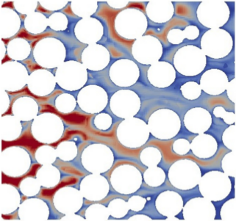  Figure 1. Contour plots of particle concentration in a median section of the domain. | 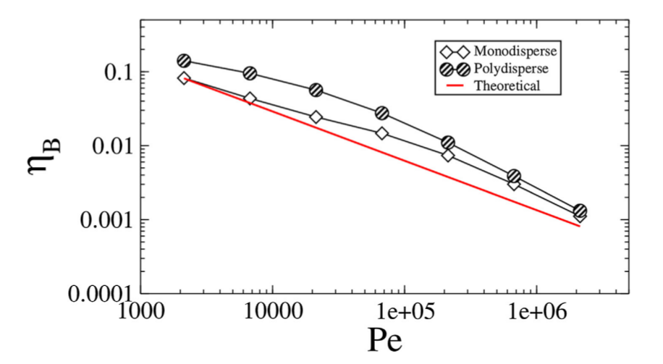  Figure 2. Contour plots of particle concentration in a median section of the domain.
4. Conclusions
This work employs an innovative technique for the generation of random packing, useful to represent a variety of random media, and specifically packed bed reactors, improving on the classical filtration theory, which is based on simplified models of arranged spherical collectors. Then, the main modelling advance of this work is presented, which is the description of the polydispersity of the particle population: this was done here via the solution of the population balance equation, solved by the quadrature method of moments. The results from these simulations show a marked difference with respect to the theoretical predictions and evidence the pitfalls of the simplified description valid for monodisperse populations, evidencing how the proposed model can greatly improve the description of particle transport and deposition in real filtration and catalytic processes.
References
- Boccardo, G., Sethi, R. and Marchisio, D.L., 2018. Fine and ultrafine particle deposition in packed-bed catalytic reactors, Chemical Engineering Science, In press.
- Marchisio, D.L. and Fox, R.O., 2013. Computational models for polydisperse particulate and multiphase systems. Cambridge University Press.
- Boccardo, G., Augier, F., Haroun, Y., Ferre, D. and Marchisio, D.L., 2015. Validation of a novel open-source work-flow for the simulation of packed-bed reactors. Chemical Engineering Journal, 279, pp.809-820.

