Influence of microbubble aeration on hydrodynamics and mass transfer in a lab scaled Stirred Tank Reactor
Simon Matthes¹, Benjamin Thomas², Paul Bubenheim², Andreas Liese²,
Koichi Terasaka³, Michael Schlüter¹
1 Institute of Multiphase Flows, Hamburg University of Technology, Germany;
2 Institute of Technical Biocatalysis, Hamburg University of Technology, Germany;
3 Department of Applied Chemistry, Keio University, Japan
*Corresponding author: simon.matthes@tuhh.de
Highlights
- Mass transfer measurements for microbubble aerated systems.
- Comparison of microbubble aeration and conventional aeration.
- Determination of the influence of BSD on the performance of gas-liquid systems.

1. Introduction
Many chemical and biocatalytic reactions are consuming gaseous species like oxygen, provided by the mass transfer across interfaces of multiphase contact apparatuses. In large-scale processes the gas is often supplied to the liquid bulk phase by bubble aeration. Especially for biocatalytic reactions the macroscopic aeration can lead to reduced enzyme activity by foaming and induced shear forces. For fast chemical reactions in multiphase flows, the mass transfer limitation is often the bottleneck for a process optimization and becomes “a critical factor in equipment sizing” [2]. Considering bubbles with diameters less than 100 μm, large volume-specific interfacial areas a and therefore high mass transfer rates k_{L}a of the gaseous reactant on its way to the bulk phase are offered. In addition the high Laplace pressure at that size is leading to an acceleration of the mass transfer. Compared to large-scale bubble aeration, the potential of using bubbles with diameters smaller than 100 μm is less explored so far.
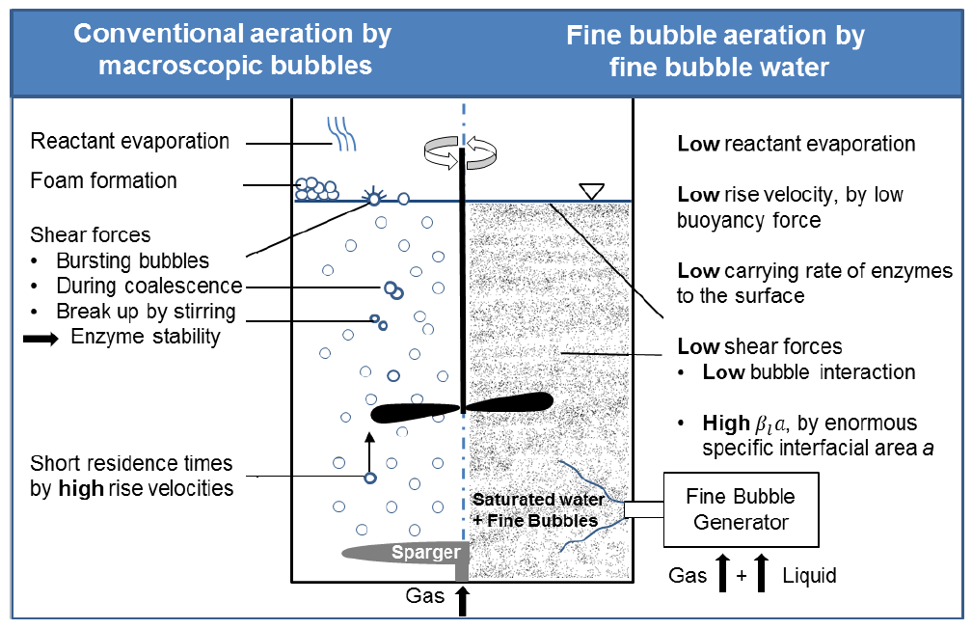
At that point this project starts investigating the aeration with fine bubbles, due to the rising demand in process engineering for aeration with high mass transfer performance, low pressure drop, low shear stress and the avoidance of foaming.

Figure 1. Comparison between conventional aeration and fine bubble aeration in biocatalytic processes in a STR.
Furthermore, the rise velocity of a bubble decreases with decreasing bubble diameter leading to higher residence time and low induced shear stress. To determine the potential of fine bubbles for biocatalytic processes, the promising properties of fine bubble aeration compared to conventional aeration (as shown in figure 1) is under investigation in close collaboration with the Institute of Technical Biocatalysis (ITB) at the Hamburg University of Technology and Prof. Koichi Terasaka from Keio University, Japan.
2. Methods and results
To quantify the influence of fine bubble aeration on the hydrodynamics and the mass transfer, measurements of the bubble size distribution (BSD) and the mass transfer rates from oxygen into the liquid phase are executed in a 3 L stirred tank reactor. The BSD is measured near by the stirrer using an endoscopic probe by SOPAT GmbH. The effect of different stirring speeds and gas flow rates are determined for the reference system deionized water/ air and the two aqueous solutions of glucose (133 mmol/L), with and without 67 mg/L bovine serum albumin (BSA), and rhododendrol (10 mmol/L) as bioactalytic model systems which are also aerated with air. All investigations took place in a turbulent state at stirrer speeds of 400, 600 and 800 rpm and gas flow rates from 25 mL/min up to 100 mL/min. Different fine bubble generators working under the principle of the pressurized dissolution and the spiral liquid flow method are used [1]. The microbubble aeration is compared with conventional aeration by membranes of pore sizes from 0.5 μm up to 2 μm regarding their performance and influence on the liquid systems. A well mixing of the system and therefore a homogeneous distribution of the bubbles is assumed. Figure 2 shows the BSD for the 2 µm membrane and its mass transfer performance.
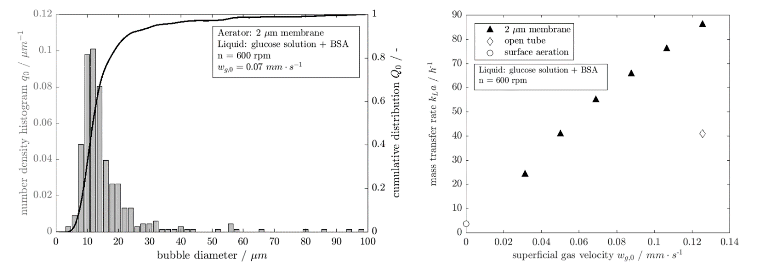

Figure 2. Bubble size distribution measured via SOPAT-VI Pl (left) and mass transfer rates for different gas flow rates for a sinterstone with a pore size of 2 μm producing microbubbles (right).
4. Acknowledgement
The authors gratefully acknowledge the financial support provided by the Deutsche Forschungsgemeinschaft (DFG) within the project (SCHL-617_LI-899).
References
- K. Terasaka et al., Chem. Eng. Sci. 66 (2011) 3172-3179.
- P. Zehner, P. Kraume, Bubble Columns, Wiley-VCH Verlag GmbH & Co. KGaA, Weinheim, 2005.

