Novel bio-based polybenzoxazine/epoxy materials for self-healing and/or shape memory applications
Aleš Ručigaj, Rok Ambrožič, Matjaž Krajnc
University of Ljubljana, Faculty of Chemistry and Chemical Technology, Večna pot 113, 1000 Ljubljana, Slovenia
*Corresponding author: Ales.Rucigaj@fkkt.uni-lj.si
Highlights
- Bio-based polybenzoxazine/epoxy (co)polymers were targeted designed.
- The DSC study showed several overlapping curing mechanisms.
- The prepared advanced materials showed self-healing and/or shape-memory potential.

1. Introduction
The growing demand for advanced materials synthesis along with the negative impact of classic petrol-based products on the environment forced both academic and industrial researchers to find new development pathways towards bio-based materials production. Preparation of polybenzoxazines, which are a newly developed class of thermosetting material with excellent thermal and mechanical properties, may be considered as a promising way to unlock different renewable resources, such as natural phenols and amines, and enable preparation of novel smart materials. In this context, unique benzoxazine monomers with designed properties of the final material, such as self-healing and/or shape memory ability, were synthesized from naturally occurring chemicals. To enhanced chain mobility, which should have a beneficial effect on self-healing and shape memory properties, bio-based epoxy resins were introduced and thermally copolymerized with benzoxazine monomers to form a final copolymeric network.
2. Methods
Chemical structure and thermal behavior of newly synthesized benzoxazine monomers were characterized by ¹H and ¹³C NMR technique and DSC analysis, respectively. Once benzoxazine-epoxy (co)polymeric networks were formed by thermally induced ring-opening polymerization, mechanical properties of resulting material were investigated by DMA measurements. Final smart material shape memory and/or self-healing behaviors were quality and quantity studied by visual examinations and by performing DMA cycles and tensile stress tests, respectively.
3. Results and discussion
Initially, novel benzoxazine monomers were synthesized from bio-based phenols (resorcinol, diphenolic acid and cardanol) and amines (octadecylamine and series of polyether diamines), according to the standard procedure. Once benzoxazine monomers were fully characterized, thermal cross-linking and/or (co)polymerization with commercially available bio-based epoxy resin (resorcinol diglycidyl ether) took place. Recently published studies show excellent epoxy-benzoxazine compatibility through ether linking copolymerization and formation of 3-dimensional structure. The DSC study of the cross-linking process indicates various curing mechanisms, such as thermally stimulated benzoxazine ring-opening, benzoxazine homopolymerization, benzoxazine catalysed epoxy ring-opening and epoxy-benzoxazine copolymerization, might occur. Moreover, by introducing epoxy resin into the polybenzoxazine network, higher chain flexibility, favourable for self-healing and shape memory ability, was formed. Therefore, all tested materials possessed thermally assisted shape memory (Figure 1), at least to a certain extent. In addition, final material properties can be target designed by suitable selection of raw materials. For instance, chemicals rich with aliphatic chains (from cardanol, octadecylamine and polyether diamines) resulted in higher chain flexibility, while chemicals rich with aromatic rings (from resorcinol, diphenolic acid) gave more rigid structure.
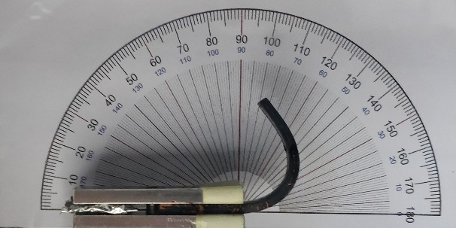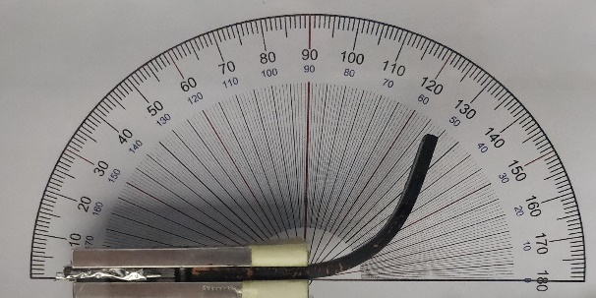
t = 95 s
t = 60 s
t = 0 s
t = 15 s
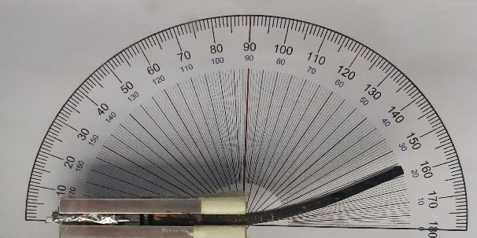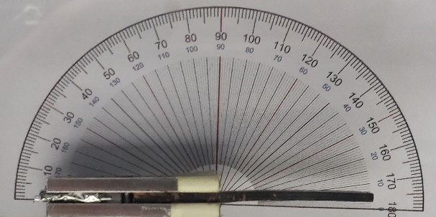
Figure 1. Thermally assisted shape memory effect of benzoxazine/epoxy copolymer based on resorcinol and octadecylamine.
Furthermore, self-healing ability of polybenzoxazines was accomplished by incorporation of additional site groups (COOH) capable of an extra intermolecular and intramolecular hydrogen bonding formation, which enables connection and reconnection between several bonding sections, leading to self-healing effect.
4. Conclusions
Bio-based polybenzoxazine/epoxy (co)polymers, as promising building blocks for advanced materials, were targeted designed, depending on selected starting chemicals. Such an approach represents significant applicative potential, since materials with shape memory, self-healing or even both effects (SMASH) can be optionally prepared.
References
- M. Arslan, B. Kiskan, Y. Yagci, Macromolecules 48(5) (2015) 1329-1334.
- Y.F. Liu, J.B. Huang, X.H. Su, M. Han, H. Li, M.T. Run, H.Z. Song, Y.G. Wu, React Funct. Polym. 102 (2016) 62-69.
- X.F. Luo, P.T. Mather, Acs Macro Lett. 2(2) (2013) 152-156.
- S. Rimdusit, M. Lohwerathama, K. Hemvichian, P. Kasemsiri, I. Dueramae, Smart Mater. Struct. 22(7) (2013) 12.

