Electroreduction of CO₂ paired with lactic acid production. Towards an economically feasible system.
Elena Pérez-Gallent¹, Susan Turk¹, Roman Latsuzbaia¹, Rajat Bhardwaj¹, Anca Anastasopol¹, Francesc Sastre-Calabuig², Amanda Cristina Garcia¹, Erwin Giling¹, Earl Goetheer^{1,3}
1 Department of Sustainable Process and Energy Systems, TNO, Leeghwaterstraat 44, 2628 CA Delft, The Netherlands; 2 Department of Material Solutions, TNO High Tech Campus 25, 5600JW, Eindhoven, The Netherlands; 3 Process and Energy, Delft University of Technology, Leeghwaterstraat 39, 2628 CB Delft, The Netherlands
*Corresponding author: elena.perezgallent@tno.nl
Highlights
- Co-production of two added value products, carbon monoxide and lactic acid.
- Reduction of 35% in energy consumption.
- 7 fold increase in product value.
- Combined faradaic efficiencies up to 160 %.

1. Introduction
The electrochemical conversion of carbon dioxide presents a significant opportunity to create valuable chemicals or fuels¹. However, the process is not implemented in the industry due to the high energy needed to overcome the high overpotentials of the reaction²⁻³. The electrochemical reduction of CO₂ can be made economically more interesting by pairing to a compatible reaction where a valuable product is formed. With this approach, two valuable product are formed with the same energy usage. This study proves a paired electrochemical process where carbon dioxide is reduced to carbon monoxide and 1,2-propandiol is oxidized to lactic acid. With this strategy, a reduction of 35% in energy consumption during CO₂ reduction, and a 7 fold increase in product value per unit of energy used was achieved.

2. Methods
The electrochemical measurements were performed in a flow cell with a 200 mL reservoir of anolyte and catholyte which were recirculated at 25 l/h. Different currents (15, 30 50 mA/cm²) were applied by the use of a potentiostat connected to a 10 cm² gold plate cathode and a 10 cm² carbon felt anode. A 0.5 M KHCO₃ solution where pure CO₂ was bubbled through was used as a catholyte, and a 0.5 M KHCO₃/ 0.5 M K₂CO₃ solution which contained 20 mM ACT-TEMPO as a mediator and 20 mM 1,2-propanediol (PDO) as a reactant was used as anolyte. The gaseous products were analyzed by gas chromatography and the liquid products were analyzed by high performance liquid chromatography.
3. Results and discussion
During electrochemical reduction of CO₂ paired with 1,2-propanediol oxidation performed at 15 mA/cm² a faradaic efficiency of 80% of carbon monoxide and a faradaic efficiency of 80 % to lactic acid was observed, making a combined 160 % total faradaic efficiency. During the paired reaction, a cell voltage of 2.6 V was measured, while during the non-paired reaction (oxygen formation as counter reaction) a cell voltage of 4 V was measured. The decrease of 1.4 V in the cell voltage lead to an reduction in the cost per ton of CO formed when the reaction is performed in a paired manner. In addition, if the counter reaction is based upon oxygen evolution reaction (non-paired) instead of lactic acid production (paired), only one valuable product is formed. The combined value of carbon monoxide and lactic acid makes the paired reaction economically more beneficial per unit of energy used. Figure 1 shows the value of products formed in € per kWh and the cost in € per ton of CO formed for a) the paired reaction and b) the non-paired reaction.
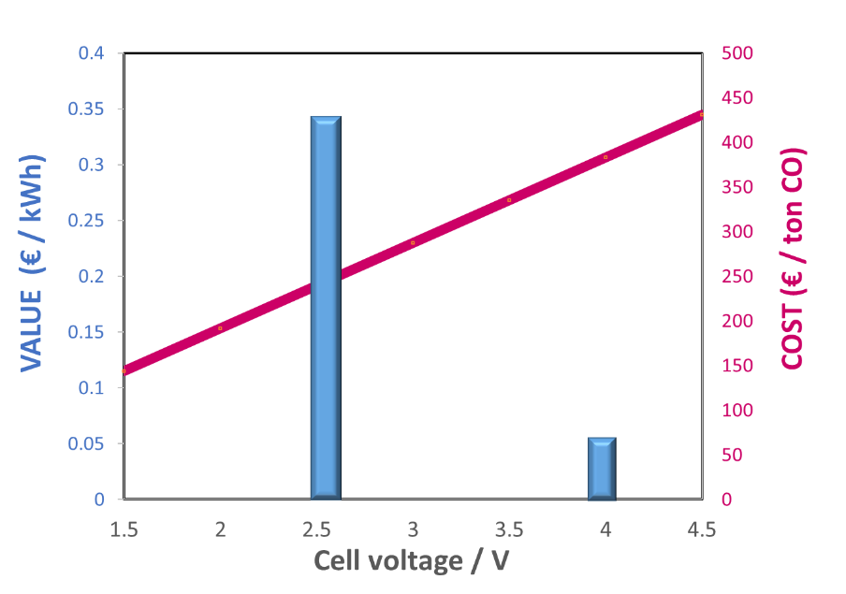
A)
B)

Figure 1. Techno economic comparison of the a) paired and b) non-paired electrolysis in terms of cost per ton of CO formed (pink line) and in terms of the value of the products formed (blue bars). The green boxes indicate the cell potential at which the reactions take place.

4. Conclusions
We have demonstrated that pairing CO₂ reduction to an electrochemical reaction which produce an added value chemical, a significant increase in product value can be achieved. In addition, if the cell potential needed to drive the reactions is reduced, an important decrease in energy usage can be accomplished. This strategy allows to move towards an economically viable electrochemical CO₂ conversion.
References
- Hori, Y.; Wakebe, H.; Tsukamoto, T.; Koga, O., Electrochimica Acta, 39 (1994) 1833–1839.
- Seh, Z. W.; Kibsgaard, J.; Dickens, C. F.; Chorkendorff, I.; Nørskov, J. K.; Jaramillo, T. F., Science, 355 (2017) 6321
- Durst, J.; Rudnev, A.; Dutta, A.; Fu, Y.; Herranz, J.; Kaliginedi, V.; Kuzume, A.; Permyakova, A. A.; Paratcha, Y.; Broekmann, P.; Schmidt, T. J., CHIMIA International Journal for Chemistry, 69 (2015) 769-776

