Flow regimes of immiscible liquid-liquid systems in stirred vessels
Francesco Maluta^{1*}, Teresa Megna¹, Giuseppina Montante², Alessandro Paglianti¹
¹ DICAM, Università di Bologna, via Terracini 34, Bologna, Italy; ² CHIMIND, Università di Bologna, via Terracini 34, Bologna, Italy
*Corresponding author: francesco.maluta2@unibo.it
Highlights
- Drawdown and dispersion of oil droplets in water are investigated by ERT.
- A procedure for liquid-liquid flow maps identification in stirred tanks is proposed.
- The flow map for moderately concentrated water-diesel fuel systems is presented.

1. Introduction
The impeller speed required to successfully disperse one immiscible phase in another in stirred vessels is a very important process parameter, which experimental determination is not straightforward [1], particularly in dense liquid-liquid systems. This work has the goal to suggest a new procedure to obtain the flow map of immiscible liquid-liquid systems, based on the measurements of the dispersed phase distribution by Electrical Resistance Tomography (ERT).

2. Methods
The investigation concerns a moderately concentrated immiscible liquid-liquid system, consisting of diesel oil of density, ρ_{oil}, equal to 810 kg/m³ at ambient conditions, and demineralized water, containing 0.5 g/L of NaCl for enhancing the conductivity difference with the non-conductive oil phase, as required by the ERT technique. The dispersion is obtained in a flat bottomed fully baffled tank of diameter, T, equal to 232 mm stirred with a Rushton turbine of diameter, D, equal to T/3, placed at the clearance, C, equal to T/2. The distribution of the diesel fuel in water is observed at different impeller speeds, N, going from complete segregated conditions to fully dispersion. Data are collected at different average oil volume fractions in the vessel, varying from 0.05 to 0.14, keeping the total liquid height, H_{L}, in still conditions always equal to T. The analysis is based on the time-averaged conductivity data on four horizontal vessel sections (axial elevations, z, equal to 60, 110, 160, 210 mm), consisting on 316 values per plane, with a square mesh with each cell of 11.5 mm side. For each condition, the time-averaged conductivity is obtained from 1000 instantaneous measurements. The ERT instrumentations and the data acquisition systems are similar to those adopted in previous investigations [2].
3. Results and discussion
Different flow conditions have been identified through the analysis of the time-averaged conductivity data on the four measurement planes. Starting from the complete segregated conditions, the just drawdown and the complete dispersion of the oil have been detected subtracting the mean conductivity value obtained at fixed impeller speed from the value recorded at N=0 on the plane at z=160mm, being this plane just below the liquid-liquid interface at N=0. By monitoring the local maximum absolute value of the conductivity difference from the completely segregated condition (N=0) on the plane at z=160 mm at increasing N, an evolution curve is obtained, as shown in Fig.1, relevant to diesel fuel volume fraction of 0.14.

As shown in Fig.1, through a linearization procedure of the experimental data (open circles), we identified the just drawdown impeller speed as the intersection of the two lines, highlighted in red, and the just completely dispersed impeller speed as the intersection highlighted in black. The homogeneous dispersion condition was identified once the variation of the conductivity on the four measurement planes reached an asymptotical value. By the procedure described above, a flow map of the different regimes can be identified.
The flow map relevant to the conditions investigated in this work is shown in Fig.2, where the Froude number, Fr; [3] is defined as:
Fr= $\frac{{DN}^{2}}{g}{\left(\frac{ρ_{water}}{ρ_{water-}ρ_{oil}}\right)}^{0.42}{\left(\frac{D}{T}\right)}^{3.65}$.

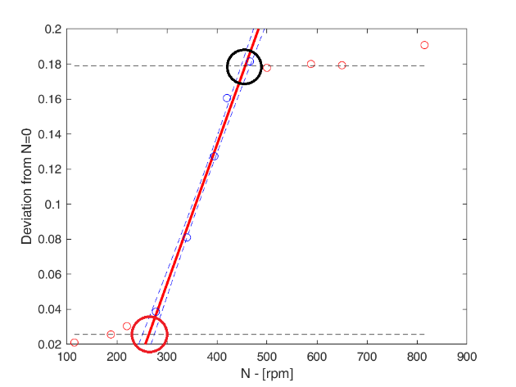Figure 1. Experimental data and identification of the drawdown and completely dispersed impeller speeds.
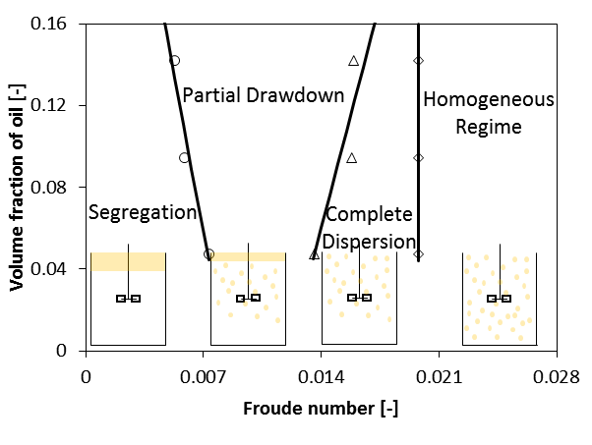Figure 2. Flow map for the diesel fuel-water system.

4. Conclusions
A novel method is proposed for obtaining the flow map of immiscible liquid-liquid systems in stirred tanks based on the collection and a suitable analysis of ERT data. The method can be easily applied to any vessel size and liquid volume fraction, thus providing a useful guideline for the selection of the operating conditions of stirred vessels.

References
[1] D.A. Brown, P.J. Jones, J.C. Middleton, G. Papadoloulos, E.B. Arik, in Handbook of Industrial Mixing, Chapter 4 (2014), 189.
[2] A. Paglianti, C. Carletti, A. Busciglio, G. Montante, Can. J. Chem. Eng. 95 (2017) 1789–1799.
[3] G.E.H. Joosten, J.G.M Schilder, A.M. Broere, Trans. Inst. Chem. Eng. 55 (1977) 220–222.

