Adsorption of sulfur and nitrogen compounds present in commercial diesel.
Marco Figueiredo*, Luana Baia, Wallace Souza, Cláudia Veloso and André Costa.

State University of Rio de Janeiro, Rio de Janeiro, Maracanã, BRASIL.
* Corresponding author: mgaya@uerj.br

Highlights
• Higher removal of sulfur compounds by silica in isothermal and kinetic tests.
• Clay showed higher affinity for nitrogen compounds.
• The adsorption capacity of nitrogenous compounds was greater than that of sulphides

1. Introduction
In order to mitigate the damages caused by man's action on the environment, more restrictive legislation has been created, one of which is to reduce the sulfur content in fuels, in order to reduce the emission of SOx to the environment. This is responsible for the formation of acid rain, besides being directly harmful to human health, particularly in relation to the respiratory tract [1 and 3]. At the beginning of this century, regulations in different countries reduced the sulfur content to 15 mg kg-1 (USA, EU and Japan) [1] and 10 mg kg-1 (Brazil) [2]. The process used to remove sulfur compounds is hydrotreatment which is highly severe in energy and hydrogen consumption. Alternative processes with lower cost are being studied in order to remove this contaminant, being the adsorption one of these processes. In the present work, the adsorption of nitrogenous and sulfur compounds present in diesel samples was evaluated in three commercial adsorbents: silica, clay and coal. Kinetic curves and adsorption isotherms were obtained. In the modeling of the kinetic curves was used mass transfer model and isotherm data were adjusted by the Langmuir-Freundlich Model.
2. Methods
The adsorbents were characterized as texture properties, thermogravimetric data, chemical composition and acidity. The kinetic and isothermal tests were performed in a Dubnoff bath, where in the kinetic tests the ratio of diesel volume / adsorbent mass used was 2: 1 (mL / g), at 40 ° C, shaking of 2.5Hz and range of between 30 and 360 minutes. The isotherm tests were performed by varying the diesel / mass ratio of adsorbent between 1.25: 1 and 100: 1 (mL / g), time of 420 minutes and using the same agitation and temperature of the kinetic tests.

3. Results and discussion
The silica sample was the one that removed the largest quantity of sulfur compounds among the studied adsorbents, while the clay was the second adsorbent with the highest removal of this contaminant. In the equilibrium range studied between 1.25: 1 and 10: 1 mL of diesel: g adsorbent, the amount of sulfur compounds removed by silica ranged from 3.03 to 7.74 mmol of sulfur / kg adsorbent for the range studied.
The following sequence for the adsorption capacity of the nitrogen compounds was obtained: clay> silica> coal for the entire concentration range in the studied fluid phase. The ratio of volume (mL) of diesel per mass (g) of adsorbent ranged from 1.25: 1 to 100: 1 and an adsorption capacity of 1.48 to 34.43 mmol of nitrogen / kg of adsorbent was obtained. In order to adjust the adsorption isotherms, the Langmuir-Freundlich model was the most suitable for the treatment of the equilibrium data.
The experimental data for the nitrogen compounds presented a satisfactory fit, while for the sulfur compounds some points showed a greater dispersion. It is observed a greater removal of nitrogen compounds by the clay, while the silica presents a greater removal of the sulphur compounds, as already observed in the adsorption isotherm tests using the same charge and adsorbent. It is also noted that both nitrogen and sulfur compounds reach equilibrium faster in silica than in clay, which may be associated with the higher pore volume of this material.
The results show that the diffusive resistance is higher for sulfur compounds (lower diffusion coefficient) in relation to nitrogen ones, and silica presented the lowest diffusive resistance, in the removal of both contaminants in relation to the clay. This lower resistance to silica adsorption may be due to the fact that this material has the highest pores volume.
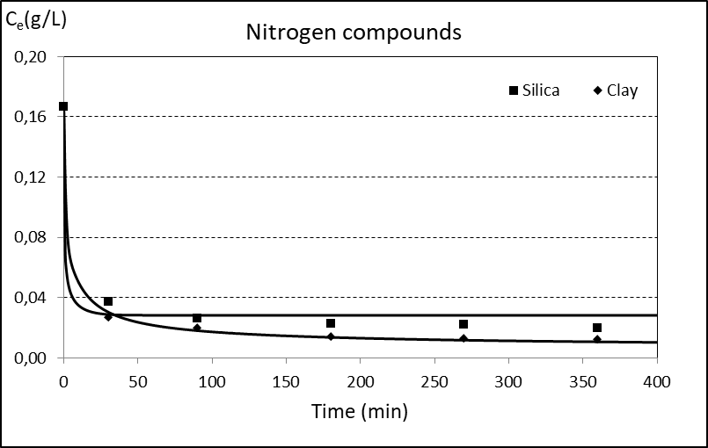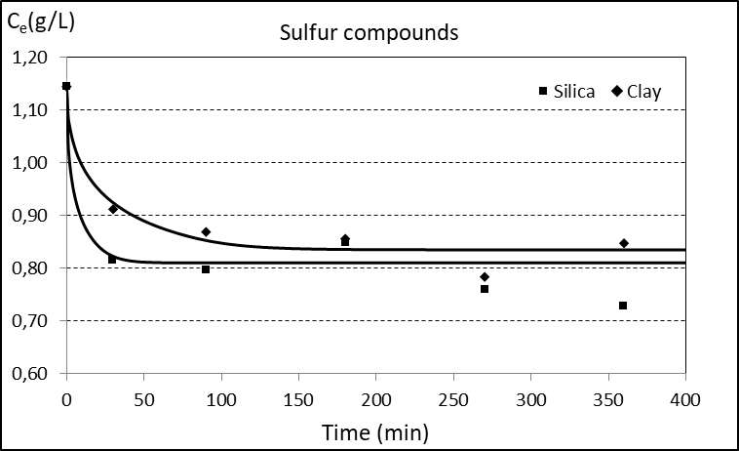
Figure 1. Kinetic curve of adsorption of nitrogen and sulfur compounds.
4. Conclusions
The results showed a higher affinity of the adsorbents for the nitrogen compounds in relation to the sulfur compounds. In equilibrium isotherm tests with diesel, silica and clay removed the largest amount of sulfur and nitrogen compounds, respectively. The effective diffusivity values ​​estimated in the kinetic curves indicated a lower resistance of the sulfur and nitrogen compounds to the diffusion in the presence of silica.

References
- A. Stanislaus, A. Marafi, M.S. Rana. Catalysis Today, v. 153, n. 1-2, p. 1-68, 2010.
- J.M.P.F. Silva, E.B. Silveira, A.L.H. Costa, C.O. Veloso, C.A. Henriques, F.M.Zotin, M.L.L. Paredes, R.A.Reis, S.S.X. Chiaro. Ind. & Eng. Chem. Res., v. 53, p. 16000−16014, 2014.
- S.W. Lee, J.W. Ryu, W.Min. Catalysis Surveys from Asia, v. 7, n. 4, 2003.

