Synthesis of Cephalexin in Aqueous Two-Phase System.
Lucie Vobecka¹, Linda Ticha¹, Zdenek Slouka¹, Michal Pribyl¹
1 University of Chemistry and Technology Prague, Technicka 3, 166 28 Prague, Czech Republic
*Corresponding author: lucie.vobecka@vscht.cz
Highlights
- Optimization of aqueous two-phase systems (ATPS) for the production of cephalexin.
- Optimal conditions for reaction kinetics (temperature, enzyme quantity)
- Extraction of cephalexin and recycling of enzyme on microscale.

1. Introduction
We focus on the possibility of efficient production of cephalexin in microfluidic devices by the enzyme penicillin acylase (E). The following simplified reaction scheme shows the mechanism of the cephalexin (CEX) synthesis:
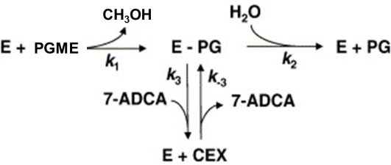
Hydrolysis of substrate phenyl glycine methyl ester (PGME) together with consumption of product by the enzyme take place. To optimize the productivity, it is necessary to separate either the products or the enzyme from the reaction mixture to enable the enzyme recovery and prevent product disintegration. One of the possible solutions is based on the use of aqueous two-phase systems (ATPS), which are widely used in separation and purification applications. Because of high water content in both the immiscible phases, ATPS provide mild environment for proteins or even living cells in downstream processing [1].
Microreactor technologies bring important benefits if compared to classical bioreactor systems such as the reduction of transport resistances, precise control of hydrodynamic conditions, the possibility of integration of several unit operations into one device etc.
2. Methods
The first aim of these studies is to find ATPS with optimal separation efficiency, i.e. ATPS that exhibits a high difference in the partition coefficients of the enzyme and the reaction products [2]. Several ATPS based on polyethylene glycol (PEG)/phosphate are tested. The next aim is to find optimal conditions for reaction kinetics with optimal cephalexin yield, the period with maximal product yield, duration of reaction. The experiments are performed at several temperatures and with different enzyme concentrations. Further, the extraction of cephalexin and enzyme recovery is studied. The reaction is carried out in the ATPS, then the immiscible phases are separated and the phase with enzyme content is mixed with fresh phase containing reaction substrates. Analysis of substrate and product concentrations are carried out by HPLC analysis using Agilent 1260 Infinity Series device equipped with UV-VIS detector and Waters C18 column (WAT066224). Finally, the whole system is transferred into the microfluidic environment and the process is carried out in a continuous manner with the enzyme recycle.
3. Results and discussion
We found that ATPS consisting of 15 wt % of PEG 4000, 12 wt % of phosphates, 73 wt % of water (pH = 7.0 after dissolution) provides optimal separation of cephalexin which prefers the top PEG phase unlike the free enzyme accumulated in the bottom salty phase [2].
Experiments with reaction kinetics show that higher quantity of enzyme leads to significant increase in the reaction speed but unfortunately decreases stability of synthesized cephalexin. In the same manner, higher temperature increases reaction speed, however, it decreases cephalexin stability. At the end, we found conditions with optimal reaction speed and cephalexin stability.
Figure 1 shows the cephalexin concentration synthesized and extracted to the top phase in each step of enzyme recovery. It is seen that synthesized amount of cephalexin slightly decreases in each step of enzyme recycling, but the enzyme seems to have almost the same activity also after recovery.
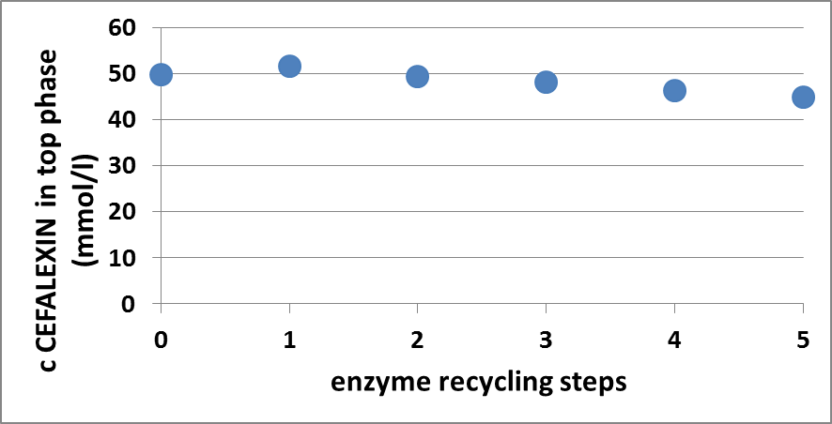
Figure 1. Concentration of Cephalexin in the top phase in the dependence on the number of cycles of the enzyme use.
4. Conclusions
We optimized conditions under which cefalexin is separated from the reaction mixture with the use of aqueous two-phase system. We experimentally determined the composition of the ATPS and also the reaction conditions at which we reach highest cefalexin yield along with reasonable time duration. We further showed that enzyme retains it stability and can be recycled n the given process. This process was adopted to the microfluidic format which allows integration of several processes and very good control of the experimental conditions.
References
- S.Raja , V. R. Murty , V. Thivaharan , V. Rajasekar , V. Ramesh, Science and Technology,1,2011, 7-16
- L. Vobecká, A. Romanov, Z. Slouka, P. Hasal, M. Přibyl, New Biotechnology. 47 (2018) 73-79.

