Multicomponent separation of nadolol stereoisomers combining different preparative technologies and chiral and achiral-chiral strategies
Rami Arafah^{1,2}, António Ribeiro^{1,2}, Alírio Rodrigues³, Luís Pais^{1,2}
1 Centro de Investigação de Montanha (CIMO), Instituto Politécnico de Bragança, Campus de Santa Apolónia, 5300-253 Bragança, Portugal; 2 Laboratory of Separation and Reaction Engineering, School of Technology and Management, Polytechnic Institute of Bragança, Bragança, Portugal; 3 Laboratory of Separation and Reaction Engineering – Laboratory of Catalysis and Materials, Associate Laboratory LSRE-LCM, Faculty of Engineering, University of Porto, Rua Dr. Roberto Frias s/n, 4200-465 Porto, Portugal.
*Corresponding author: pais@ipb.pt
Highlights
- Strategies for the complete preparative separation of nadolol chiral drug.
- Optimization of different solvent compositions using chiral and achiral adsorbents.
- Experimental chiral separation by preparative and SMB chromatography.

1. Introduction
Nadolol is a common prescribed pharmaceutical drug for the relieve of several cardiovascular diseases and represents a very interesting case-study of multicomponent chiral separation since it is composed by four stereoisomers, being two pairs of enantiomers. In this way, it introduces the possibility of alternative strategies, using different kind of preparative separation sequences and techniques, the use of different packings (chiral and achiral stationary phases), and the corresponding mobile phase optimization at both normal and reversed-phase modes.
When considering preparative and multicomponent separation, the complexity deeply increases by introducing the necessity of multi-step separation sequences (or a much more complex multi-region separation process), by opening the possibility to combine chiral and achiral stationary phases (when in presence of stereoisomers instead of just one pair of enantiomers) and to combine different separation techniques (fixed-bed and simulated moving bed (SMB) related processes). The design of the complete preparative separation of nadolol stereoisomers asks for a global experimental and simulation methodology considering both the characterization and optimization of each separation step and its sequences to achieve the four nadolol components pure. New strategies using combinations of achiral and chiral stationary phases and sequences of different separation techniques will be presented. Extensive experimental and simulation results for the complete separation of all the four nadolol stereoisomers using Chiralpak IA (chiral) and different Waters C18 (achiral) stationary phases will be presented.
2. Methods
For the analytical measurements, an analytical Knauer HPLC was equipped with one Smartline 1050 pump, a 10 mL pump head and two detectors in series: a Smartline UV detector 2520 a polarimeter detector (Chiralser IBZ, Messtechnik, Germany). These measurements were performed using a Chiralpak IA column obtained from Daicel and a XBridge C18 column obtained from Waters. Both columns have the same analytical dimensions (250 mm L × 4.6 mm ID) and packed with 5 μm particle size materials. For the preparative measurements, a preparative Knauer HPLC system equipped with a Smartline UV detector 2520, two Smartline 1050 pumps with 50 mL pump heads, was used. Three different preparative columns (100 mm L × 20 mm ID) were used, a Chiralpak IA (particle size diameter 20 μm), a SiliaChrom XT18 and a XBridge C18 column (both with a particle size diameter of 10 μm). The pseudo-binary SMB separation of nadolol stereoisomers was performed on a laboratory-scale SMB unit built on the LSRE group, Faculty of Engineering, University of Porto. The SMB unit was operated using a [1-2-2-1] column configuration. The SMB unit was operated with six Chiralpak IA columns for the pseudo-binary enantiomer separation and six XBridge C18 columns for the binary separation of the two nadolol racemates. Additionally, a commercial Azura Fixed-Bed prep HPLC system obtained from Knauer was also used for the binary separation of nadolol racemates. This system was equipped with two preparative HPLC pumps P2.1L model with 250 mL/min pump heads, one UV detector UVD2.1L model and a unique Waters XBridge prep C18 column (30 mm ID x 250 mm L) with particle size diameter of 10 μm.
3. Results and discussion
An extensive set of experimental and simulation results will be presented (see Fig. 1). Results will include the identification of the stereoisomers present in both nadolol racemates by means of using UV and polarimeter detectors in series. Then, a complete methodology developed during the last years by our group will be explained and applied to scale-up the separation process from analytical to preparative scales [1-3].
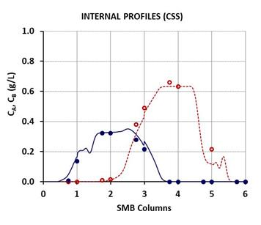 | 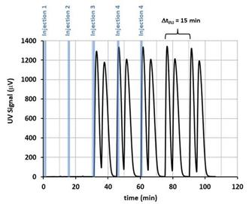
Figure 1. Experimental preparative separations of nadolol racemates using (left) Flex-SMB unit
and (right) Fixed-Bed Azura pilot unit, both with achiral adsorbent under reversed-phase mode.
4. Conclusions
The results recently obtained by our research team for this topic clearly support the capacity to enhance the knowledge on the chromatographic separation of chiral pharmaceuticals using fixed-bed and SMB preparative chromatography. In this communication, it will be introduced original and innovative challenges through the real separation of multicomponent (quaternary) chiral mixtures which represents an important step forward for the pharmaceutical industry.
Acknowledgments
This work is a result of project “AIProcMat@N2020-Advanced Industrial Processes and Materials for a Sustainable Northern Region of Portugal 2020,” with the reference NORTE‐01‐0145‐FEDER‐000006, supported by Norte Portugal Regional Operational Program (NORTE 2020), under the Portugal 2020 Partnership Agreement, through the European Regional Development Fund (ERDF), and of project POCI‐01‐0145‐FEDER‐006984-Associate Laboratory LSRE‐LCM funded by ERDF through COMPETE2020-Programa Operacional Competitividade e Internacionalização (POCI)—and by national funds through Fundação para a Ciência e a Tecnologia (FCT).
References
- A.E. Ribeiro, A.E. Rodrigues, L.S. Pais, Chirality 25 (2013) 197-205.
- R.S. Arafah, A.E. Ribeiro, A.E. Rodrigues, L.S. Pais, Chirality 28 (2016) 399-408.
- R.S. Arafah, A.E. Ribeiro, A.E. Rodrigues, L.S. Pais, Chirality 31 (2019) 62-71.

