Hydrothermal Treatment of Spent Contaminated Ion Exchange Resins in Sub and Supercritical Water.
Antoine Leybros, Jean-Christophe Ruiz, Thibault d’Halluin, Egle Ferreri and Agnès Grandjean
CEA, DEN, Univ. Montpellier, DE2D, SEAD, LPSD, F30207 Bagnols sur Cèze, France;
*Corresponding author: antoine.leybros@cea.fr
Highlights
- Efficiency of hydrothermal process to degrade Cs; Sr; Co and Eu exchanged IER.
- Leaching yields around 100 % are obtained for Cs; Sr and Eu using batch setup.
- A semi-dynamic process allows an efficient treatment of IERs.

1. Introduction
Some water treatment systems in nuclear industry involve Ion Exchange Resins (IER) to control water chemistry, minimize equipment corrosion and remove radioactive contaminants. Typically, the volume of contaminated IER from a nuclear power plant is around 5-7 m³ per reactor and per year. The different issues studied for these IER solid waste is either the immobilization in an inert matrix (cement, bitumen, polymer) or the mineralization, so as to obtain inorganic residues before solidification [1]. Among mineralization processes, hydrothermal treatment in sub or supercritical water may be a promising alternative to leach resins and recover radionuclides such as ¹³⁷Cs, ⁹⁰Sr, ⁶⁰Co or transuranic in an aqueous solution. Thus, the secondary waste would be solid waste of lower radioactivity, which may be incinerated or immobilized, and liquid wastewater containing radionuclides, which can be managed simply by the liquid treatment facility. Previous studies carried out using continuous supercritical water oxidation setup allow to reach 99.9% degradation yields on crushed IER [2]. Unfortunately, owing to IER radiolytical and thermal deterioration and high radioactivity, a grinding preprocessing step is not easy to manage. This is the reason why batch and semi-dynamic process have been considered on millimeter size resins. This study deals with the feasibility of leaching IER by hydrolysis and/or oxidation (by H₂O₂) runs carried out with temperature and pressure respectively ranging from 100 and 450°C and from 20 and 300 bar.
2. Methods
Considered IER are strong cationic Amberlite IRN77 and anionic Amberlite IRN78. Contamination of each species of interest (Cs, Sr, Co and Eu) is 10 mg/g IER. The setup used to carry out runs under subcritical and supercritical hydrothermal conditions is described Figure 1. A titanium jacket allows to confine aggressive species and protect reactor outer walls from corrosion. Furthermore, this jacket is flexible to compensate any difference of pressure with the reactor. During batch experimental runs, {IER/ water or water + H₂O₂ with stoichiometric ratio equal to 1.3} mixture is introduced into the jacket while the reactor is filled with water, with equivalent volume ratios. This ratio has been set to reach targeted autogenous pressure (between 60 and 290 bar) according to operating temperature (300 or 450°C). The duration of runs is about 4h.
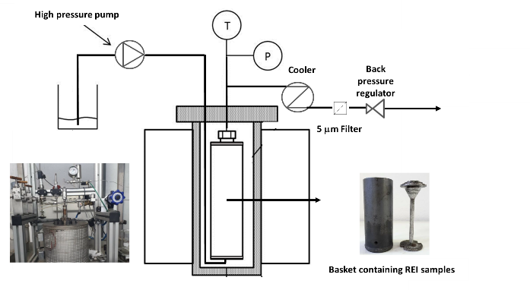
Figure 1. Experimental setup for hydrothermal treatment of IER (semi-dynamic mode)
Then, the experimental setup has been modified to be used in semi-dynamic mode. IER samples are introduced into a basket, inside the reactor, which is then fed continuously with a {water or water + H₂O₂} stream at a 5 mL/min flow rate. The reactor is heated until the working temperature is reached (set between 100 and 290°C). Pressure (from 5 to 50 bar) is controlled by a back pressure regulator. The aqueous effluents are then recovered downstream, in a collector, after cooling and depressurization. The treatment capacity of this setup is 50 g of IER per batch.
Solid residues as well as generated effluents are gravimetrically analyzed. TOC-metry is used to measure carbon degradation yields. ICP-AES and AAS analyzers are used to measure ions release (Sr, Co, Eu and Cs).
3. Results and discussion
Experimental runs in batch mode allow to highlight following trends. Whatever operating conditions, carbon degradation yields higher than 86% are obtained, with especially yield around 99.7% for hydrothermal oxidation of IRN77 IER at 450°C/290 bar. Cs, Sr and Eu leaching yields close to 100% are noticeable not only for supercritical water treatment of IRN77 or {IRN77/IRN78} mixtures but also for subcritical water treatment at 300°C/for 70 bar. On the contrary, Co leaching yield is lower than 10% for each experimental run, because of “CoS type compounds” precipitation. Speciation study in hydrothermal medium is in progress to predict and explain these results.
Semi-dynamic device allows to entirely decontaminate 50g of exchanged IER in 3h with softer operating conditions (200°C/50 bar/oxidation with H₂O₂). Furthermore, significant cobalt extraction capacity, around 460 mg/kg of water, has been obtained. Such results will be considered both for the process scale-up and for the compatibility with the downstream wastewater treatment plant.
References
- J. Wang, Z. Wan, Prog. Nucl. Energ. 78 (2015) 47-55.
- A. Leybros, A. Roubaud, P. Guichardon, O. Boutin, J. Supercrit. Fluids. 51 (2010) 369-375.

