Engineering hemicellulose-lignin complexes’ extraction for obtaining emulsion stabilizing hydrocolloids
Jussi Rissanen¹, Maarit Lahtinen², Kirsi Mikkonen² ,*Henrik Grénman¹
¹ Laboratory of Industrial Chemistry and Reaction Engineering, Johan Gadolin
Process Chemistry Centre, Åbo Akademi University, Turku/Åbo, Finland
²Department of Food and Nutrition, University of Helsinki, Helsinki, Finland
*Corresponding author: henrik.grenman@abo.fi
Highlights
- Wood based compounds have the potential to be excellent stabilizers in food, pharmaceutics, and cosmetics
- Spruce GGM displayed exceptional capacity to inhibit lipid oxidation and act as a multifunctional stabilizer
- GGM was extracted with hot water using an additive, which is suitable for the alimentary and cosmetics industry
- The extraction rate was enhanced with the additive and amphiphilic water soluble lignin-hemicelluloses were formed

1. Introduction
The performance of hemicellulose-based compounds from lignocelluloses in the potential products is determined largely by the chemical composition and the structure of the molecules. The objective in the extraction processes has mostly been to obtain completely pure fractions of hemicellulose, lignin, and cellulose. However, a controlled mixed structure of the compounds can be an advantage in certain applications.
Recently researchers has shown, that galactoglucomannan (GGM) based compounds have the potential to replace the “golden standard” food stabilizer gum Arabic (GA) in food, pharmaceutics, and cosmetics. [1, 2] In these studies, GGM displayed exceptional capacity to inhibit lipid oxidation and act as a multifunctional stabilizer, enhancing both the physical and oxidative stability of emulsions. The higher content of phenolic residues in GGM compared to GA was concluded to contribute to GGM’s excellent oxidation inhibition capacity. The exact mechanisms behind the beneficial influence of lignin residues in the GGM are unclear, as is the influence of the structure and composition of the lignin-hemicellulose complexes (LCC) on their performance. The basic phenomenon has been established, but many of the details are in the dark.
2. Methods
In our recent study, hemicellulose-lignin complexes from spruce were extracted with pressurized hot water (PHWE) in a batch reactor using a well separable additive, which is suitable for the alimentary and cosmetics industry. Detailed GC analysis and NMR were used in the characterization of the extracted compounds. The complexes were utilized for emulsion stabilization studies in collaboration with specialists in alimentary research and emulsions. Different wood species combined with varying reaction conditions were tested and their performance as emulsion stabilizers and anti-oxidizing agents was evaluated.
3. Results and discussion
The results clearly demonstrated that the extraction rate was considerably enhanced with the additive (Fig. 1) and about 10-15% more lignin (Klason lignin in solid) was dissolved compared to normal PHWE. Moreover, the NMR results indicated that lignin stays covalently bound to the dissolved hemicelluloses forming amphiphilic water soluble LCC. The extraction method also influenced e.g. the molar mass of the obtained macromolecules as displayed in Figure 2. Clear differences in emulsification and antioxidant properties were observed between the samples. Revealing the detailed mechanisms of dissolution combined with understanding the mechanisms of emulsion stabilization are key factors for being able to tune the properties of the extracted compounds by varying the experimental conditions.

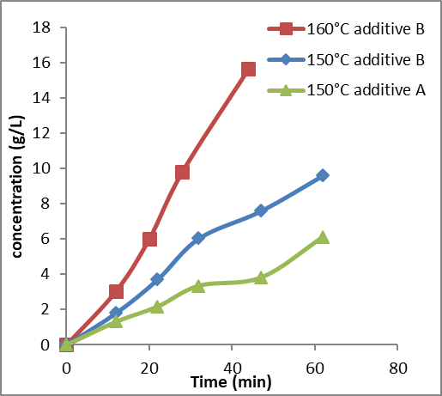
Figure 1. The enhancement of the extraction
rate by selected additive.
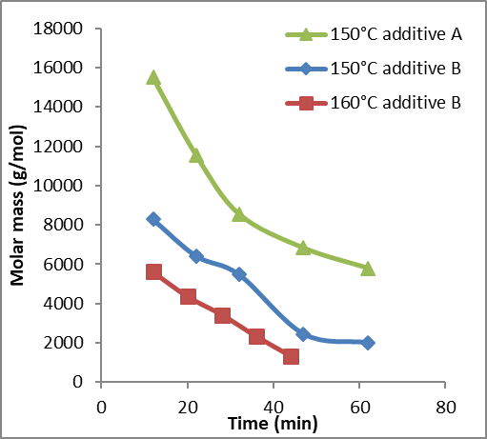
Figure 2. The influence of additive addition
to the molar mass of the macromolecules.

4. Conclusions
The current interdisciplinary research focuses on building on a newly developed extraction method for enhancing hemicelluloses extraction, which enables tuning the lignin content and properties of the LCC. The work bridges the state of the art knowledge in the safely enhanced extraction of hemicelluloses-lignin compounds and the related reaction engineering (chemical engineering) and the utilization of the LCC for alimentary purposes (alimentary chemistry). Moreover, the potential utilization is by no means limited to the alimentary industry, but fields such as cosmetics and health products are highly viable.
References [Calibri 10]
- K. S. Mikkonen, C. Xu, C. Berton-Carabin, K. Schroën, Food Hydrocolloid. 52 (2016), 615-624.
- M. Lehtonen, S. Teräslahti, C. Xu, M. Madhav, A-M. Lampi, K. Mikkonen. Food Hydrocolloids, 58, (2016), 255-266

