Efficient synthesis of chiral amino alcohol using 2-step enzyme cascades in repetitive batch mode
Kevin Mack^{1,2}*, Vanessa Erdmann¹, Dörte Rother^{1,2}
¹ IBG-1: Biotechnology, Forschungszentrum Jülich GmbH; ² Aachen Biology and Biotechnology, RWTH Aachen University
*Corresponding author: ke.mack@fz-juelich.de
Highlights
- Novel amino alcohol products from cheap bulk chemicals.
- Excellent conversions in combination with excellent ee and de values.
- Improved specific space-time yield by enzyme immobilization.
1. Introduction
Vicinal amino alcohols can be applied as active pharmaceutical ingredients and key building blocks in industrial applications. Due to their multiple chiral centers, asymmetric synthesis is challenging. Here we present a sequential 2-step enzymatic reaction (figure 1) targeting the selective synthesis of three of four stereoisomers of the building block 1-amino-1-phenylpropan-2-ol (APP).
Figure 1: Atom- and step efficient two-step reaction setup for the asymmetric synthesis of all APP isomers.
For the first cascade step, either a benzaldehyde lyase (BAL) or a benzoylformate decarboxylase (BFD) is used.^{[1,2]} This gives access to the intermediate 2-hydroxy-1-phenylpropan-1-one (HPP). The second step to APP is carried out using transaminases. The product APP was produced with excellent sereoselectivity and conversion. For further optimization, the reaction was set up with immobilized enzymes. HaloTag® and EziG™ immobilization methods were chosen and showed similar good results with improved specific space time yields (sSTY).
2. Methods
Conversion of products and intermediates were analyzed by high performance liquid chromatography and a supercritical fluid chromatography. Transaminase activity was determined in a photometer^{[3]}. HaloTag® immobilization was carried out as described ^{[4]}, the immobilization protocol on EziG™ was developed during this Project.
3. Results and discussion
For the first cascade step of the (R)-selective carboligase from Pseudomonas fluorescens (PfBAL) or a (S)-selective carboligase from Pseudomonas putida (PpBFD) is applied.^{[1,2]} This gives access to the intermediate HPP. The second step to APP is carried out with either a transaminase from Bacillus megaterium (BmTA) or Arthrobacter sp. (AsTA). The complete cascade was demonstrated in 1 mL scale and scaled up to 30 mL reaction volume. Both scales showed good conversions of 93%-98% and ee of 97%-99% as well as de of 92%-99% in all three possible cases. To cut on process cost by reusing the catalyst, three different enzyme formulations were compared to each other. The example BmTA showed that HaloTag® immobilization enabled 75% remaining activity while the free enzyme and the EziG™ immobilization had 100% activity. For optimal reaction design and to determine sSTY (free enzyme 0.12 g/(l*h)), the full 2-step reaction to (1R,2S)-APP was set up with HaloTag®^{[4]} (1.20 g/(l*h)) as well as EziG™^{[5]} (3.77 g/(l*h)) immobilized enzymes in repetitive batch mode and compared.(figure 2)
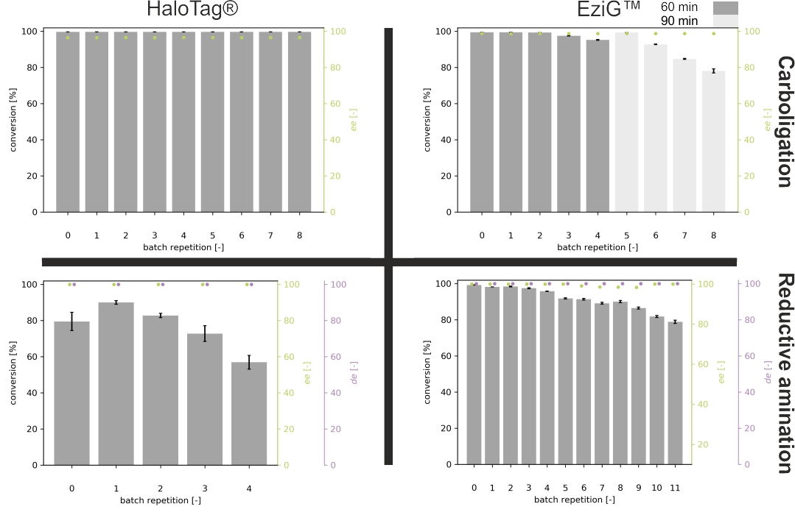
Figure 2: Repetitive batch reaction with HaloTag® and EziG™ towards (1S,2R)-APP.
60-90 min carboligation with PpBFD var. and 24-72 h Transamination with BmTA
4. Conclusions
The 2-step reaction was displayed with high conversions in combination with excellent ee as well as de values with purified enzymes. sSTY of the reaction could be improved by immobilizing and reusing the enzyme. In addition to the improved sSTY, the EziG™ carrier was tested for reusability, which could be a crucial step for an ecologic and economic reaction setup and passed the testing with very good results. The concepts presented here will be further expanded to similar products and enzymes to make complex enzymatic and chemo enzymatic cascades feasible with high sSTY in larger scales.
References
[1] Janzen, E. et al.; Bioorg. Chem. 34, 345–361 (2006).
[2] Hailes, H. C. et al.; FEBS J. 280, 6374–6394 (2013)
[3] Schätzle S. et al.; Anal Chem.; 81, 8244-8248 (2009)
[4] Döbber, J. et al.; Green Chem. 20, 544-552 (2018)
[5] Cassimhee, K. et al.; Chem. Commun. 50, 9134-9137 (2014)

