Confined liquid distribution in structured packings: Study of liquid films around a perforated topography
Manasa IYER^{1,2}, Hervé DUVAL¹, Joel CASALINHO¹, Jacopo SEIWERT², Mikael WATTIAU²
1 Laboratoire LGPM, CentraleSupélec, Université Paris-Saclay, Gif-sur-Yvette, 91190, France ;
2 Centre de Recherche Paris-Saclay, Air Liquide Research & Development, 1, chemin de la Porte des Loges, Les Loges-en-Josas - BP 126, 78354 Jouy-en-Josas, France

*Corresponding author: manasa.periyapattana@airliquide.com
Highlights
- Film thickness profile over a perforated plate.
- Characterisation of different flow regimes.
- Critical flow rate at which the fluid fills the perforation.

1. Introduction
Falling films on structured packings are extensively studied because of their increased application in the distillation and absorption industries. A class of structured packings consists in stacks of metal sheets. These sheets usually comprise of various complex geometrical intricacies such as corrugations, perforation of various shapes that play a significant role in the local fluid redistribution. The unique flow paths of the liquid and the gas phases over the structured packing, caused by their complex geometry, gives motivation to investigate the physics of the fluid distribution over these topologies. The presence of a topography perturbs the fluid free surface and in a short time, several instabilities can be observed through the deformation of the free surface. The effect of perforations and micro-texture on liquid spreading over the surface of corrugated packing was examined experimentally by Pavlenko et al. (2017). Zhao & Cerro (1992) performed an experimental work over macro and micro structures in which he characterized the mechanics of the viscous film flows by measuring film thickness profiles, streamline patterns and free-surface velocities. More recently, Xie et al. (2018) have studied the liquid flow patterns over several shaped open window at different flow rates. However, in their experiments, perforated plates are supplied with liquid only on one side whereas supply of liquid is maintained on both sides of the metal sheets in real distillation conditions.
In our experimental study, we focus on the fluid redistribution mechanism specific to these topographies in order to clearly understand its contribution towards the spreading of the liquid over a packing. We aim to measure and characterise the local deformation of the film around the topography over a perforated aluminium plate while the fluid supply is maintained on both faces of the plate. The concept of two-face supply of the fluid over such a topographical plate has not been tested before and thus brings new insights on the film behavior around the topographical surfaces.
2. Methods
The film topology and the film pattern in and around the perforation is visualized by using a high speed camera (Phantom v310). With this method, characteristic flow patterns in the perforation and preferred flow paths around the perforation are qualitatively investigated. To measure the free surface topography, Confocal Chromatic Imaging (CCI) (Kofman et al. 2014) technique is used.
3. Results and discussion
The effect of the topography is studied for various aspect ratio of the perforation (diameter d, thickness t) for a range of Reynolds number Re (2 - 63) using three different liquids (Kapitza number Ka = 3, 63, 342). For each configuration, the flow transition from the state of fluid passing around the perforation to the state of fluid filling the perforation is observed. For all configurations, we measure the critical flow rate at which the fluid fills the perforation. Regime transition occurs at a critical value of the Reynolds number (built with the critical rate) which depends on the Kapitza and Bond number (built with the perforation characteristic length).
Complete two-dimensional map of the free-surface shape of a liquid film in the vicinity of the topography is being constructed by measuring the film thickness using CCI.
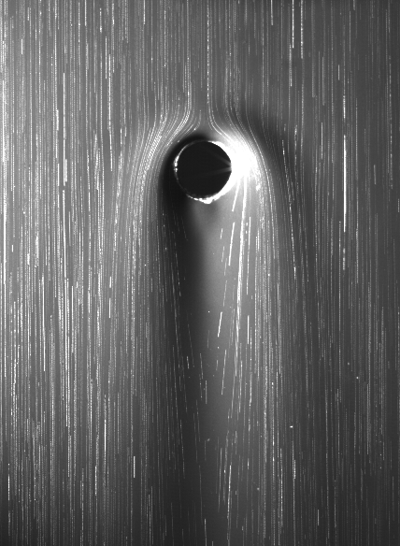
Figure 1. Superimposed image of the thin falling film over a perforated plate seeded with silver coated particles to visualise the free surface streamlines for a low Re flow (Re = 0.5) for silicone oil of ν = 100 cSt.
4. Conclusions
In the present work, flow patterns specific to the perforated topography is investigated qualitatively and quantitatively to gain better understanding of the fluid distribution in microscale flow phenomena that may occur on the structured packing. This permits us to optimise the design of structured packings and thereby it could reduce the pressure drop in the column and thus the energy consumption.
References
- H. Xie, J. Hu, C.Wang, and G. Dai. Liquid flow transition and confined free film formation on a vertical plate with an open window. Experimental Thermal and Fluid Science, 92:174–183, 2018.
- A. N. Pavlenko, O. A. Volodin, and A. S. Surtaev. Hydrodynamics in falling liquid films on surfaces with complex geometry. Applied Thermal Engineering, 114:1265–1274, 2017.
- L. Zhao and R. Cerro. Experimental characterization of viscous film flows over complex surfaces. International journal of multiphase flow, 18(4):495–516, 1992.
- N. Kofman, S. Mergui, and C. Ruyer-Quil. Three-dimensional instabilities of quasi-solitary waves in a falling liquid film.Journal of Fluid Mechanics, 757:854–887, 2014.

