Synthesis and Modification of Water-Stable CPL-2 MOF for Ethylene/Ethane Separation.

Huan Xiang¹, Yilai Jiao², Flor R. Sinperstein^{1,*}, Xiaolei Fan^{1,*}
1 School of Chemical Engineering and Analytical Science, The University of Manchester, Manchester M13 9PL, United Kingdom; 2 Shenyang National Laboratory for Materials Science, Institute of Metal Research, Chinese Academy of Sciences, 72 Wenhua Road, Shenyang 110016, China

*Corresponding authors: Flor.Siperstein@manchester.ac.uk; xiaolei.fan@manchester.ac.uk

Highlights
- CPL-2 MOF exhibits preferential adsorption of ethylene over ethane.
- CPL-2 MOF is relatively hydrophobic and shows excellent water stability under humid conditions.
- Ethylene/ethane adsorption selectivity was enhanced six-fold by silver ions modification.

1. Introduction
Adsorptive separation of ethylene/ethane mixture has growing interest in petrochemical industries compared to the conventional energy-intensive cryogenic distillation.[1] Metal-organic frameworks (MOFs) have attracted considerable attention in gas adsorption and separation due to their combined properties of large surface area, functionalised and adjustable pore structure and surface.[2] However, the open metal sites in MOFs interact strongly with water molecules, resulting in material decomposition and poor water stability,[3] limiting their potential in practical settings. Therefore, development of water-stable materials with high selectivity is of great importance to accomplish the ethylene/ethane separation.
In this work, pillared-layer CPL-2 MOF was selected as the model MOF and synthesised at room temperature for separating binary ethylene/ethane mixture. The water stability of CPL-2 was evaluated under dynamic humid conditions. Ag(I) ions modification of CPL-2 was also conducted to explore the possibility of improving the selectivity of CPL MOFs in ethylene/ethane separation.
2. Methods
Hydrothermal synthesis was used to prepare CPL-2. Silver ions modified CPL-2 MOFs (denoted as Ag/CPL-2) were prepared using the incipient wetness impregnation method. Dynamic water vapour adsorption analyses at 25 °C and 50 °C with relative humidity values ranging from 0% to 90% (10% per step) were measured using a dynamic vapour sorption (DVS 1) equipment. Prior to the water vapour adsorption, all samples were dried at 0% relative humidity for 3 h. Intelligent gravimetric analyser (IGA-001) based on the static gravimetric technique was applied to determine ethylene and ethane adsorption isotherms on developed CPL-2 and Ag/CPL-2 materials at a constant temperature of 25 °C, 35 °C and 50 °C, respectively. The adsorption selectivity was calculated as a ratio of Henry’s constants.
3. Results and discussion
CPL-2 can be easily synthesised at room temperature, which was confirmed by XRD and SEM analysis. Characteristic peaks at 2θ = 6.4°, 8.8°, 10.3° and 12.6°, matching the simulated results, were identified in all the synthesised CPL-2 MOFs, confirming the presence of the pillared-layer structure in the crystalline domain. All SEM images show squared slab-shaped crystals aggregated together with sizes ranging from 0.2 μm to 2.5 μm. The synthesised CPL-2 has excellent water stability confirmed by the dynamic water vapour adsorption analysis under 90% relative humidity, showing no significant framework decomposition, even at 50 °C. The calculated selectivity based on gravimetric single-component gas adsorption experiments shows the significantly improved C₂H₄/C₂H₆ selectivity from 1.2 to 6.6 after loading 10% (theoretical) of sliver ions on CPL-2.
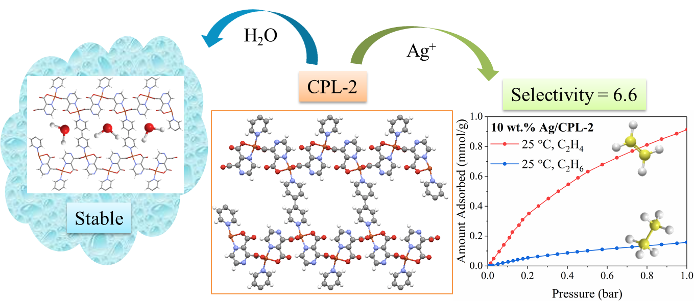
Figure 1. Schematic presentation of CPL-2 framework and its water stability and adsorption performance in C₂H₄/C₂H₆ separation.
4. Conclusions
The synthesis of CPL-2 is facile with fast crystallization, i.e. 3 h is sufficient to prepare CPL-2 MOF at room temperature. CPL-2 demonstrated the outstanding water stability under dynamic humid conditions at 25 °C and 50 °C, showing the reversible water vapour adsorption under the conditions used. Gas adsorption study shows that 10 wt.% Ag/CPL-2 by Ag(I) impregnation gave the best adsorption performance considering both capacity and selectivity towards C₂H₄ over C₂H₆. The good selectivity combined with the water stability makes it promising and potentially feasible to use CPL-2 in the separation of ethylene/ethane mixtures, especially under conditions where water vapour exists.
References
[1] L. Li, R.B. Lin, R. Krishna, H. Li, S. Xiang, H. Wu, J. Li, W. Zhou, B. Chen, Ethane/ethylene separation in a metal-organic framework with iron-peroxo sites, Science 362 (2018) 443-446.
[2] Y. He, W. Zhou, R. Krishna, B. Chen, Microporous metal-organic frameworks for storage and separation of small hydrocarbons, Chem. Commun. 48 (2012) 11813-11831.
[3] N. Al-Janabi, P. Hill, L. Torrente-Murciano, A. Garforth, P. Gorgojo, F. Siperstein, X. Fan, Mapping the Cu-BTC metal-organic framework (HKUST-1) stability envelope in the presence of water vapour for CO2 adsorption from flue gases, Chem. Eng. J. 281 (2015) 669-677.

