Energy-efficient Operation of a Multi-unit Recovery Cycle in
EU’s largest Viscose Fiber Plant.
José Luis Pitarch¹, Christian Jasch², Marc Kalliski³, Yannik-Noel Misz³, María P. Marcos^{1,4}, César de Prada^{1,4}, Gerhard Seyfriedsberger², Sebastian Engell³
1 Systems Engineering and Automatic Control department, Universidad de Valladolid. C/Real de Burgos S/N, 47011, Valladolid, Spain; 2 Lenzing AG. Werkstraße 2, 4860, Lenzing, Austria; 3 Department of Biochemical and Chemical Engineering, Technische Universität Dortmund, Emil-Figge-Str. 70, 44221, Dortmund, Germany; 4 Institute of Sustainable Processes, Universidad de Valladolid. C/Real de Burgos S/N, 47011, Valladolid, Spain.
*Corresponding author: jose.pitarch@autom.uva.es
Highlights
- Improved control and real-time process optimization leads to substantial savings.
- Monitoring and modelling the performance degradation in equipment is key.
- Integrating control, optimization and maintenance scheduling is the future path.
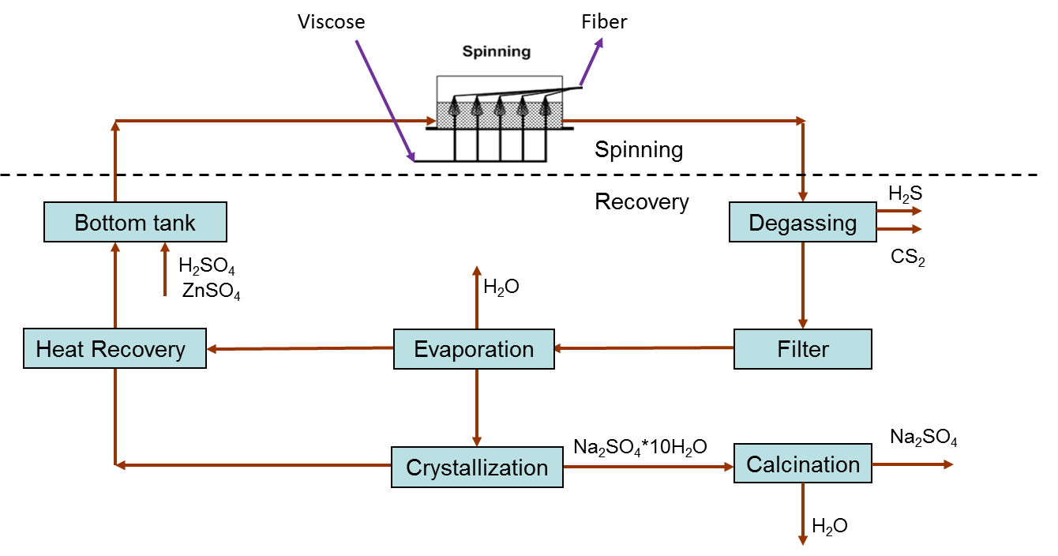
1. Introduction
Figure 1. Spinbath recovery cycle.
Lenzing AG in Austria is the world’s largest viscose fiber production plant. Lenzing’s fibers are made from wood: They are botanic products derived from renewable sources and processed with resource conserving technologies. The production of these high-quality viscose fibers is a multi-step chemical technological process. The key role in terms of resource efficiency within the viscose-fiber production belongs to the spinbath recovery cycle. The recovery cycle itself (see Figure 1) is a sequence of basic operations carried out in several multi-unit networks. Due to its high-energy demand, the LENZING use case within the SPIRE project CoPro is particularly focused on the evaporation stage and the heat-recovery network.
2. Challenges
The first challenge concerns with the evaporation stage, where about 30 plants of different capacities and performances need to be allocated to recover the spinbath of around 10 lines of fibers production. Furthermore, in addition to fulfill continuous production demands, operational constraints such as possibility of physical connection or plants temporal availability need to be enforced. And, of course, this load allocation from spinbaths to plants needs to be done in the most energy-efficient way, i.e. with minimum specific-steam consumption (SSC).
Additionally to the above allocation problem, the evaporation plants suffer from performance degradation due to fouling inside the heat exchangers. Various cleaning operations can be chosen to get rid of the fouling effects, but the personnel for maintenance is limited, so only a single plant can be cleaned per day. Hence, a feasible (must) and optimal (desired) scheduling of the maintenance operations over time is to be found. However, this is not independent from load allocation, and it is also affected by uncertainty in future predictions of production demands and weather. Therefore, an integral real-time scheduling optimization is a desirable outcome of the CoPro project.
Some of the plants are equipped with surface condensers as cooling systems. These condensers are fed with river water and the issue is: the more water is directed to the condensers, the more efficient the plants are. However, water is shared in a network with other parts of the factory, and its usage is subject to environmental regulation. Thus, an additional problem is to find the optimal water distribution to the evaporation network. But, this task is coupled with the plants allocation, as varying performance of the cooling systems may enable different decisions in the load allocation. Therefore, a tradeoff between plants efficiency and water usage is to be set up for optimization.
3. Results so far and outlook
In order to address the above challenges, a physics-based grey-box model for an evaporator was initially built to find the optimal control policy (lowest SSC) and to study the fouling effects [1]. Then, based on this work, simplified surrogate models for each plant operating with the new control were built. These models (updated periodically) serve in a mixed-integer quadratic optimization which suggests the best plant allocation to spinbaths in near-real time [2]. Savings of around 250 k€/year (1.8% more efficient operation) were gathered with the new decision support system (DSS).
In parallel to this, models to predict the performance loss over time due to fouling were identified from experimental tests so that, by balancing the operation and cleaning costs, nonlinear optimization problems predict the best future day for cleaning in each plant, as well as the optimal cleaning task [1],[2]. Preliminary tests onsite with 5 plants show a potential benefit of 25 k€/year. The implementation to the whole evaporation network and heat-recovery one as well is ongoing.
Regression models for the surface condensers have been also identified from experiments, measuring the SSC variations at different water flows and temperatures. With these, a nonlinear optimization suggests the best water distribution to plants by balancing the savings in SSC with the water costs (subject to usage constraints) [3]. This setup can be integrated with the load-allocation optimization in a centralized fashion, and solved in near-real time using BONMIN. Tests in simulation show additional savings about 200 k€/year, but these may be too optimistic, as the effects of limiting the water usage in other parts of the factory is not considered yet in the optimization.
Finally, the integration of the plants load allocation and maintenance scheduling is already set up and tested in simulation with reasonable computational demands [4]. However, including uncertainty via scenarios in a two-stage optimization approach increases considerably the problem complexity (hence, resolution time) so alternatives for problem decomposition are under study.
References
- J.L. Pitarch, C.G. Palacín, C. De Prada, B. Voglauer, G. Seyfriedsberger. Optimisation of the resource efficiency in an industrial evaporation system. Journal of Process Control, 56, 2017, pp. 1–12.
- M. Kalliski, J.L. Pitarch, C. Jasch, C. de Prada. Support to Decision-Making in a Network of Industrial Evaporators. Revista Iberoamericana de Automática e Informática Industrial, 16(1), 2019, pp. 26-35.
- M.P. Marcos, J.L. Pitarch, C. de Prada, C. Jasch. Modelling and real-time optimisation of an industrial cooling-water network. 22nd Inter. Conf. on System Theory, Control and Computing, 2018, pp. 591-596.
- C.G. Palacín, J.L. Pitarch, C. Jasch, C.A. Méndez, C. de Prada. Robust Integrated Production-Maintenance Scheduling for an Evaporation Network. Computers & Chemical Engineering, 110, 2018, pp. 140-151.

