Continuous scalable synthesis of reactive intermediates: Grignard Reagents and Grignard Reaction
M. G. Menges-Flanagan*, E. Deitmann, L. Gössl, C. Hofmann, P. Löb
Fraunhofer Institute for Microengineering and Microsystems IMM, Carl-Zeiss-Str. 18-20, 55129 Mainz, Germany
*Corresponding author: Gabriele.menges-flanagan@imm.fraunhofer.de
Highlights
- Continuous synthesis of industrially relevant Grignard reagents.
- Grignard reaction immediately following the reactive intermediate synthesis.
- Scalable processes allowing throughputs of tens of liters per hour.
- Improved product quality and flexible production to improve time-to-market.

1. Introduction
For over 100 years, Grignard reagents (RMgX) and their either simultaneous (Barbier reaction) or subsequent reaction (Grignard reaction) with other halides, aldehydes, ketones, etc. have been a most useful tool for process chemists seeking to form new C-C bonds.¹ However, drawbacks such as variable incubation periods for their initial formation, high exothermicity requiring effective heat management, as well as side reactions such as Wurtz coupling pose challenges to be overcome when aiming at large scale industrial production of such compounds. Here, continuous processing will benefit the Grignard reagent formation and Grignard reaction through improved heat management and the continuous provision of a large Mg excess with the aim to significantly suppress unwanted side product formation.
2. Methods
All solvents and reagents were purchased from commercial suppliers and were used without further purification. The set-up consists of Postnova syringe pumps while tempering of the reactors is achieved by the use of thermostatic baths. Progress of the reactions could be followed by recording the temperatures within the reactors. The family of reactors used for the continuous Grignard reagent formation spanning a wide range of accessible flow rates is given in Figure 1. Titration of the Grignard reagent was done following the method of Lin and Paquette² or Krasovskiy and Knochel³.
3. Results and discussion
Initially, a laboratory scale reactor was established by 3D laser melting and tested for the continuous synthesis of a number of common Grignard reagents via processing of solid/liquid mixtures. In contrast to conventional processing of Grignard reagents, in this case a large excess of Mg within the reactor with integrated mechanical Mg activation, was used to suppress unwanted side reactions and allow for full halide conversion within one passage through the reactor with residence times on the order of 3-30 minutes depending on concentration and reactivity. A broad applicability of this approach was established by synthesizing multiple alkyl and aryl Grignard reagents at varying concentrations in qualities comparable to commercially available products. Additionally, a number of Grignard reactions were also performed on the laboratory scale using freshly prepared Grignard reagents omitting the need for storage of these rather reactive intermediates. Lastly, results will be presented on scale-up efforts undertaken to build a larger scale pilot reactor set-up allowing for halide throughputs of up to 20l/h as well as again including an immediate second step (Grignard reaction) after online detection of Grignard reagent quality formed.
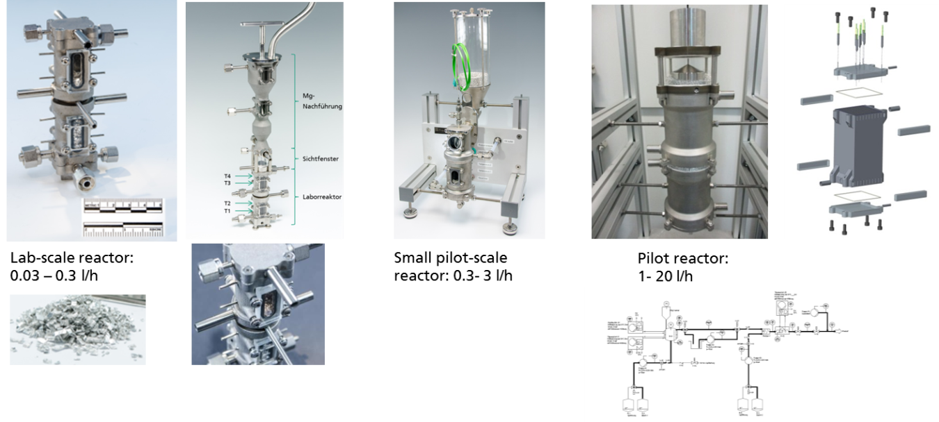
Figure 1. Family of scalable 3D laser sintered reactors for Grignard reagent formation and Grignard reaction.
4. Conclusions
In conclusion, a continuously operating laboratory set-up for Grignard reagent formation manufactured via 3D laser melting was established and tested in the optimization of process parameters for scalable continuous Grignard reagent formation. It was aimed at full halide conversion within a single reactor passage with the goal of achieving maximum throughput with minimal energy input (heating/cooling). After Grignard reagent formation was established continuously, it was immediately followed by Grignard reactions consuming the reactive intermediate omitting the need to store this reagent over prolonged time periods. Finally, efforts are underway to scale-up the two steps to pilot-scale throughputs to halide solution flow rates of up to 10-20l/h.
References
- V. Grignard, in CR Hebd. Séances Acad. Sci., Ser. C. 130, 1900, pp 1322–1324.
- H.-S. Lin, L. A. Paquette, Synth. Commun. 1994, 24(17), 2503-2506.
- A. Krasovskiy, P. Knochel, Synthesis 2006, 5, 890-891.York, 2009, pp. 181–304.

