**Elucidation of micropollutants biodegradation mechanisms in tertiary MBBR treatment.**

S. Mehran Abtahi Fa, Salma Oualia Claire Joannis Cassana, Sandra Beauforta, Agathe Juppeau Flambarda , Sophie Pecastainga, Thierry Trotouinb, Fanny Terrissec, Jonathan Gerborec, Claire Albasia

*a Laboratoire de Génie Chimique, Université de Toulouse, CNRS, INPT, UPS, Toulouse, France.*

*b Veolia, Centre régional Toulouse Pyrénées, 22 avenue Marcel Dassault, 31506 Toulouse, France.*

*c Biovitis S.A., Le Bourg, 15400 Saint-Étienne-de-Chomeil, France.*

*\*Corresponding author: claire.albasi@ensiacet.fr*

**Highlights**

* The potential of tertiary MBBRs was investigated in terms of MPs removal.
* MPs biodegradation by the biofilm was higher than by the suspended biomass.
* The profile of the microbial abundance reveals acclimation of the biofilm biomass.

**1. Introduction**

Nowadays, the scientific community is faced with the newly-born challenge of micropollutants (MPs) in aquatic resources. Since effluents of wastewater treatment plants have been globally recognized as the main source of these compounds in the aquatic environment, additional steps during wastewater treatment are one of the best options to reduce the release of these compounds into surface waters. To date, identification of technically and economically feasible advanced wastewater treatment options for elimination of MPs from secondary-treated effluent like adsorption processes, advanced oxidation processes and membrane filtrations is gaining importance. Regardless of these options that are recognized costly and laborious, there has been lower attention to innovative and cost-effective moving bed biofilm reactors (MBBRs) so far. High sludge retention time (SRT) obtaining in low hydraulic retention time (HRT) has given a dazzling attitude to MBBR reactors for high-efficient removal of carbon, nutrients and recently MPs. In the present work, we provide further insights into the key parameters involved in the removal of four MPs from secondary-treated municipal wastewater using a pilot-scale MBBR reactor. The biodegradation mechanisms were pointed out as the main removal pathways and the structural behavior of the microbial abundance was followed over the time.

**2. Methods**

Four identical lab-scale glass MBBR reactors, each with an effective volume of 3.1 L, were operated in a parallel mode under the ambient temperature, fed by a synthetic effluent after seeding with activated sludge. While two of them were used as references, the both others were fed with the MPs (17ß-Estradiol, Diclofenac, Naproxen, et 4n-Nonylphenol). Biofilm development on the surface of Z-MBBR carriers was monitored by microscopic observation (Epifluorescence and SEM).

Samples for MPs measurements were shipped to an indipendant laboratory named La Drome, located in France – to be analyzed under the license of COFRAC by LC-MS-MS measurements). Meanwhile, the biomass profile were characterized by means of DNA extraction and qPCR analysis through the large groups of the microbial [1].

**3. Results and discussion**

After stepwise establishment of a mature biofilm, abiotic and biotic removals of MPs were studied. Since no MPs reduction was observed by the both photodegradation and volatilization, abiotic removal of MPs was ascribed to the sorption onto the biomass. Target MPs i.e. Naproxen, Diclofenac, 17ß-Estradiol and 4n-Nonylphenol, arranged in the ascending order of hydrophobicity, abiotically declined up to 2.8%, 4%, 9.5% and 15%, respectively. MPs absorption onto the suspended biomass was found around two times more than the biofilm. When comparing abiotic and biotic aspects, we found that biotic removal outperformed its counterpart for all compounds as Diclofenac, Naproxen, 17ß-Estradiol and 4n-Nonylphenol were biodegraded by 72.8, 80.6, 84.7 and 84.4%, respectively. The effect of the changes in organic loading rates (OLRs) was investigated on the pseudo-first order degradation constants (kbiol), revealing the dominant biodegradation mechanism of co-metabolism for the removal of Diclofenac, Naproxen, and 4n-Nonylphenol., while 17ß-Estradiol obeyed the biodegradation mechanism of competitive inhibition. As summarized in figure 1, biotic removals of all MPs were quantified higher in the biofilm compared to the suspended biomass. [1]

The specific monitoring of the microbial community (figure 2) by molecular biology tools allowed us to understand the key role of some microorganisms in the degradation of targeted MPs, to identify those suitable and potentially involved in this degradation. A major presence of *Actinobacteria* was pointed out.



**Figure 1.** Contribution of micropollutants removal mechanisms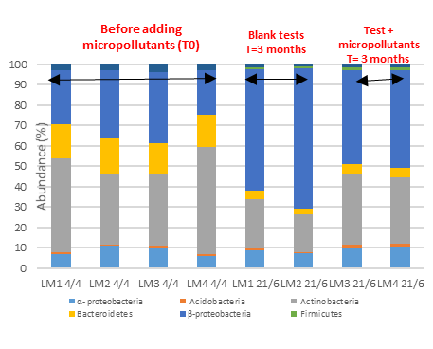**Figure 2** Microbial abundance in the mixed liquor – large groups (same type of data available for biofilm)

**4. Conclusions**

To draw a conclusion, a quite high removal of recalcitrant MPs is achievable in tertiary MBBRs, thanks to a biomass acclimation with microbial community selection, making them a promising technology that supports both pathways of co-metabolism and competitive inhibition.

**References**

**[1] Stadler et al, 2017**. Microbial Biotechnology, 11, 995–1007

[2] **Abtahi, S.M., et al 2018**. Sci. Total Environ. 643, 1464–1480.