Sonochemical Synthesis of Dolomite (CaMg(CO₃)₂) for Utilize Seawater Resources and Application for Phosphor Material
Shinnosuke Kamei¹, Masakazu Matsumoto², Shigeki Furukawa¹
1 Department of Sustainable Engineering, College of Industrial Technology, Nihon University, Chiba, Japan 275-8575; 2 Department of Liberal Arts and Basic Sciences, College of Industrial Technology, Nihon University, Chiba, Japan 275-8575
*kamei.shinnosuke@nihon-u.ac.jp
Highlights
- A new synthetic approach of dolomite (CaMg(CO₃)₂) with ultra-sound irradiation by a liquid phase reaction was found.
- The average particle diameter was 470 nm.
- From energy dispersive X-ray spectrometry, dolomite of the high purity (Ca/Mg atomic ratio of 1.08) was successfully synthesized with the ultrasonic irradiation.
- Red-emitting Eu³⁺ doped dolomite phosphor and green-emitting Ce³⁺-Tb³⁺ codoped dolomite phosphor were successfully synthesized by immersion treatment.

1. Introduction
Recently, ultrasonic irradiation assisted synthesis of inorganic materials has been actively conducted. On the other hand, synthesis of alkaline earth metal carbonate from the components dissolved in seawater is expected We focused on dolomite (CaMg(CO₃)₂). Dolomite is a double salt in which calcium carbonate (CaCO₃) and magnesium carbonate (MgCO₃) are regularly combined at a molar ratio of 1:1. By using ultrasonic irradiation, it is advantageous that the particle diameter obtained becomes nano-sized. Therefore, the synthesis of nanomaterial from seawater becomes possible. We introduce a new synthetic approach to obtain dolomite and report the synthesis of dolomite phosphor as an application material.
2. Methods
The preparation of CaMg(CO₃)₂ nano-powder was used CaCl₂, MgCl₂, NaHCO₃ and Na₂CO₃ powders as starting materials. Mixing of suspension was carried out by the mechanical stirring and the ultrasonic irradiation. With stirring and the ultrasonic irradiation (20kHz, 40W, 3-6mm horn diameter) reaction was maintained at 65°C for 1 hour. After reaction, the resulting suspension was filtered, washed with pure water, and dried at 40°C. Similarly, the same treatment was carried out using de-K ion bittern. The synthesis of dolomite phosphors used immersion method. The product was immersed in europium chloride solutions of 0.05～0.20 mol･dm⁻³ at room temperature, for 1 hours, with suspension concentration 1 mass%. Eu³⁺ doped dolomite phosphors were thus obtained. Using the same method, Ce³⁺-Tb³⁺ codoped dolomite phosphors were obtained. Each sample was characterized by X-ray diffraction, scanning electron microscopy and Energy dispersive X-ray spectrometry. The fluorescence properties of the sample were measured using a spectrophotometer.
3. Results and discussion
Figure 1 shows the XRD patterns of the sample prepared with sonochemistry reaction. The diffraction patterns of the prepared samples showed good agreement with the powder patterns of dolomite and the single phase of dolomite was confirmed. In the case of using de-K ion bittern, the synthesis of dolomite was possible by controlling Ca concentration in de-K ion bittern. Figure 2 shows SEM image the sample prepared with sonochemistry reaction. The average particle diameter was 470 nm. Nano-sized particles are prepared easily made by sonochemistry reaction method. Moreover, from energy dispersive X-ray spectrometry, The Ca/Mg atomic ratio was 1.08. It was shown that dolomite of high purity can be easily synthesized. On fluorescence property of Eu³⁺ doped dolomite phosphor, the emission band was observed at 614 nm which is attributed to the ⁵D₀-⁷F₁ transition of Eu³⁺ under excitation at 254 nm. In the case of Ce³⁺-Tb³⁺ codoped dolomite phosphor, the emission band was observed at 544 nm which is attributed to the ⁵D₄-⁷F₅ transition of Tb³⁺ under excitation at 254 nm. It was possible to make the prepared dolomite samples into phosphor materials.
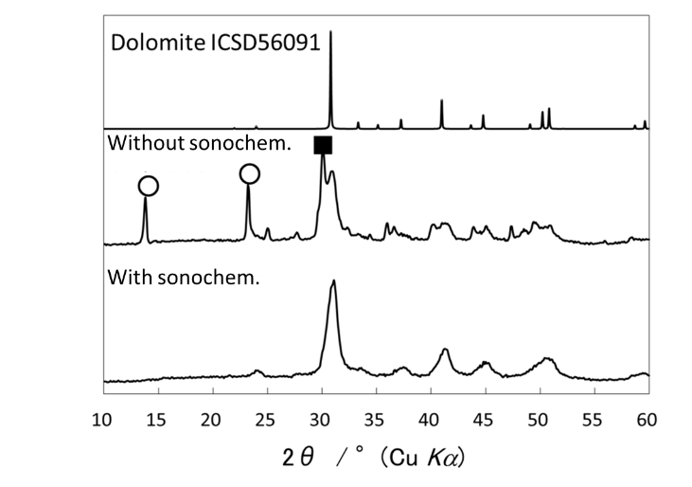
Figure 1. XRD patterns of the sample prepared with sonochemistry reaction.
○: Magnesium carbonate trihydrate
■: Base-magnesium carbonate
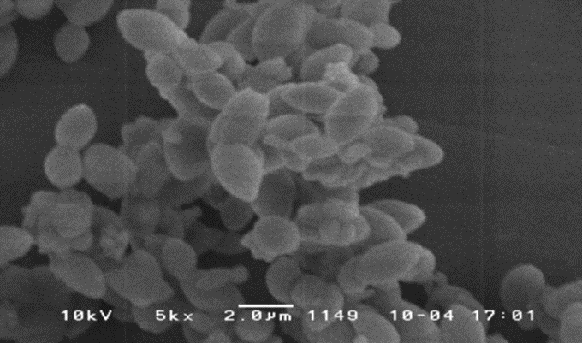
Figure 2. SEM image of the sample prepared with sonochemistry reaction.

4. Conclusions
We found a new synthesis of dolomite with ultrasonic irradiation under simple aqueous solution. Dolomite could be synthesized even using de-K ion bittern that is one of concentrated seawater. By immersion treatment, it was possible to synthesize dolomite phosphors showing the red or the green emission.
Reference
- S. Kamei, M. Matsumoto, S. Furukawa, The 7th Asian Particle Technology Symposium (APT 2017), Nanotechnology, PJ-8 (2017).

