Scalable production of silicate glass flakes via compression in the liquid phase
Julian Esper¹, Alexander Strobel^{1,2}, Stefan Romeis¹, Wolfgang Peukert^{1,2*}
¹Institute of Particle Technology, Friedrich-Alexander Universität Erlangen-Nürnberg; ² Interdisciplinary Center for Functional Particle Systems (FPS), Friedrich-Alexander Universität Erlangen-Nürnberg
*Corresponding author: wolfgang.peukert@fau.de
Highlights
- Production of silica-based glass flakes in the liquid phase
- Characterization of process parameter influence on Feret diameter and flake thickness
- Influence of glass composition on brittle-ductile transition particle size

1. Introduction
Comminution is a frequently applied, scalable and versatile unit operation of chemical process engineering and particle technology [1-3]. Comminution processes are applied for a wide range of materials including minerals, ceramics, foods, drugs and waste. The acting stressing mechanisms are usually divided into one-sided impact or two-sided compression. In stirred media mills, particle stressing and size reduction takes place between colliding grinding beads, i.e. by compression. In general, comminution processes can be described by the ‘process function’ and the ‘material function’ [4-6]. The ‘process function’ links process parameters such as grinding bead size or stirrer tip speed to the actual stressing conditions in the mill. The ‘material function’ describes the reaction of a material to the stressing conditions. Clearly, both functions are widely distributed, are so far often unknown but can be determined by recent progress based on stressing of mechanically well-characterized model particles [4-6]. Typically irregular shaped particles with a rather wide size distribution are obtained from comminution. Whereas crystalline materials have been extensively studied there is only a very limited amount of information on wet comminution of amorphous materials with complex chemical composition. In this study, we characterize the stressing behavior and deformation of silica-based glasses with different chemical compositions in a stirred media mill and analyze characteristic dimensional parameters via SEM image analysis.
2. Methods
Commercially available soda lime glass (Carl Roth, Germany) and borosilicate glass (Schott, Germany) were used for all experiments. The as-received bulk materials were pre-crushed with pestle and mortar and classified to a size ≤ 250 µm prior to wet grinding. All wet grinding experiments were conducted in a stirred media mill PE075 (Netzsch, Germany). The grinding parameters were varied in terms of stirring speed and process time as well as grinding bead size to determine the possible influence of the process parameters on the final product particle size. All shape-anisotropic particles were characterized in means of the Feret diameter and average flake thickness via SEM image analysis. Furthermore, true powder density and mass-specific surface area were determined via helium pycnometry and nitrogen adsorption measurements, respectively. These results were used to determine the Sauter diameter and the theoretical Feret diameter for comparison with experimental values from single particle micromanipulation experiments.
3. Results and discussion
All experiments show that the process can be divided into two distinct steps. The first step comprises the size reduction where irregularly shaped feed particles are crushed in between agitated milling beads until a certain particle size, also known as the brittle-to-ductile transition particle size, is reached. In the second step, the compression and deformation of the glass particles takes place without further fracture. The main size reduction can be observed during the first processing hour whereas plastic deformation is the predominant mechanism afterwards. This can be seen in Fig. 1 where the average flake thickness is shown for different stirring speeds and processing times. The average transferred energy E₅₀ per collision determined according to Strobel et al. was 0.48 µJ (v_{tip} 4.87 m s⁻¹) which indicates that the energy transferred in one collision is sufficient to plastically deform a glass fragment into a plate-like particle [5]. The stirrer tip speed seems to exhibit only a minor influence on the average lateral dimensions of the flakes. However, it shows a significant influence on the average flake thickness. The average flake thickness decreases with longer processing times and converges at around 185 nm.
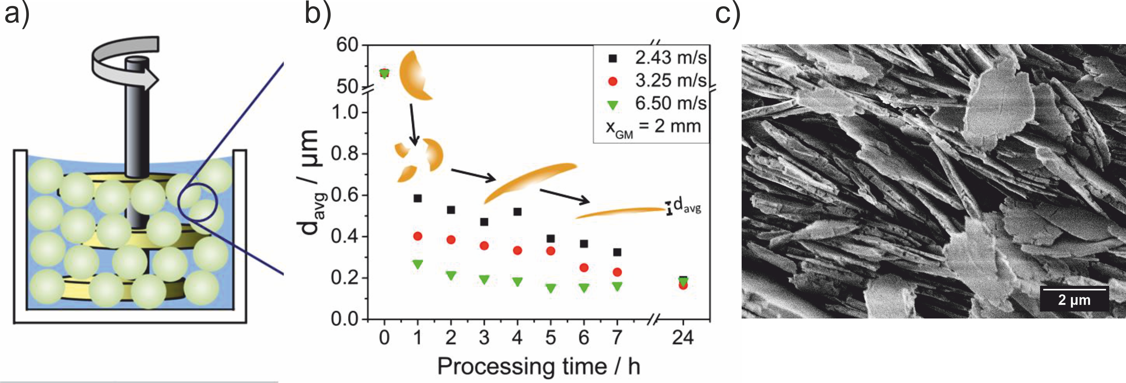
Figure 1. (a) Schematic of a stirred media mill and (b) flake thickness evolution of soda lime glass flakes for different process times and stirring speeds and (c) SEM side view of obtained glass flakes.
4. Conclusions
A facile and fully scalable method to produce amorphous silica-based glass flakes w presented. The influence and effects of stirring speed, process time and bead size is systematically examined and depicted. Our experiments show, that size reduction occurs only during the first hour of grinding while a plastic deformation of the glass fragments is the predominant mechanism in the following hours of process time. These remarkable results are unique because wet grinding is used here as a novel method for well-controlled particle shape formation. The Feret diameter and thickness distributions for all glasses as determined via SEM image analysis and the corresponding size distributions are found to be quite narrow.
References
- A. Kwade, Powder Technology 105 (1999) 14-20.
- F. Müller, R. F. Polke, Powder Technology 105 (1999) 2-13.
- O. Orumwense, E. Forssberg, Min. Processing and Extractive Metallurgy Review 11 (1992) 107-127.
- W. Peukert, Adv. In Chem. Eng. 46 (2015) 1-81.
- A. Strobel, W. Peukert, Chem. Eng. Res. & Design (2018) 859-869.
- A. Strobel, W. Peukert, Powder Technology 305 (2017) 652-661.

