The Experiment and Simulation Analysis of the Effect Of CO₂ and Steam On Syngas Composition of Natural Gas Non-Catalyst Partial Oxidation.
Zhenghua Dai*, Guangsuo Yu, Haifeng Lu
Key Laboratory of Coal Gasification and Energy Chemical Engineering of Ministry of Education, East China University of Science and Technology, Shanghai 200237, China
*Corresponding author: chinadai@ecust.edu.cn
Highlights
- The syngas composition of non-catalyst partial oxidation should be adjusted to satisfy the request of different chemical synthesis.
- CO₂ has bigger adjustment range of H₂/CO ratio than that of steam.
- The multi-reforming by CO₂ or Steam addition is feasible.

1. Introduction
Non-catalyst partial oxidation technology has been widely used to produce syngas by reforming of hydrocarbon, including gas (natural gas, shale gas, refinery gas, coalbed gas, coke oven gas, pyrolysis gas, etc.) and liquid (residual oil, asphalt, deoiled asphalt, biomass oil, etc.). For natural gas non-catalyst partial oxidation, the H₂/CO of syngas is about 1.8, which is agreed well with the request of FT synthesis. But for other process, such as carbonylation and glycol, the H₂/CO should be close to 1 and 2 respectively. So the syngas composition of non-catalyst partial oxidation should be adjusted to satisfy the request of different chemical synthesis. That means a multi-reforming method by CO₂ or Steam addition.
2. Methods
The experimental platform for the non-catalyst partial oxidation of natural gas is shown in Fig.1.
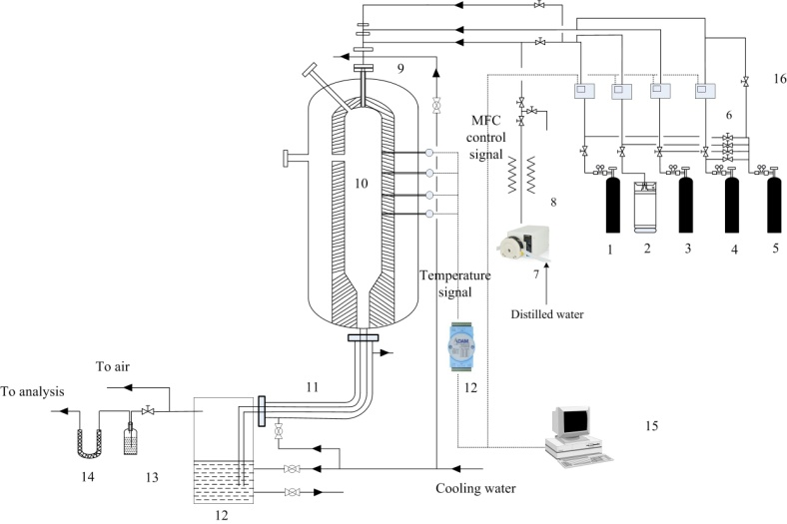
Fig. 1 Diagram of natural gas non-catalyst partial oxidation hot-model experiment platform
The reactor network model of the reformer is shown in Fig. 2.The reactions in the reformer are described by GRI-3.0.
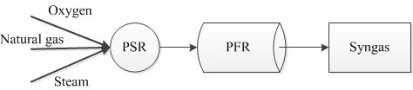
Fig.2 Schematic diagram of reactor network (PSR: 12.758m³; PFR: Length=7.08m, Diameter=1.8m)
3. Results and discussion
(a) CO2 (b) Steam
Fig. 3 Effects of CO2 and Steam addition on the syngas compositions
The experiment results of the Effects of CO₂ and Steam addition on the syngas compositions are shown in Fig.3. For the case of the O₂/CH₄=0.95, the H₂/CO is decreased from 1.5 to 1.24 when the CO₂/CH₄ is increased from 0 to 0.16; However, the H₂/CO ratio is increased slightly from 1.62 to 1.65 When the H₂O/CH₄ ratio is increased from 0 to 0.24.
Table 1 shows the feasibility analysis results of multi-reforming. The greater of required adjustment of H₂/CO ratio, the addition amount of Steam or CO₂ into the reformer is greater. Correspondingly, the oxygen and natural gas consumption per unit effective gas is slightly increased.
Table1 The multi-reforming analysis
 | 1 | 2 | 3 | 4 | 5
O₂/NG(v/v) | 0.775 | 0.690 | 0.657 | 0.675 | 0.720
Steam(CO₂)/NG (v/v) | 1.80(H2O) | 0.48(H2O) | 0.107(H2O) | 0.15(CO₂) | 0.52(CO₂)
H₂(v%) | 63.02 | 63.16 | 62.83 | 57.45 | 45.13
CO(v%) | 25.15 | 31.65 | 33.87 | 38.35 | 44.60
CH(v%) | 0.62 | 0.60 | 0.76 | 0.61 | 0.64
H₂/CO | 2.51 | 2.00 | 1.86 | 1.50 | 1.01
T，K | 1522 | 1562 | 1578 | 1570 | 1533
Oxygen Nm³/kNm³(CO+H₂) | 317 | 262 | 247 | 255 | 283
Natural gas Nm³/kNm³(CO+H₂) | 409 | 379 | 376 | 378 | 392
4. Conclusions
CO₂ has bigger adjustment range of H₂/CO than that of steam. This paper presents the feasibility of multi-reforming on the natural gas non-catalyst partial oxidation by CO₂ or H₂O addition.

