Green Solvent Selection and Early Stage Process Design for the Homogeneously Catalyzed Reductive Amination of Long-chain Aldehydes
Steffen Linke^{1,}*, Kevin McBride², Karsten Hans Georg Rätze¹ Kai Sundmacher^{1,2}
1 Otto-von-Guericke University Magdeburg, Chair for Process Systems Engineering, Universitätsplatz 2, 39106 Magdeburg, Germany; 2 Max Planck Institute for Dynamics of Complex Technical Systems, Process Systems Engineering, Sandtorstraße 1, 39106 Magdeburg, Germany
*Corresponding author: linke@mpi-magdeburg.mpg.de
Highlights
- Integrated computer-aided solvent selection and process design.
- Performance evaluation in terms of thermodynamic and environmental criteria.
- Application of the methodology to a challenging, complex reaction.

1. Introduction
One of the major challenges facing chemical engineering today is the transition from fossil-based resources towards renewable alternatives. In pursuit of this goal, difficulties arise connected to the conversion of biomass into useful substrates. Not only this, but there are additional questions regarding how to efficiently use the long chained molecules gained from such biomass conversions [1]. This leads to the need for new process concepts. One such promising approach for the functionalization of long chained molecules is homogeneous catalysis. The use of homogeneous catalysts enables mild reaction conditions, higher selectivities with respect to the target products, and high reaction rates. However, the most critical step in homogenously catalyzed processes is usually the recovery of the often expensive transition metal catalysts (e.g. Rhodium). Liquid extraction can efficiently solve this separation problem using a suitable solvent as extraction agent [2]. In most cases, the choice of the solvent is made on the basis on expert’s knowledge and predictive tools, like the Hansen parameters or COSMO-RS that explore the direct functionality of the solvent without consideration of the efficiency of the entire process.
In this work, we present a new approach to compare systematically the performance of different solvents – determined by computer-aided solvent screening – on the process level, and exemplify it for the reductive amination of long chained aldehydes [3]. Besides thermodynamic properties, our approach includes environmental, health and safety criteria (EHS) in order to select a green solvent, and it estimates the technological-economic process performance of green solvents.
2. Methods
For the generation of possible solvent candidates, screening of approx. 7800 molecules using COSMO-RS was performed, thereby taking into account the boiling point, the solubility of the Rhodium-based catalyst and the size of the liquid-liquid miscibility gap wherein liquid-liquid extraction of the catalyst can be performed. For the evaluation of the EHS criteria, we took various QSAR models found in the VEGA toolbox [4] and created from these several ensemble models to represent each predicted characteristic. Finally, the ensemble model results were compressed into a single, overall green solvent index in order to efficiently rank solvents. EHS end-points considered are carcinogenicity, mutagenicity, fish toxicity, biodegradability, persistence, among others. After identifying a set of suitable solvents, process design based around these candidate solvents is performed. The separation task is defined by the composition formed after the reaction; there may be one or two liquid phases depending on the solvent used in the reaction. For the downstream process, we consider liquid-liquid and vapor-liquid separations. The split factor for each separation step is calculated with COSMO-RS due to the lack of experimental data at this design stage.
3. Results and discussion
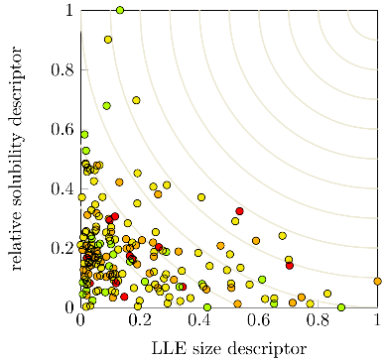
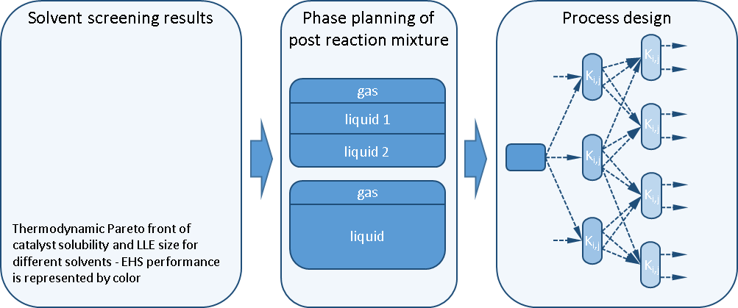
In figure 1, the general design methodology is illustrated starting with the thermodynamic and EHS solvent screening, and ending with the process design.
Figure 1. Main concept for the solvent selection and process design approach.
4. Conclusions
We present a combined solvent-process design approach for homogeneously catalyzed reactions and discuss the benefit of early stage process design compared to simple solvent screening methodologies. Simultaneously, the performance potential of green solvents is evaluated.
Acknowledgement
This research work was conducted within the Collaborative Research Centre “InPROMPT: Integrated Chemical Processes in Liquid Multiphase Systems” (Project B9). The financial support from the German Research Foundation (DFG) under the grant SFB/TRR 63 is gratefully acknowledged. S.L. is also affiliated with the „International Max Planck Research School for Advanced Methods in Process and Systems Engineering (IMPRS ProEng, Magdeburg)”.
References
- A. Behr, A.J. Vorholt, Homogeneous Catalysis with Renewables, Springer Nature, 2017
- K. McBride, N.M. Kaiser, K. Sundmacher, Comput. Chem. Eng. 105 (2017), pp. 212-223.
- A. Behr, R. Roll, J. Mol. Catal. A: Chem. 239 (2005), pp. 180-184.
- E. Benfanati, A. Manganaro, G. Gini, CEUR workshop proceedings Vol. 1107 (2013)

