Development of a new experimental method to determine inherent dissolution properties of active pharmaceutical ingredients
Dominik Sleziona¹, Amelie Mattusch¹, Sebastian Klosa¹, Gerhard Schaldach¹, David R. Ely², Gabriele Sadowski³, Markus Thommes¹
¹ TU Dortmund, Department of Biochemical and Chemical Engineering, Laboratory of Solids Process Engineering, Emil-Figge-Str. 68, 44227 Dortmund, Germany; ² Ivy Tech Community College, 3101 S Creasy Ln, Lafayette, IN 47905, USA; ³ TU Dortmund, Department of Biochemical and Chemical Engineering, Laboratory of Thermodynamics, Technical University Dortmund, Emil-Figge-Str. 70, 44227 Dortmund, Germany
*Corresponding author: markus.thommes@tu-dortmund.de
Highlights
- Drug release can be limited by diffusion or surface reaction kinetics.
- A flow channel was constructed to ensure well-defined fluid conditions.
- Intrinsic material data were derived by analyzing four different drugs.
- A model that accounts for diffusion- and surface reaction limited drug release was developed.

1. Introduction
The dissolution behavior is a crucial factor in novel drug substance formulation. The two main factors limiting the dissolution kinetics of active pharmaceutical ingredients are diffusion (Fick, 1855) and surface reaction kinetics (Paus et al., 2015).
2. Methods
Dissolution experiments such as the intrinsic dissolution test described in the pharmacopeia (European Pharmacopoeia Commission, 2017) have been performed for many years. To overcome the disadvantages of the intrinsic dissolution test, a flow channel was constructed and evaluated to ensure well defined flow conditions. The mass transfer rates from a flat, solid surface into the solvent flowing over the solid surface within the flow channel were used to derive a mathematical model that distinguishes between diffusion limited and surface reaction limited drug release.
3. Results and Discussion
A rectangular flow channel was designed (Shah and Nelson, 1975) (Figure 1, left) based on fluid dynamics calculations (Ansys CFX® 19.1, Ansys Inc., Canonsburg, USA). A rectangular surface with a width to height ratio of 5 was chosen (Ward-Smith, 1980). The characteristic velocities for a flow of Re 250 are color coaded. The powder sample was compress into a die resulting in a well-defined sample surface. The sample concentration in the dissolution media was measured by UV spectroscopy. The right-hand image in Figure 1 shows the weight flux from the sample as function of the Reynolds number. For particularly low Reynolds numbers, the weight flux is limited by diffusion (intercept with the ordinate (Re=0); J^{w}_{D}). For high Reynolds numbers (Re > 150) the weight flux begins to level out indicating it is limited by the surface reaction. Between those stages the weight flux depends on the flow conditions and is a function of the Reynolds number.
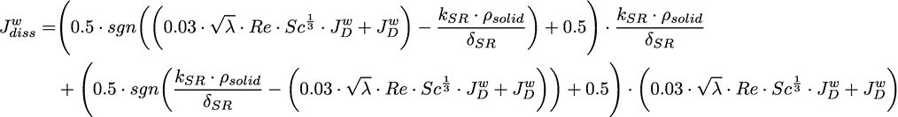
The weight flux from pure diffusion is quite similar for the two tested model substances. This is unsurprising based on their similar molecular size, which is used to predict diffusivity via the Stokes-Einstein correlation. Theophylline shows a much higher flux at high Reynolds number compared to benzocaine, which indicates a faster surface reaction for theophylline. The reason is not clear yet and needs to be investigated further. The linear correlation between flux and Reynolds number (0 < Re < 150) can be attributed to convection and is captured by an approach based on Prandlt’s work (Brauer and Mewes, 1971).
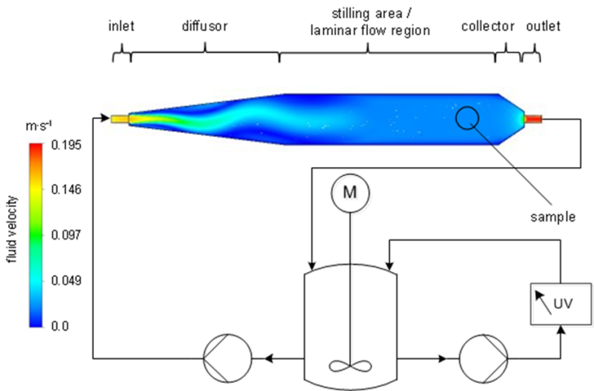
Figure 1. Set up of the flow channel dissolution experiment (left) and the resulting weight flux of benzocaine, theophylline as a function of the Reynolds numbers (av, n = 3).
4. Conclusions
A new intrinsic dissolution setup has been deigned in order to overcome the limitations of the pharmacopeia test. This enables diffusion- and surface reaction limited regimes for drug release to be determined experimentally. Two model drugs were tested and differences were observed.
References
[1] European Pharmacopoeia Commission (2017) European pharmacopoeia, Vol. 9.0, Council of Europe.
[2] Fick, A. (1855) Ueber Diffusion, Annalen der Physik 170, 59-86.
[3] Paus, R., Ji, Y., Braak, F.,Sadowski, G. (2015) Dissolution of crystalline pharmaceuticals: experimental investigation and thermodynamic modeling, Industrial & Engineering Chemistry Research 54, 731-742.
[4] Shah, A. C. and Nelson, K. G. (1975) Evaluation of a convective diffusion drug dissolution rate model, Journal of Pharmaceutical Sciences 64, 1518-1520.
[5] Ward-Smith, A. J. (1980) Internal Fluid Flow-The fluid dynamics of flow in pipes and ducts, Nasa Sti/recon Technical Report A 81.
[6] Brauer, H., Mewes, D. (1971),Stoffaustausch enschließlich chemischer Reaktionen, Sauerländer.

