Engineering Yarrowia lipolytica for high-yield lipid production
from lignocellulosic biomass
Sun-Mi Lee^{1, 2, 3, *}, Sangdo Yook¹, Jiwon Kim^{1, 4}
¹ Clean Energy Research Center, Korea Institute of Science and Technology (KIST), Seoul 02792, Republic of Kore; ² Clean Energy and Chemical Engineering, University of Science and Technology, Daejeon 34113, Republic of Korea; ³Green School (Graduate School of Energy and Environment), Korea University, Seoul 02841, Republic of Korea; ⁴Department of Biotechnology, Korea University, Seoul 02841, Republic of Korea
*Corresponding author: smlee@kist.re.kr
Highlights
- Yarrowia lipolytica was engineered to efficiently convert xylose into lipids
- Isomerase-base pathway enabled Y. lipolytica high-yield lipid production from xylose
- Isomerase-based pathway supported simultaneous co-fermentation of glucose and xylose

1. Introduction
Lignocellulosic biomass is one of the most attractive renewable resources for fuels and chemicals production. Yarrowia lipolytica, non-conventional oleaginous yeast, is a promising host for biodiesel and oleochemical production from lignocellulosic biomass. With advances in metabolic engineering, Y. lipolytica efficiently converts glucose into lipids up to 90% of its cell mass [1]. Yet, Y. lipolytica hardly utilize xylose, the second most sugar component of lignocellulosic biomass, limiting high-yield lipid production from lignocellulosic biomass.
2. Methods
To efficiently produce lipids from lignocellulosic biomass, we developed an efficient xylose utilizing Y. lipolytica harboring isomerase-based pathway. To do so, we first introduced xylose isomerase pathway, and then evolved the rationally engineered strain to better support xylose metabolism. The xylose utilizing performance of the engineered strain was evaluated during xylose fermentation as a sole carbon source, and during the fermentation of lignocellulosic hydrolysates.
3. Results and discussion
The newly developed xylose utilizing Y. lipolytica (YSXAK) showed high-yield lipid production from xylose as a sole carbon source. The lipid yield of isomerase-based xylose utilizing strain of YSXAK was five times higher than that of an oxidoreductase-based strain with cofactor imbalance issue [2]. Moreover, YSXAK simultaneously utilized both glucose and xylose to produce lipids suggesting efficient co-fermentation of lignocellulosic biomass. To understand the different genetic background contributed to efficient xylose utilization, comparative whole-genome sequence analysis was conducted identifying beneficial mutations occurred during evolutionary engineering.

A B
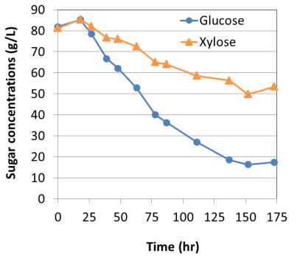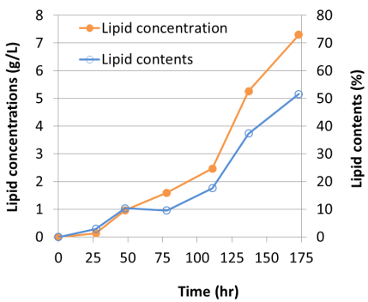
Figure 1. Sugar consumption and lipid production of xylose utilizing Y. lipolytica during glucose/xylose co-fermentation
4. Conclusions
Through combinatorial engineering, we developed an efficient isomerase-based xylose utilizing strain of Y. lipolytica, and demonstrated high-yield lipid production from xylose and simultaneous co-fermentation of glucose and xylose. This study shows the potential of xylose utilizing Y. lipolytica harboring an isomerase pathway for more economical and sustainable biodiesel and oleochemical production from lignocellulosic biomass.
References
- J. K. Ko, S. Lee, Curr. Opin. Biotech. 50(2018) 72-80
- H. Li, H. Alper, Biotechnol. J. 11 (2016) 1230-1240

