**Enhancement of CO2 Absorption by Ionic Liquid Electrospray**

Hidemasa Takana1, Nozomi Hara1, Takashi Makino2 and Mitsuhiro Kanakubo2

*1 Institute of Fluid Science, Tohoku University, 2-1-1 Katahira Aoba-ku, Sendai 980-8577, JAPAN*

*2 National Institute of Advanced Industrial Science and Technology (AIST), JAPAN*

*\*takana@tohoku.ac.jp*

**Highlights**

* Ionic liquid electrospray characteristics have been clarified by high speed imaging. Ionic liquid electrospray behavior can be categorized into four modes depending on applied voltage and feeding flow rate.
* Ionic liquid electrospray produces nano droplets and it was successfully demonstrated that ionic liquid electrospray enhances CO2 absorption even at low CO2 concentration.
* The absorbed amount of CO2 for 20 minutes increases by 220 % by ionic liquid electrospray.

1. **Introduction**

Ionic liquids (ILs) are ambient temperature molten salts, which generally consist of a bulky organic cation and organic/inorganic anion. ILs exhibit unique characteristics such as non-volatility, non-flammable, thermal and chemical stability. Moreover, ILs have drawn great attention as a potential CO2 absorbents. ILs capture CO2 chemically and reversibly desorb CO2 by heating.

Since CO2 chemical absorption occurs at the gas-liquid interface, the absorption rate can be enhanced by increasing the specific surface area. In this study, nano order IL droplets are generated by electrospray with aiming enhanced CO2 chemisorption. The characteristics of IL electrospray were experimentally evaluated and the effect of applied voltage on the CO2 absorption performance was discussed with correlating to spray behavior.

1. 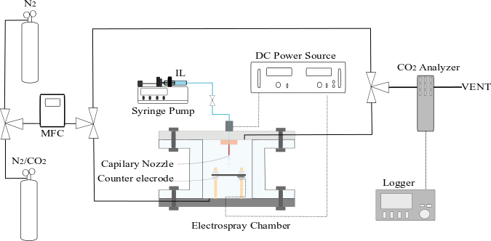**Methods**

Schematic illustration of experimental setup is shown in Fig. 1. Both upper and lower flanges of an acrylic chamber with volume of 50.3 cm3 has gas inlet and outlet ports of 4 mm in diameter. The CO2/N2 gas (1.03% CO2) and N2 gas (≥ 99.999%) is introduced in the changer and flows out from the outlet port. CO2 concentration is monitored by CO2 analyzer (VAISALA GMP252) at downstream of outlet port. The capillary tube made of a fused silica (ID: 100 μm, OD: 375 μm, GL Sciences) was used as a nozzle. Positive DC high voltage was applied to the capillary nozzle with the counter ring electrode grounded. The electrode gap distance between the center of ring electrode of nozzle tip was set to be 6 mm. 1-ethyl-3-methylimidazolium acetate ([EMIM][Ac], ≥ 95.0%, SIGMA-ALDRICH) was used in this study as an absorbent. Droplet size distribution was optically measured by aerosol spectrometer (WELAS 2070 PALAS) for the sampling time of 30 seconds. Electro spray behavior was characterized by taking high-speed shadow graph images at the flame rate of 4000 fps (FASTCAM SA-X2, Photron). In the CO2 absorption experiments, CO2/N2 premixed gas was supplied at a constant flow rate of 20 ml/min.

**Figure 1.** Schematic illustration of experimental setup.

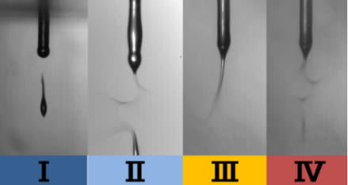**3. Results and discussion**

Fig. 2 shows shadow graph images taken by high speed camera. IL spray can be categorized into 4 modes depending on applied voltage and flow rate. The mode I is referred to as “dripping mode” with rather large droplets of ~0.2 mm. The mode Ⅱ generates not only large droplets like mode I but also fine droplets through breakup of the liquid thread extended from the Taylor cone. In mode Ⅲ, ultrafine droplets are continuously generated from the liquid thread tip due to electrostatic repulsion. The typical droplet size distribution of model III is shown in figure 3. The peak diameter of 255 nm is generated in this mode. The mode Ⅳ is observed at a relatively high voltage when corona discharge appears around the Taylor cone. Since ionized gas layer shields electric field at the tip of the ionic liquid thread, larger droplet is primary generated just like mode II followed by finer droplets generation by secondary breakup due to high electric field. In the following experiments, the ionic liquid flow rate was fixed at 2 mL/h.

**Figure 3.** Droplet size distribution in mode III.

**Figure 2.** Observed spray modes in

ionic liquid electrospray.

Fig. 4 shows the time traces of CO2 concentration. When 8.0 kV is applied (mode IV), CO2 concentration rapidly decreases at the initial period. The reaction rate in this case enhanced by approximately 10 times compared to the case without applied voltage. The absorbed amount of CO2 for 20 minutes also increases by 220 %. When shutting down IL supply and applied voltage, CO2 concentration recovers. Slower increase in 8.0 kV is because of the attached fine droplets remains on the chamber wall. From this result, it has been clearly shown that atomization of ionic liquid by electrostatic spray enhances the CO2 absorption even under low CO2 concentration conditions.

**Figure 3.** Time traces of CO2 concentration with various applied voltages.

**4. Conclusions**

The characteristics of IL electrospray was clarified using high-speed imaging and the effect of IL electrospray on CO2 absorption was shown with correlating to the spray characteristics.

**Acknowledgment**

Part of this research was supported by JSPS KAKENHI Grant Number 16H04262.