Validation of a novel flexible electrochemical microreactor by its application to electroorganic syntheses
Athanassios Ziogas¹, Christian Hofmann¹, Sebastian Baranyai^{1,2}, Patrick Löb¹, Gunther Kolb¹
¹ Fraunhofer Institute for Microengineering and Microsystems IMM, Mainz, Germany; ² Hochschule Konstanz Technik, Wirtschaft und Gestaltung HTWG, Konstanz, Germany
*Corresponding author: athanassios.ziogas@imm.fraunhofer.de
Highlights
- New, modular electrochemical microreactor addressing high pressure operation and production scale.
- Application to electroorganic synthesis.
- Asymmetric Kolbe electrolysis and cation pool / flow method.
- Utilization of additive manufacturing for reactor plates realization.

1. Introduction
Organic electrochemistry is considered as future emerging technology for the environment-friendly production of chemical compounds. The search for “green” synthesis routes, the emergence of novel synthesis strategies and also the ambition for a direct utilization of sustainable (excess) electric energy foster the development in this field.^{[1]} Nevertheless, there are still challenges and problems linked to electrosynthesis and there is also a need for flexible reactor concepts.^{[2]} Electrochemical microreactors - characterized by small electrode distances and great surface-to-volume-ratios - contribute to solve these issues.
2. Design and manufacturing of the novel electrochemical microreactor
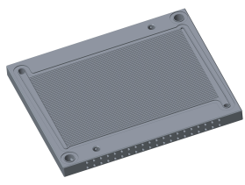
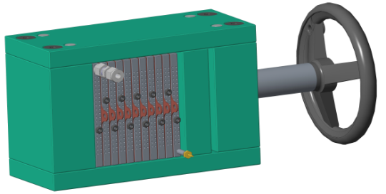
Taking into account current user requirements, Fraunhofer IMM developed based on its experience in the field of electrochemical microreactors ^{[3]} an innovative reactor concept (Fig. 1) following a plate stack design addressing especially the aspects modularity, flexibility, high pressure operation and accessibility of production scale.
Figure 2.
CAD illustration of single reactor plate with micro-structured electrode and integrated heat exchanger (left). CAD illustration of assembled flexible electrochemical microreactor with 11 reactor plates (right).

The single reactor plates hosting the structured electrodes typically on both sides and equipped with an integrated heat exchanger have been realized by a sequence of different fabrication steps:
- additive manufacturing to realize the base plates with their complex fluid structures
- surface coating (e.g. with PTFE) of the plates for electric insulation
- milling to create the micro channels on the plates surface
- electroplating to deposit different electrode materials
The basic reactor plates (outer dimension: 100 mm x 118 mm) provide an active electrode surface of 54 cm² via 67 micro channels (800 µm x 100 µm x 10 cm) and a channel volume of 0.5 cm³ per structured plate side. The reactor is designed for operations up to 200 °C and up to 100 bar for electrolyte flow rates up to 200 mL min⁻¹.
3. Results and discussion
The reactor concept allows a multitude of operation possibilities in view of numbers of electrode assembly units in use, functionality (mono or bipolar cell configuration, undivided or divided cell configuration) and operation mode of the stack (parallel, serial or mixed operation). With that also numbering-up and scale-up possibilities are provided. The reactor concept is validated by the use of different reactor assembly configurations for two electroorganic syntheses. Former results regarding the Kolbe electrolysis to produce fuels from fatty acids ^{[4]} could be further improved with the new reactor concept. E.g. for the asymmetric continuous Kolbe electrolysis at current densities of 1.7 kA*m⁻² and residence time of 0.1 s the Faraday efficiency could be increased further to 91% (at quantitative yield and a selectivity towards 97% of n-alkanes). This application example illustrates nicely the precise control over process conditions during the synthesis and the resulting control over product composition (see Figure 2). The Cation Pool / Flow method ^{[5]} as modern organic synthesis approach has also been used for the successful reactor concept validation.

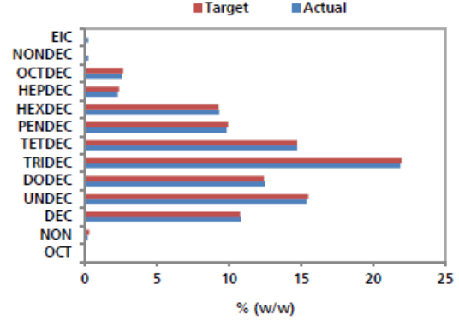
Figure 2. Comparison between target and achieved results of jet oil by Kolbe electroorganic synthesis.

4. Conclusions
Fraunhofer IMM has developed an innovative electrochemical microreactor addressing especially the aspects modularity, flexibility, high pressure operation and accessibility of production scale and validated the reactor concept by applying it in the Kolbe electrolysis and Cation Pool / Flow method.
References
[1] A. Wiebe et al., Angew. Chem. 130 (2018) 2-30.
[2] M. Yan et al., Angew. Chem. Int. Ed. 56 (2017) 2-9.
[3] A. Ziogas et al., J. Appl. Electrochem. 39 (12) (2009) 2297-2313.
[4] A. Ziogas et al., WO 2016/70075 A1.
[5] J. Yoshida et al., Chem. Eur. J. 2002, 8, No.12

