Characterization of a Microfluidic Device
Manufactured by Reactive Ion Etching
Jens Bobers^{1*}, Maurice Hesselmann, Arndt-Christian Schneider, Jakob Zimmermann², Norbert Kockmann¹
1 TU Dortmund University, Biochemical and Chemical Engineering, Laboratory of Equipment Design,
Emil-Figge-Str. 68, 44227 Dortmund, Germany;
2 TU Dortmund University, Electrical Engineering & Information Technology, Intelligent Microsystems Institute, Emil-Figge-Str. 68, 44227 Dortmund, Germany
*Corresponding author: jens.bobers@tu-dortmund.de
Highlights
- New manufacturing process for microstructured devices.
- Etch rate of the RIE process increased by increasing SF₆ and oxygen flow rates at higher pressure.
- Resulting surface roughness minimized with high gas flow rates at high pressure.
- Linear relation between pressure drop and Reynolds number indicates laminar flow.

1. Introduction
Two-phase droplet flow in microchannels is of great potential providing high specific surface, low liquid hold-up and, intensified chemical reactions. A new manufacturing process for polyimide-based microfluidic devices was developed. Reactive ion etching (RIE) was used as production technique obtaining anisotropic etching and high spatial resolution. Polyimide (PI) withstands most solvents, acids and bases and is suitable for RIE. The combination of RIE and PI for microfluidic devices provides high geometric flexibility, reproducibility and, wide range of applications. The production process was applied on microfluidic geometry for droplet generation. [1–3]
2. Methods
The etching gas for the RIE process contains sulphur hexafluoride (SF₆), oxygen (O₂), and argon (Ar). A 2⁴ full factorial designed experiment was used to analyze the effects of the investigated parameters on the surface roughness and etch rate and to determine the interactions between these parameters. The experiments were performed with an RIE apparatus Plasmalab® µEtch (Oxford Instruments plc, Abingdon, UK). The gas composition during the RIE process and the total pressure were varied between 133 and 266 Pa. The pressure drop of the manufactured geometry was measured as an indicator of the prevailing flow regime (see Figure 1, left).
3. Results and discussion
The physical etching during RIE is caused chiefly by the argon ions and partly by the oxygen atoms. The chemical etching is performed by fluoride ions generated from SF₆. The optimal parameter settings was found with all parameters on high level since the positive effect on the etch rate exceeds the minor increase of roughness. A value of 0.7137 µm min⁻¹ was found for the etch rate and for mean surface roughness 0.5878 µm were measured with a mean etch depth of 50 µm. The measured pressure drop was compared to calculated values using the Darcy Weisbach equation for flow inside a tube and with a fitted constant, respectively (see Figure 1, right). The linear course of the pressure drop indicates laminar flow regime and only a minor influence of the surface roughness and the channel widening on the liquid flow [4].
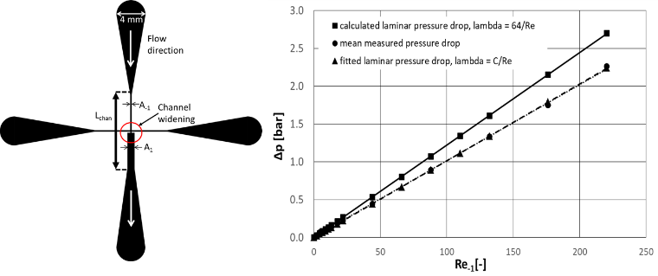
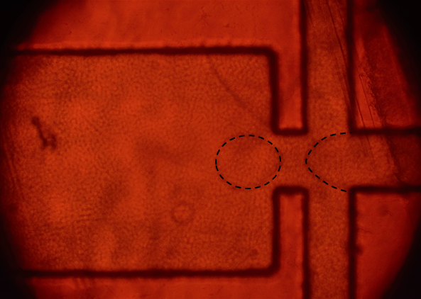

Figure 1: Manufactured geometry (left) with observed drop flow for water/silicone oil (0.01 ml min⁻¹/0.1 ml min⁻¹), measured and calculated single-phase (water) pressure drop plotted against the highest Reynolds number (right), constant C fitted on the measured values and found as 53
4. Conclusions
A RIE manufacturing process for microstructured devices was developed and characterized regarding to the etch rate and surface roughness. A microstructured droplet generator with a widening from 100 µm to 300 µm was manufactured with the optimized parameter settings and drop flow was observed for water in silicone oil. The course of the pressure drop implicates a laminar flow regime for the investigated flow rates. The linear part of the Darcy Weisbach equation dominates the pressure drop in contrast to the contribution of the quadratic part. This indicates that the small straight channel have the greatest impact on the total pressure drop in contrast to the surface quality and other geometric influences.
References
[1] Hwang, Y.-J., Coley, C. W., Abolhasani, M., Marzinzik, A. L., Koch, G., Spanka, C., Lehmann, H. and Jensen, K. F. "A segmented flow platform for on-demand medicinal chemistry and compound synthesis in oscillating droplets." Chem. commun. Vol. 53 No.49 (2017) pp. 6649 – 6652.
[2] Buder, U., Klitzing, J.-P. v. and Obermeier, E. "Reactive ion etching for bulk structuring of polyimide." Sensors and Actuators A: Physical Vol. 132 No.1 (2006) pp. 393 – 399.
[3] Dittrich, P. S. and Manz, A. "Lab-on-a-chip." Nature rev. Drug discovery Vol. 5 No.3 (2006) pp. 210 – 218.
[4] Agarwal, N., Ponoth, S., Plawsky, J. and Persans, P. D. "Roughness evolution in polyimide films during plasma etching." Appl. Phys. Lett. Vol. 78 No.16 (2001) pp. 2294 – 2296.

