ENHANCED FIXED-BED REACTOR FLEXIBILITY THROUGH OPTIMAL CONTROL AND DESIGN FOR CO2 METHANATION
Jens Bremer¹, Ronny Tobias Zimmermann², Kai Sundmacher^{1,2}
1 Max-Planck-Institut für Dynamik komplexer technischer Systeme, Sandtorstraße 1, 39106 Magdeburg, Germany
2 Otto-von-Guericke Universität, Universitätsplatz 2, 39106 Magdeburg, Germany;
*Corresponding author: bremerj@mpi-magdeburg.mpg.de
Highlights
- Detailed model analysis under dynamic conditions with special focus on heat management and catalyst properties.
- Proposing operation strategies to effectively deal with reactor load changes.
- Exploring potentials for advanced control methods (optimal control).

1. Introduction
The current trend towards a more flexible production to react on markets as well as on volatile inputs (e.g., coming from renewable sources), contains many new challenges and requires concepts for dynamic process operation. Thus, the interest in prediction of the process dynamics has become more important than ever before [1-3]. The present work in particular deals with dynamic load changes of fixed-bed reactors for carbon dioxide methanation by use of hydrogen generated via water electrolysis, an important example of Power-to-X (PtX) production processes. Particularly in view of vehicles fueled with compressed natural gas (CNG), synthetic methane (SNG) is a very attractive, easy-to-distribute substitute fuel. Moreover, carbon dioxide methanation is a key reaction in the context of chemical conversion networks for the storage of electrical surplus energy. However, the reaction is strongly exothermic such that distinct hot-spots are formed within the catalytic fixed-bed that can influence the catalyst stability and process safety [4]. On top of that, these reactors are characterized by extraordinary dynamic behaviors (e.g. wrong-way behavior), due to complex interactions between heat and mass transport, reaction, and fluid flow phenomena. Consequently, intelligent dynamic interactions are required to guarantee time-optimal load transitions, while ensuring long-term stable and safe reactor operation.
2. Methods
Detailed dynamic reactor models from first-principals are used to analyze the reactor behavior under dynamic scenarios. One- and two-dimensional, pseudo-homogenous, tubular reactor model including wall and cooling channel are used to get detailed information about the reaction heat propagation and to analyze extraordinary dynamic behaviors. Additionally a heterogeneous model is compared with the homogenous model in order to show the impact of the solid catalytic phase and its corresponding diffusional limitation. Special attention is given to its impact on reactor dynamics, an often stated but rarely illustrated problem under industrially relevant conditions. Furthermore, the reactor models are embedded into frameworks for linear and advanced/optimal control. Thereby, the objective is to keep track of a constant reactor conversion in scenarios of changing loads (realized via feed velocity and feed pressure changes). All studies are performed in-silico using MATLAB.
3. Results and discussion
Preliminary results for control trajectories performed with and without (closed- and open-loop) well-known PI-controller are illustrated in Figure 1. The changing load influences both the position and the intensity of the reactive zone (hot-spot). Wrong-way behavior occurs within the first minute and lead to a temperature overshoot of up to 100 K. Furthermore, we observed that under certain conditions a load change performed via pressure changes is much less affecting the target conversion, as compared to the velocity-based load change. However, by changing the coolant temperature after disturbing the velocity in a closed-loop set-up with a PI controller, the target conversion is effectively restored after approximately 300 seconds with reduced temperature overshoot. Further results will focus on optimal control trajectories that allow for faster transitions while considering technical restrictions (e.g. maximal catalyst bed temperature).
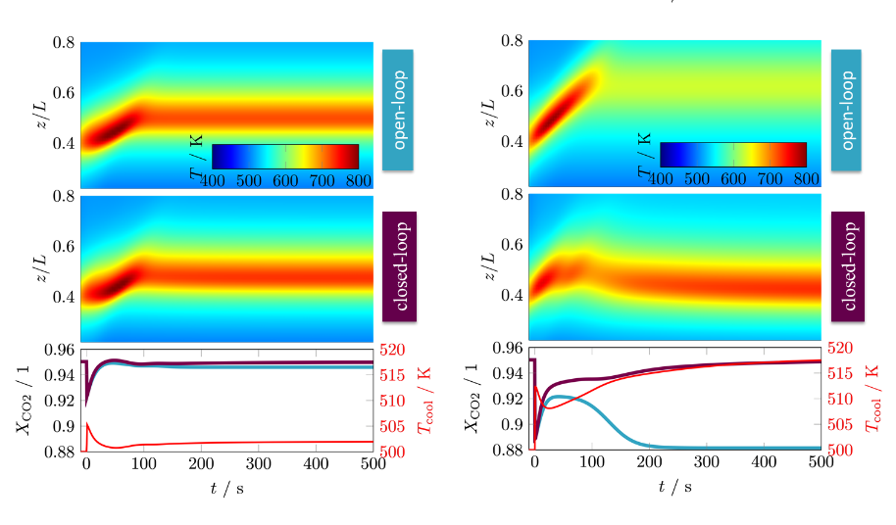
Figure 1. Load change with positive pressure step from 10 to 15 bar (left) and with positive gas flow step from 1 to 1.5 m/s (right). Upper surface plots: space-time behavior at the reactors central axis. Lower plot: control trajectories (red) and CO₂ conversion trajectories in open- (blue) and closed-loop (violet) set-up.
4. Conclusions
Our results comprehensively show how complex the dynamic behavior of the investigated exothermic reactor for methanation is. Powerful computational tools allow for an effective analysis of these behaviors and also reveal to what extent an intervention with suitable controls becomes feasible. With this, we intend to deliver a deeper understanding for dynamic reactor operation and derive new operation strategies that allow for a more flexible and sustainable production within future production concepts. Since our results are mainly related to the heat generated by the reaction, the outcomes of this study are also relevant to other exothermic reactions, e.g. methanol production from CO₂ and green hydrogen.
References
- G. Eigenberger, Ullmann's Encyclopedia of Industrial Chemistry, Wiley-VCH, Weinheim, 2003.
- G. Eigenberger, H. Schuler, Int. Chem. Eng. 29 (1989) 12 – 25.
- O. Kalthoff, D. Vortmeyer, Chem. Eng. Sc. 35 (1980) 1637-1643.
- J. Bremer, K.H.G. Rätze, K. Sundmacher, AIChE J. 63 (2017) 23–31.

