Purification of macromolecules combined with a simultaneous BTC analysis on a single Akta system
Rok Ambrožič¹, Petra Modic¹, Gorazd Hribar², Aleš Podgornik¹
1 University of Ljubljana, Faculty of Chemistry and Chemical Technology, Večna pot 113, 1000 Ljubljana, Slovenia
2 Lek d.d., Technical Development Biologics Mengeš, Kolodvorska 27, 1234 Mengeš, Slovenia
*Corresponding author: Rok.Ambrozic@fkkt.uni-lj.si
Highlights
- Modified chromatographic system with on-line column outflow analysis was designed.
- Robust method enabled breakthrough curve (BTC) detection for different target molecules.
- The limit detection concentration was enhanced by increasing the injected mass.
- Different case studies with different process dynamics were used for validation.

1. Introduction
A preparative high-performance liquid chromatography (pHPLC) remains an extensively used technique for a downstream operation for commercially important bio macromolecules, such as proteins and nucleic acids. Since process time becoming more and more critical for biopharmaceutical manufacturing, fast and effective chromatographic methods are widely required. In this context, target molecule breakthrough point determination should be of a great interest, mainly due to high evaluation of the final product. Therefore, modified chromatographic system with on line examination of preparative column outflow, which enabled detection of target molecule breakthrough point, was developed. Different case study samples, such as i) monoclonal antibodies (mAb), ii) protein aggregates and iii) plasmid DNA (pDNA), were used to validated and verified the system with automotive software method.
2. Methods
All experiments were performed with ÄKTA Explorer (GE Healthcare Life Science, UK) modified HPLC chromatographic system which enabled on-line analysis of preparative column outflow by simultaneously injection outflow from preparative column on separate selective analytical column where target molecule(s) was/were analyzed. Cationic and/or anionic exchangers were used as chromatographic supporters (along with selective protein A membrane), dependent on the investigated case study (feed sample) and its characteristics.
3. Results and discussion
To validate modified system and its method, the sample of pure mAb was loaded on a CEX preparative column and its breakthrough curves were investigated by UV absorbance measurements (Figure 1 left). No noticeable differences between breakthrough profile determined directly from measurements of UV absorbance from preparative column (blue line) and breakthrough profile determined with on-line detection by protein A analysis (red squares) was detected, meaning system and method were designed correctly. Furthermore, breakthrough curve of unpurified mAb was investigated by the same method (Figure 1 right) to determined breakthrough curve of target molecule (mAb) in heterogeneous mixture (real sample). Although UV absorbance signal directly from preparative column was completely occupied throughout the experiment and as such unusable, on-line detection by protein A membrane enabled clear detection of mAb breakthrough point.
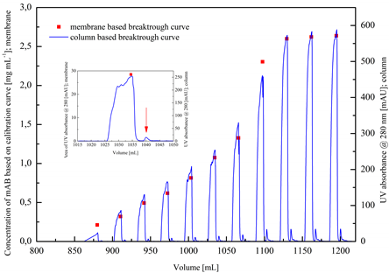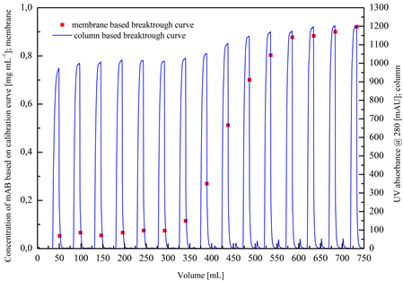
Figure 1. Protein A membrane (red squares) and CEX preparative column (blue line) based breakthrough curve of purified (left) and unpurified (right) mAb.
Additionally, modified HPLC system with the same analytical approach enabled efficient detection of protein aggregate, even below 1 % of total protein concentration. Since protein aggregates present a big concern in protein manufacturing, a fast and an efficient method for its detection should be widely required. Plasmid DNA was selected as a final case study, due to complex pDNA-RNA dynamics. However, excellent results with highly functional analysis for both target types of molecules were obtained without further modification of the system and/or method.
Finally, limit detection concentration was easily reduced by increasing the numbers of injection per each analyze step, what linearly increased injected mass and improved target molecule detection resolution. This simple, but extremely operative, solution was especially useful when target molecule concentration was below detection limit (in the early stages of breakthrough).
4. Conclusions
The modified HPLC system with automatize software method has proved to be very effective in detection of target bio macromolecules in preparative column outflow, even if the target concentration was below 1 % of feed concentration. Furthermore, system and method simple implemented into other pharmaceutical environments and its significant applicative potential should be enormous additional advantage for everyday use.
References
- D. Winters, C. Chu, K. Walker, J. Chrom. A 1424 (2015) 51-58.
- A. Jungbauer, R. Hahn, J. Chrom. A 1184(1-2) (2008) 62-79.
- D. Yoo, J. Provchy, C. Park, C. Schulz, K. Walker, J. Chrom. A 1344 (2014) 23-30.
- V. Smrekar, F. Smrekar, A. Strancar, A. Podgornik, J. Chrom. A 1276 (2013) 58-64.

