**Particle Size Control of Recovered Mg(OH)2 in Concentrated Brine Discharged from Sea Salt Manufacturing Process**

Akira Kubo1, Toshiyuki Sato1, Masakazu Matsumoto1, Toshihiko Hiaki1*

*1 Department of Applied Molecular Chemistry, Nihon University,* 1-2-1, Izumi-cho, Narashino, Chiba 275-8575 Japan

*\*Corresponding author: hiaki.toshihiko@nihon-u.ac.jp*

**Highlights**

* A morphology of Mg(OH)2 is affected to stirring rate.
* A crystallinity is expected to change by stirring rate.
* The amount of Mg(OH)2 depends on reaction time.

**1. Introduction**

Concentrated brine discharged from sea salt manufacturing process in Japan contains of value metal resources. The brine after recovering potassium chloride by cooling crystallization gives removed potassium bittern(RPB) as by-product. A part of RPB has been wasting to be hard to recover their resources, however, it is concerned with environment load. Combining their recovery increasing and to decrease environmental load are required, then Mg2+ is focus on as a representative resource. When Mg2+ is obtained from concentrated brine by reactive crystallization, Mg(OH)2 would be produced to add a precipitator as primary product. However, the method gives a task to be slow on dry and filter process due to small crystal size of Mg(OH)2. There have been many studies to increase a crystal size. For example, they are suggested kinds and addition method of precipitator. Otherwise, main cause of secondary nucleation in industrial equipment occurs from the stirring, there are hardly suggestion by the study to be controlled the crystal size.

The purpose of this study is to grow a Mg(OH)2 crystals by the stirring conditions. For reagent, MgCl2 ・6H2O and Ca(OH)2 were used by material and precipitator. Both reaction times and stirring condition are operation factors.

**2. Methods**

2.1 Material and operation

Mg(OH)2 was precipitated by adding 6.0 mmol Ca(OH)2 powder to 300 ml for 0.5 M MgCl2 solution. The precipitate was filtered and washed third with 3 ml distilled water, dried at 60 ℃ for 24 hours. The product was identified by X-Ray Diffraction (XRD) and a morphology was observed by Scanning Electron Microscope (SEM). The XRD pattern of Mg(OH)2 is based on the JCPDS No. 07-0239.

2.2 Reaction time and stirring rate

Mixer (SM-101, AS ONE Co.) is equipped with 3-blades propeller (d = 55 mm). The reaction time was considered at 301 rpm from 60 min to 300 min, the precipitates were identified at constant time. The stirring rate was considered at 180 min from 301 rpm to 496 rpm. Their products were compared with SEM images and XRD patterns.

3. Results and discussion

Fig. 1-(A) shows the XRD patterns of a precipitates to be altered reaction time. When the reaction time was 60 min, the characteristic peak of Ca(OH)2 at 2θ = 32° is detected. However, when reaction time was more than 120 min, the peak of Ca(OH)2 could disappear. The peaks intensity of Mg(OH)2 gradually increased as diminishing peaks intensity of Ca(OH)2, the amount of Mg(OH)2 is expected to increase.

Fig. 1-(B) shows the XRD patterns of a precipitates to be altered stirring rate. Pay attention at 2θ = 38°, the intensity of Mg(OH)2 was stronger as slowing the stirring rate. This phenomenon is considered that decrease of the stirring rate is hard to occur the contact nucleation, then the crystal size is expected to grow. Otherwise, Fig.2 indicated the SEM images at their conditions. From the Fig.2-(a) and (b), the aggregation of primary particle was observed a ellipse-like morphology for secondary particle, however, Fig. 2-(c) cannot check a primary particle. A gap in secondary particle by distorted shape of primary particle is expected to decrease the crystallinity. Consequently, to be the slower stirring rate may facilitate the crystallinity and size of Mg(OH)2.



Intensity [-]

2*θ*/CuKα [degree]

Intensity [-]

2*θ*/CuKα [degree]

(B)



Mg(OH)2 (JCPDS No. 07-0239)

Ca(OH)2 (JCPDS No. 04-0733)

(A)

Fig. 1 Effect of reaction time and stirring rate on XRD patterns, A) reaction time, B) stirring rate

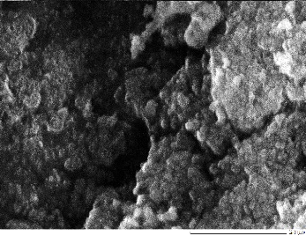

2 μm

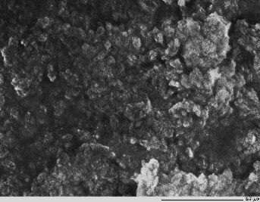

2 μm

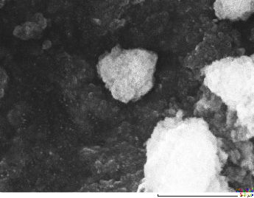

2 μm

**(a) (b) (c)**

Fig. 2 Morphology of the products by changing the stirring rate, (a) 301 rpm, (b) 400 rpm, and (c) 496 rpm

**4. Conclusions**

This study was carried out to increase a crystal size of Mg(OH)2 by reactive crystallization. The stirring rate and reaction time is considered to affect for the crystal size, their precipitates are identified and observed by XRD and SEM. From the XRD patterns, the amount of Mg(OH)2 and crystal size were changed by operation conditions. From the SEM images, the crystallinity and the crystal size of Mg(OH)2 are expected to increase at the slower stirring rate condition.

Acknowledgement

This research was supported by the Salt Science Research Foundation （No.18A5）, Japan.