Enhanced permeate flux through nano-filtration Polyphenylsulfone membrane using modified silica nanoparticles

Mohammad Mehdi Zarei^{1,3}, Frances Neville², Roberto Moreno-Atanasio^{1,3}, Grant B. Webber^{1,3}
1 School of Engineering, The University of Newcastle, Callaghan, NSW 2308, Australia
2 School of Environmental and Life Sciences, The University of Newcastle, Callaghan, NSW 2308, Australia
3 Priority Research Centre for Advanced Particle Processing and Transport, The University of Newcastle, Callaghan, NSW 2308, Australia
*Corresponding author: Mohammadmehdi.zarei@uon.edu.au
Highlights
- Manufacturing new mixed matrix membranes (PPSU/SiO₂).
- Preparation of silica nanoparticles incorporated with PEI.
- The antifouling performance of PPSU membranes greatly improved.
- The nanocomposite membrane presented excellent removal efficiency of copper ions.
1. Introduction
Polyphenylsulfone membranes (PPSU) are a promising option for separation applications due to their high versatility to control pore size distribution and their chemical and thermal stability. However, the applications of PPSU membrane are limited due to their hydrophobicity which decreases water permeability and increases membrane fouling in an aqueous environment [1].
During the past decade, blending of the membranes with organic/inorganic modifiers such as nano-particles and copolymers has become the most common approach to improve membrane performance. Specially nanocomposite membranes which are composed of polymers and nanoparticles have received special attention [2]. Silica nanoparticles (SNPs), due to their low cost and surface OH moieties, may be selected as a promising filler for membrane modification as they improve the hydrophilicity [3] and water flux capacity of the membranes [4, 5].
In the present work, PPSU membrane will be fabricated by addition of modified silica nanoparticles. The performance of the prepared membrane will be analysed. Then the results will be used to enhance the membrane rate of water transport, hydrophilicity and copper rejection. Finally, the comparison of the performance of synthesised membranes will be presented.
2. Methods
All PPSU blended membranes were prepared using the non-solvent induced phase inversion method [6]. In the preparation of the blend membranes, PPSU with different concentration of SiO₂ nanoparticles was employed as the membrane bulk material. The morphology, the distribution of the silica nanoparticles and the presence of chemical functional groups in the prepared membranes have been investigated via field emission-scanning electron microscopy (FE-SEM) and attenuated total reflectance Fourier-transform infrared spectroscopy (ATR-FTIR). Finally, the performance of the prepared membranes were characterised and compared in terms of hydrophilicity, water flux, fouling resistance and copper rejection.
3. Results and discussion
Water flux over time of the prepared membranes was investigated at 500 kPa constant pressure (Fig. 1). As shown in the figure, water flux of PPSU/SiO₂ membrane is remarkably higher than that of the neat PPSU membrane due to its higher hydrophilicity and higher pore size as these characteristics were enhanced with the addition of silica nanoparticles. In addition, it is quite clear that the water flux declined which may be due to clogging of the membrane pores by the presence of copper ions. Also, the result of copper rejection is shown in Figure 2. As can be seen in the figure, the copper rejection of the neat PPSU membrane was reported 43%. However, the results were altered to about 57% and 79% for 0.2 wt% and 0.4 wt% of PPSU/SiO₂ membranes, respectively. These changes indicated that silica nanoparticles played a significant role in enhancing the copper rejection ratio of the blended membranes.
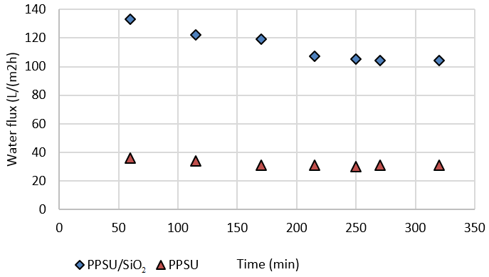 | 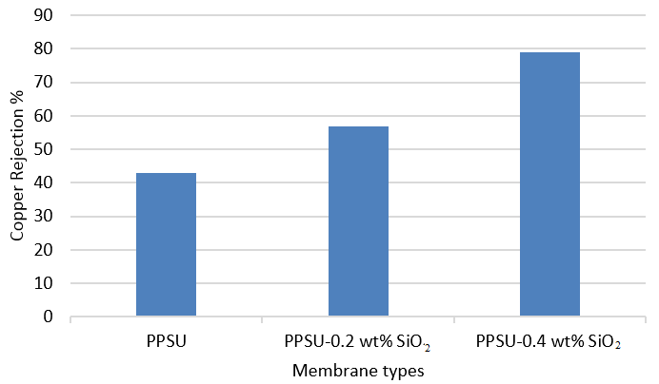
Figure 1. Water flux of PPSU membranes | Figure 2. Copper rejection of PPSU membranes
4. Conclusions
A new approach was used to modify PPSU membrane using a phase inversion method in order to improve the membrane properties such as hydrophilicity and anti-fouling. The addition of modified silica nanoparticles to the polymer casting solution resulted in a considerable improvement in the fabricated membrane hydrophilicity and water flux.
References

[1] Daraei, P., et al., Novel polyethersulfone nanocomposite membrane prepared by PANI/Fe₃O₄ nanoparticles with enhanced performance for Cu (II) removal from water. Journal of Membrane Science, 2012. 415: p. 250-259.
[2] Yurekli, Y., Removal of heavy metals in wastewater by using zeolite nano-particles impregnated polysulfone membranes. Journal of Hazardous Materials, 2016. 309: p. 53-64.
[3] Dong, H., et al., Superhydrophilic Surfaces via Polymer−SiO₂ Nanocomposites. Langmuir, 2010. 26(19): p. 15567-15573.
[4] Shen, J.-n., et al., Preparation and characterization of PES–SiO₂ organic–inorganic composite ultrafiltration membrane for raw water pretreatment. Chemical engineering journal, 2011. 168(3): p. 1272-1278.
[5] Yu, L.-Y., et al., Preparation and characterization of PVDF–SiO₂ composite hollow fiber UF membrane by sol–gel method. Journal of Membrane Science, 2009. 337(1): p. 257-265.
[6] Hwang, L.-L., H.-H. Tseng, and J.-C. Chen, Fabrication of polyphenylsulfone/polyetherimide blend membranes for ultrafiltration applications: The effects of blending ratio on membrane properties and humic acid removal performance. Journal of Membrane Science, 2011. 384(1): p. 72-81.

