DEM simulation of breakage under compressive force using a particle replacement model
Vahid Hassanzadeh^{1,*}, Christopher Wensrich², Roberto Moreno-Atanasio³
1, 3 Chemical Engineering Department, School of Engineering, The University of Newcastle, Australia;
2 Mechanical Engineering Department, School of Engineering, The University of Newcastle, Australia
*Corresponding author: vahid.hassanzadeh@uon.edu.au
Highlights
- A Particle Replacement Model was employed to simulate breakage using DEM.
- The effects of initial overlap during replacement on the system were studied.
- Relaxation factor was used to justify high contact force of particles after breakage.

1. Introduction
Comminution processes are the most expensive particle processing operations in terms of energy consumption as most of the energy is dissipated in the form of sound and plastic deformation. Therefore, this type of processes presents an important opportunity for optimization and improvement [1-3].
After introducing Discrete Element Method (DEM) by Cundall and Strack [4] many researchers took advantage of this simulation technique to study size reduction processes [5-9]. The Particle Replacement Model (PRM) has been proved to be one of the most successful models to simulate particle breakage in DEM simulations [9]. In this model, a broken spherical particle is replaced by a progeny of smaller particles instantaneously [5, 9]. PRM requires to specify the maximum stress at which the particle breaks and a breakage distribution function to determine the smaller progeny particles that are replacing the original particle.
During the replacement process, the progeny particles are required to have an initial overlap. This initial overlap causes high contact forces between the particles. Therefore, a relaxation factor has been used in the previous studies to damp the high elastic force artificially created during the replacement process [5]. In this research work, the effects of the relaxation factor on the single particle and particle bed breakage simulations were studied.
2. Methods
An in-house DEM code was developed in Fortran 77 programming language. The Hertz contact force model and equations of motions in both translational and rotational directions were used. Also, damping force models were employed to simulate the energy dissipation in particle contacts.
To simulate the breakage process the particle replacement model was implemented. When the value of the contact force exceeds a specified value, the particle is substituted by its progeny which is determined by the breakage function. The equation developed by Austin and Luckie (1972) was used to calculate the progeny particle size distribution [10]. In order to study the effect of the relaxation factor in the range between 0.05 and 1.00 two types of systems made of particles of 10 mm in diameter were considered: a single particle and a bed of 100 particles. In order to simulate the bed compression test, particles were randomly positioned within a cylinder of 5 cm in diameter. Then, a piston was moved downwards to compress the particle bed until achieving a maximum value of 450 N. An illustration of the simulations is shown in Fig. 1.
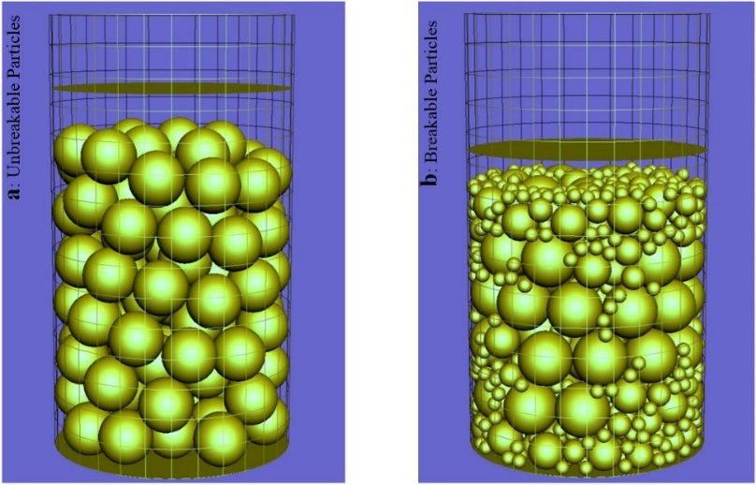
Fig. 1 Simulations of unbreakable and breakable particles after applying 450 N force on the particle bed
3. Results and discussion
In the single particle system, the kinetic energy of the progeny particles exhibited a maximum as a function of time. This maximum value and the rate at which the kinetic energy decayed after the maximum was achieved, increased by increasing the relaxation factor. This could be as a result of large energy dissipations during contacts of high-velocity particles.
For the particle bed simulations, the number of broken particles fluctuated with the relaxation factor. However, the curves of the contact force on the piston as a function of time for different values of the relaxation factor were close to each other and the elapsed times for reaching to 450 N were almost the same.
4. Conclusions
The relaxation factor used in the particle replacement model affects the simulation results considerably. However, it seems that because of the complexity of interactions between particles in a compacted bed, the influence of the factor on the results of the breakage process is not easily predictable. Therefore, it is recommended to find the optimum value of the relaxation factor by comparing the movements of the progeny particles after the breakage in the DEM simulations with the ones in the single particle breakage test. Then, the factor can be tuned finely according to the obtained particle size distribution of experimental data for the particle bed breakage tests.
References
1. Dahlstrom, D.A. and W.P. Kam, Potential energy savings in comminution by two-stage classification. International Journal of Mineral Processing, 1988. 22(1-4): p. 239-250.
2. Napier-Munn, T., Comminution Energy and How to Reduce it. JKMRC (UQ) and CEEC, 2012.
3. Napier-Munn, T., Is progress in energy-efficient comminution doomed? Minerals Engineering, 2014. 73: p. 1-6.
4. Cundall, P.A. and O.D.L. Strack, A Discrete Numerical-Model for Granular Assemblies. Geotechnique, 1979. 29(1): p. 47-65.
5. Cleary, P.W., Recent advances in dem modelling of tumbling mills. Minerals Engineering, 2001. 14(10): p. 1295-1319.
6. Potyondy, D.O. and P.A. Cundall, A bonded-particle model for rock. International Journal of Rock Mechanics and Mining Sciences, 2004. 41(8): p. 1329-1364.
7. Metzger, M.J. and B.J. Glasser, Numerical investigation of the breakage of bonded agglomerates during impact. Powder Technology, 2012. 217: p. 304-314.
8. Datta, A. and R.K. Rajamani, A direct approach of modeling batch grinding in ball mills using population balance principles and impact energy distribution. International Journal of Mineral Processing, 2002. 64(4): p. 181-200.
9. Jiménez-Herrera, N., G.K.P. Barrios, and L.M. Tavares, Comparison of breakage models in DEM in simulating impact on particle beds. Advanced Powder Technology, 2018. 29(3): p. 692-706.
10. Austin, L.G. and P.T. Luckie, The estimation of non-normalized breakage distribution parameters from batch grinding tests. Powder Technology, 1972. 5(5): p. 267-271.

