Computational fluid dynamics model of internally cooled bubbling fluidized-bed reactor for CO₂ methanation process
Son Ich Ngo¹, Young-Il Lim^{1, *}, Doyeon Lee², Kang Seok Go², Myung Won Seo²
1 Center of Sustainable Process Engineering (CoSPE), Department of Chemical Engineering, Hankyong National University, Gyeonggi-do, Anseong-si, Jungang-ro 327, 17579 Korea
2 Climate Change Research Division, Korea Institute of Energy Research, Daejeon, Yuseong-gu, Gajeong-ro 152, 34129 Korea
*Corresponding author: limyi@hknu.ac.kr
Highlights
- A CFD model was proposed for CO₂ methanation in bubbling fluidized-bed (BFB).
- An internal helical heat exchanger was employed to the BFB reactor.
- Heterogeneous reaction kinetics and multiphase heat transfer were applied.
- Temperature, solid holdup, gas composition and reaction heat were analyzed.

1. Introduction
Power-to-gas (PtG) processes are being considered as one of the most promise alternatives to integrate renewable energy resources into a current energy grid [1] via CO₂ methanation process. Computational fluid dynamics (CFD) has become a suitable tool for design and hydrodynamics evaluation of chemical processes [2,3]. Kopyscinski et al., [4] did the first attempt to apply the fluidization technology for CO methanation. Recently, Sun et al., [5] evaluated the full-loop circulating fluidized-bed using CFD for CO methanation. However, few CFD studies on bubbling fluidized-bed (BFB) reactor have been done for CO₂ methanation with H₂.
This study focuses on the design of an internally-cooled BFB (IC-BFB) reactor for CO₂ methanation with H₂ using CFD model. A heterogeneous reaction kinetics from the literature and gas-solid heat transfer model are employed to the CO₂ methanation with a Ni-based catalyst. The CFD model results on pressure, velocity, temperature, solid volume fraction, CH₄ composition, and reaction heat are presented.
2. CFD model and boundary condition
The IC-BFB includes the two domains: (1) fluidized-bed reactor with diameter of 80 mm and height of 500 mm, where the catalyst bed height is about 250 mm; (2) helical coil heat exchanger (HCHE) with a tube diameter of 6 mm and a center diameter of two coils of 30 and 60 mm, respectively.
A commercial CFD code ANSYS Fluent R19 (ANSYS Inc., USA) was used, the reaction kinetics from Xu and Froment [6] was employed via a user-defined function. The material properties and boundary conditions are summarized in Table 1. The 2D CFD domains were discretized into 39,000 cells. The time step of the unsteady-state gas-solid Eulerian two-fluid flow model was set to 1×10⁻⁴ s. The CFD domains and mesh structure are shown in Figure 1a.

Table 1. Material properties and boundary conditions.
Material type | Properties
 | Diameter [µm] | $ρ$ [kg/m³] | $λ$ [W/m/K] | $C_{p}$ [J/kg/K] | Diff. [m²/s] | Viscosity [kg/m/s]
Catalyst | 100 | 2350 kg/m³ | 0.67 | 880 | - | 1.789e-5
Gas mixture | - | SRK real gas | Ideal-gas mixing-law | Mixing law | Kinetic-theory | Ideal-gas mixing-law
BC name | Boundary conditions
 | BC type | T [K] | HTC [W/m²/K] | P [Pa] | Velocity [m/s] | CO₂/H₂/N₂ [mole %]
Inlet | Velocity inlet | 673 | - | 5e5 | 0.13 m/s | 0.2/0.8/0
Outlet | Pressure outlet | 673 | - | 5e5 | - | 0/0/1
Reactor wall | Wall | 353 | 0.3 | - | - | -
Coil wall | Wall | 470 | 135 | - | - | -
3. Results and discussion
The snapshots at t = 60 s for the contours of pressure, velocity, solid volume fraction, temperature, CH₄ mole fraction, and heterogeneous reaction heat are displayed in Figure 1b, c, d, e, f and g. Reactions are more intensive at the core of the reactor, while gas-solid mixing is enhanced by HCHE to become almost even distribution of temperature in the whole catalyst bed. The product dry gas compositions of CO₂/H₂/CH₄ = 0.079/0.329/0.592 are similar to literature [7].
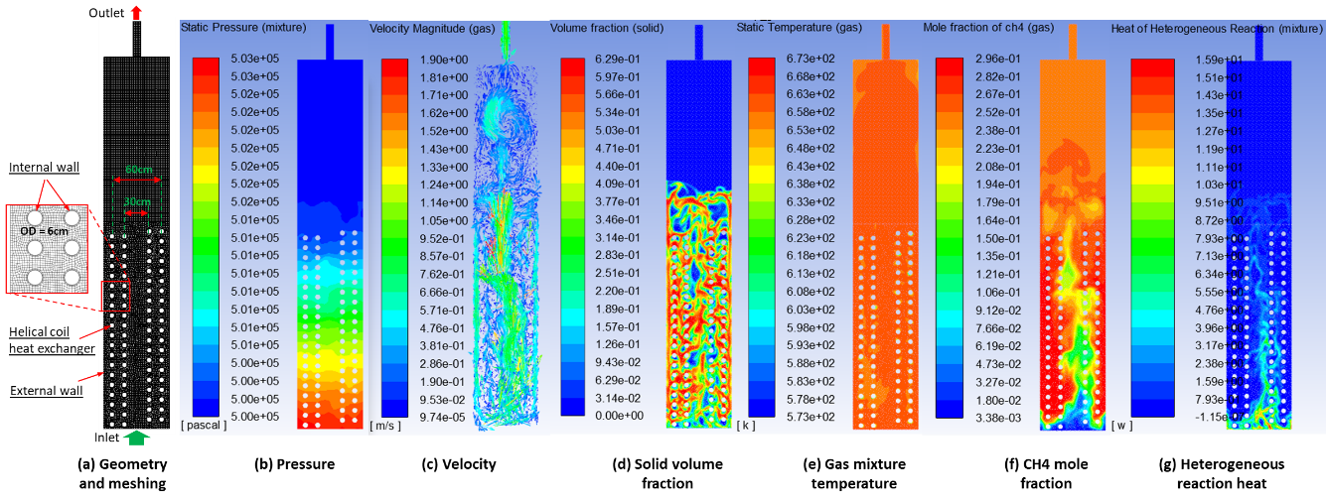
Figure 1. CFD domain and meshing, and CFD results.
4. Conclusions
An IC-BFB was modeled using a 2D Eulerian two-fluid CFD model for CO₂ methanation. The CFD model demonstrated the excellent heat and mass transfer capability of the IC-BFB reactor.
Acknowledgements
This work was conducted under framework of the research and development program of the Korea Institute of Energy Research (B9-2446).
References
[1] S.G. Jadhav, P.D. Vaidya, B.M. Bhanage, J.B. Joshi, J. Energy Chem. 25 (2014) 2557–2567.
[2] S.I. Ngo, Y.-I. Lim, W. Kim, D.J. Seo, W.L. Yoon, Appl. Energy. 236 (2019) 340–353.
[3] S.I. Ngo, Y. Il Lim, B.H. Song, U. Do Lee, J.W. Lee, J.H. Song, Powder Technol. 275 (2015) 188–198.
[4] J. Kopyscinski, T.J. Schildhauer, S.M.A. Biollaz, Chem. Eng. Sci. 66 (2011) 924–934.
[5] L. Sun, K. Luo, J. Fan, Fuel. 231 (2018) 85–93.
[6] J. Xu, G.F. Froment, AIChE J. 35 (1989) 88–96.
[7] S. Rönsch, J. Köchermann, J. Schneider, S. Matthischke, Chem. Eng. Technol. 39 (2016), 208–218.

