Relating crystalline properties with the bulk and surface chemistry of quercetin and its hydrate forms using molecular and synthonic modelling
Panayiotis Klitou^{1*}, Ian Rosbottom², Elena Simone^{1*}
1 School of Food Science and Nutrition, University of Leeds, Leeds, U.K.; 2 School of Chemical and Process Engineering, University of Leeds, Leeds, U.K.
*fspkl@leeds.ac.uk, e.simone@leeds.ac.uk
Highlights
- Water molecules satisfy hydrogen-bonding in hydrate structures
- Hydrate structures can pack more efficiently
- Hydrate structures can have different physiochemical properties

1. Introduction
Quercetin is a naturally occurring flavonoid which is ubiquitous in the human diet. It is found in many fruits and vegetables and it is known to be an antitumor agent and to exhibit antiallergic, anti-inflammatory and antioxidant activity. [1] Due to the wide range of health benefits, this compound finds use in nutraceuticals and food supplements. [1] Quercetin can exist as an anhydrous, monohydrate and dihydrate crystal form. Usually hydrates exhibit different physiochemical properties, like solubility, stability, morphology and surface chemistry. [2] Understanding these properties and selecting the most appropriate crystal form in terms of thermodynamic and kinetic stability is of critical importance for several industrial applications.
Molecular modelling is an inexpensive and quick way to gain insight into the link between crystal structure and powder properties. This can be achieved by calculating the strength, directivity and dispersive nature of the intermolecular interactions (synthons) within the crystal structure. [3]
In this work, synthonic modelling is used to explore three different hydrated crystalline structures of quercetin: the anhydrous, monohydrate and dihydrate forms, for which the bulk intrinsic and surface extrinsic synthons were examined. The role of water molecules within the three hydrated structures was studied to understand how water affects the packing and conformation energetics of quercetin crystals. This knowledge can then be used to predict physiochemical properties such as stability, and to better understand the mechanisms of nucleation and growth during the crystallization process. Furthermore, the attachment energy model is utilized here to predict the crystal morphology of each form, and by the characterisation of the surface extrinsic synthons, to explore the surface chemistry and predict surface properties such as polarity. [4]
2. Methods
The Habit 98 software (developed in house at the University of Leeds) was used for the calculation of the pairwise intermolecular interaction strengths and lattice energy. [3] This was achieved by summing all the interactions between a central molecule and all the other molecules within a sphere of fixed radius of 30Å around the central molecule. The intermolecular interactions were calculated using the Momany force-field. [3] All visualization of molecular and crystal packing were carried out in Mercury CSD Version 3.10.
3. Results and discussion
By analyzing the bulk chemistry of quercetin anhydrous, it was found that all key synthons are polar interactions, involving hydrogen bonds and permanent dipole-dipole interactions, while in the monohydrate and dihydrate structures the synthon contributing more to the lattice energy is a non-polar π-π stacking interaction. The hydrogen bonding interactions in the two hydrates are satisfied partly (monohydrate) or exclusively (dihydrate) by interaction with the water molecules.
A conformational analysis was performed and revealed that the quercetin molecules within the anhydrous structure are organized in a less planar arrangement, thus being unable to pack as efficiently and resulting in a lower unit cell density. The quercetin molecules in the monohydrate and dihydrate structures are arranged in a more planar way, due to the fact that quercetin hydrogen bonding is satisfied by the presence of water molecules. Therefore, the presence of water allow quercetin molecules to pack more closely and form the strong π-π stacking interactions, which result in higher unit cell density and greater stability, agreeing with experimental solubility data. [1]
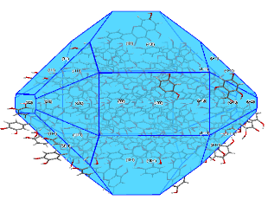
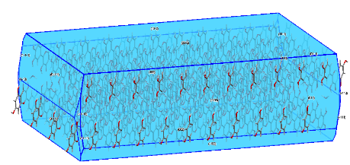
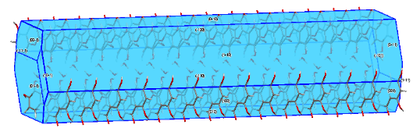
Finally, the attachment energy model was used to predict the growth rate of each face in the three structures and to identify the surface extrinsic synthons contributing to the growth of each facet. The extrinsic synthons were characterised and the surface chemistry of the different faces in each structure was studied, predicting different properties such as face polarity. The attachment energy model was further used to predict the morphology of the structures, illustrated in Figure 1.
(c)
(b)
(a)

Figure 1. Morphological predictions of quercetin anhydrous (a), monohydrate (b), and dihydrate (c)
4. Conclusions
The presented modelling results show how the presence of water molecules in the quercetin hydrate structures impacts on the type and strength of intermolecular interactions within the crystal, affecting the conformation and packing of the quercetin molecules in each structure. This results in differences in physiochemical properties, such as stability, morphology and surface chemistry. This work shows how synthonic modelling can be used as a predicting tool to better understand the relationship between crystal properties and product quality, leading to a more efficient product formulation and faster development.
References
[1] K. Srinivas, J.W. King, L.R. Howard, J.K. Monrad, J. Food Eng. 100 (2010) 208–218.
[2] A.M. Healy, Z.A. Worku, D. Kumar, A.M. Madi, Adv. Drug Deliv. Rev. 117 (2017) 25–46.
[3] I. Rosbottom, K.J. Roberts, in: K.J. Roberts, R. Docherty, R. Tamura (Eds.), Springer Netherlands, Dordrecht, 2017, pp. 109–131.
[4] P. Hartman, J. Cryst. Growth 49 (1980) 166–170.

