High performance dual-electrolyte aluminum-air flow battery
Pemika Teabnamang¹, Soorathep Kheawhom^{1,2,}*
1 Department of Chemical Engineering, Faculty of Engineering, Chulalongkorn University, Bangkok, Thailand; 2 Research Unit of Advanced Materials for Energy Storage, Chulalongkorn University, Bangkok, Thailand
*Corresponding author: soorathep.k@chula.ac.th
Highlights
- Dual-electrolyte cell using methanol anolyte suppresses anode corrosion.
- Flowing anolyte prevents passivation of aluminum anode.
- Higher water content improves discharge current density.
- Higher water content increases self-corrosion.

1. Introduction
Recently, climate change has become increasingly significant putting considerable pressure on various aspects of our environment. To address this problem, a sustainable solution for energy generation and storage are actively investigated. Electrical energy storage (EES) systems are essential for the effective utilization and integration of renewable energy sources to the power grid. EES systems offer many benefits including improving the way energy is delivered, consumed and generated. Rechargeable batteries are the most common energy storage system.
Rechargeable aluminum-air batteries are a promising EES system. Aluminum-air batteries have a high specific capacity of 2.98 Ah/g. Furthermore, the aluminum anode is an inexpensive, abundant and environmentally friendly metal with high recyclability. Nonetheless, corrosion of the aluminum anode is a critical issue for traditional aluminum-air batteries. The anodic corrosion results in the accumulation of hydrogen gas in the cell and increases the hydrogen explosion possibility. Besides, it causes unacceptably high energy losses. Various works have attempted to inhibit aluminum self-corrosion by alloying aluminum with other elements or modifying the electrolyte using certain additives. Nevertheless, these efforts have shown limited success and have often increased the complexity of the battery system. To address this issue, aluminum oxidation should take place in a non-aqueous environment with high aluminum anode activity while suppressing the corrosion rate. Methanol (CH₃OH) used as the electrolyte was found to provide a high capacity under a dual-electrolyte system in an aluminum-air battery whereby a non-aqueous electrolyte was used for the anolyte and an aqueous electrolyte was used for the catholyte. Hence, this work proposes a dual-electrolyte aluminum-air flow battery with a structure of an aluminum anode | methanol electrolyte || gel polymer electrolyte | air cathode.
2. Methods
The corrosion behavior of the aluminum anode in methanol with varying the amount of deionized water (0%, 5%, 10% and 20%) and 3 M KOH-methanol mixed solution was examined by measuring the volume of evolved hydrogen gas as a function of time. Also, the half-cell test was carried out using a three-electrode cell was used to study the electrochemical measurement and characterization. The battery cell structure consisting of aluminum anode | anolyte | anion exchange membrane | catholyte | air cathode was fabricated as shown in Fig. 1. The anolyte is 3 M KOH in methanol containing different percentages of deionized water. The catholyte is a gel polymer electrolyte based on Carbopol 940. Performances of the batteries were then examined.
3. Results and discussion
The volume of hydrogen evolved can speculate how much aluminum consumed without discharging. The results showed that hydrogen evolution is higher when the percentage of water is raised. The highest weight loss of aluminum occurred in the condition of 20% water; this condition contained the highest deionized water percentage. The results of electrochemical impedance spectroscopy showed that water in the anolyte had various effects such as decreasing aluminum double-layer, increasing mass transfer owing to the decrease in electrolyte viscosity and enhancing conductivity. Thus, increasing of deionized water leads to higher anodic corrosion.
 | 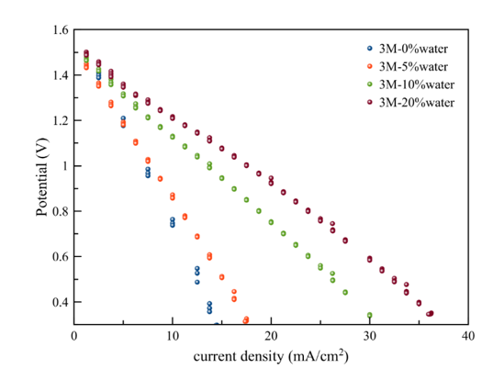
Figure 1. Schematic diagram of a dual electrolyte aluminum-air battery. | Figure 2. Polarization characteristics of the aluminum-air flow battery using different anolytes.
Figure 2 shows the polarization characteristics of the aluminum-air battery. The limiting current density for each condition slightly increased as follows: 14.97 mA/cm², 17.50 mA/cm², 30 mA/cm² and 36.3 mA/cm² at 0, 5, 10 and 20% water, respectively.
The anhydrous methanol anolyte achieved a specific capacity of 2,328 mAh/g for around 40 hrs. When the deionized water increased, the specific capacity decreased consecutively: from 1,700 mAh/g, 1,130 mAh/g and 465 mAh/g at the condition of 5, 10, and 20% water, respectively. Simultaneously, when the deionized water was increased, discharge voltage also increased, but the aluminum utilization percentage decreased. In the anhydrous methanol anolyte, the corrosion of aluminum is significantly inhibited, but the corrosion substantially increased when the amount of water increased.
4. Conclusions
The dual-electrolyte system using methanol-KOH anolyte completely suppressed the anodic corrosion and provided the highest specific capacity of 2,328 mAh/g discharging at 10 mA/cm². The aluminum consumption had more than 75%. In addition, the discharge voltage of the battery increased when the electrolyte contained water. However, the presence of water in the anolyte decreased the specific capacity as the corrosion increased. Trade-off between discharge performance and corrosion can be done adjusting the water content in the methanol-KOH anolyte.

