A novel microfluidic device to investigate tumor cell extravasation
Claudia Kühlbach^{1, 2}, Margareta M. Mueller¹, Frank Baganz², and Volker C. Hass^{1, 2}*,
1 Furtwangen University, Villingen-Schwenningen, D-78054, Germany; 2 University College London, London, WC1E 6BT,UK
*Corresponding author: volker.hass@hs-furtwangen.de
Highlights
- Novel microfluidic device for cell extravasation
- Total confluency of functional area for transmigration
- Proof of tumor cell adhesion and transendothelial migration

1. Introduction
The process of metastasis of tumor cells is highly complex and includes the steps of intravasation, tumor cell distribution by blood stream and extravasation into surrounding tissues [1]. The molecular conditions and the mechanism for extravasation are still not fully understood.
To investigate the metastatic cascade, two different microfluidic approaches are frequently pursued. The hydrogel based systems, where the endothelial cells (EC) are embedded in hydrogel take advantage of the capability of the EC to self-assemble into a tubule-like vascular network, however it cannot be subjected to flow [2]. The second approach uses EC in monolayer, cultivated in matrix protein coated microfluidic channels. These devices are often hard to control for EC confluency [3].
Here we introduce a novel microfluidic device to study tumor cell extravasation and proof its functionality, under well-established confluency control as well as the extravasation process under dynamic flow conditions.
2. Methods
Methods used include culturing and seeding of the EC, the introduction of the tumor cells and immune fluorescence staining and are described in detail in Kühlbach et al., 2018 [4].
3. Results and discussion
The microfluidic device consists of three different parts. The upper channel, together with the porous membrane, represents the vessel equivalent (Figure 1A).
The upper channel and the membrane were seeded separately with EC in monolayer. This better represents the in vivo situation, in contrast to devices which work with multilayer EC, embedded in hydrogel [2]. The lower channel acts as reservoir to collect transmigrated tumor cells. In this novel device, the EC monolayer was checked for 100% confluency, before any assembly, as a confluent EC monolayer is essential to assure a tight barrier function. The EC monolayer integrity was verified, showing a regular expression and integration of VE-Cadherin into the EC cell membrane, as described for the in vivo situation in blood capillaries [5].
Additional coating of the microfluidic unit was abandoned, as the used EC secrete collagen IV and therefore establish their own basement membrane, as described before for EC cultures [6].
When adding different flow conditions to the device, the EC changed phenotype and oriented into flow direction, similar as previously described for the in vivo situation [7].
The introduced tumor cells successfully adhere to the endothelial lining under different flow conditions. The number of adherent tumor cells was not influenced when continuous flow was applied. In contrast, when pulsating flow was adopted, the number of adherent tumor cells decreased with increase of flow velocity (Figure 1B).
The successful transendothelial migration of tumor cells under static conditions could be shown.

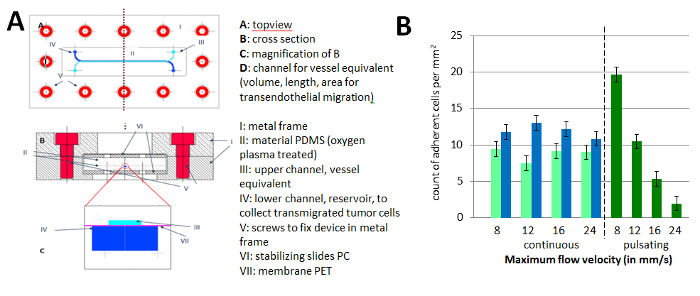
Figure 1: A: Technical drawing and measurements of the novel microfluidic device. Channel sizes: Vessel equivalent: 500 µm x 100 µm x 6.1 cm; Reservoir: 1mm x 500 µm x 6.1 cm; Membrane properties: Pore size 5 µm, pore density 6x10⁴ cm⁻², thickness 15 µm. B: Count of different tumor cells adherent to the endothelial monolayer within the vessel equivalent [4].

4. Conclusions
With our work, we introduce a novel microfluidic device overcoming problems found with other devices described in the literature. The successful functionality tests indicate that the device can be used for the in vitro research on cell extravasation. By adding adhesion inhibitors or homing factors to the system, the impact of these chemokines onto the adhesion rate and transendothelial migration could be evaluated.
References
- S. Ramaswamy, K.N. Ross, E.S. Lander, T.R. Golub, Nat. Genet. 33 (2002) 49–54.
- H. Lee, M. Chung, N.L. Jeon, MRS Bull. 39 (2014) 51–59.
- X. Cui, W. Guo, Y. Sun, B. Sun, S. Hu, D. Sun, R.H.W. Lam, Biomicrofluidics 11 (2017) 014105.
- C. Kühlbach, S. da Luz, F. Baganz, V.C. Hass, M.M. Mueller, Bioengineering 5 (2018) 40.
- E. Dejana, Nat. Rev. Mol. Cell Biol. 5 (2004) 261–270.
- R.H. Kramer, K.G. Bensch, P.M. Davison, M.A. Karasek, J. Cell Biol. 99 (1984) 692–698.
- M.J. Levesque, R.M. Nerem, J. Biomech. Eng. 107 (1985) 341–347.

